Measuring ChatGPT Code Accuracy

Easy, Medium, and Hard coding problems.

## Prompt Template:

“

Can you help solve this programming problem in Python 3?

Description:

*(Leetcode Description Goes Here)*

Provided Code:

*(Code Provided by Leetcode Goes Here)*

”

**Total Number of Programming Problems: 21**

**Total Number of Programming Problems with Errors: 3**

**Percentage of Programming Problems with Errors: 3/21 = 14.29%**

**Total Number of Code Generations (7 probs of 3 diffs = 21 probs, 21 probs x 3 gens): 63**

**Total Number of Errors: 6**

**Percentage of Generated Code with Errors: 6/63 = 9.52%**

**Percentage of Gen Code with Logical Errors: 1/63 = 1.59%**

**Percentage of Gen Code with Runtime Errors: 5/63 = 7.94%**

**Total Types of Errors: 2**

**Errors by Type:**

* **Runtime: 5, 5/6 = 83.33%**
* **Wrong Answer (Logical): 1, 1/6 = 16.67%**

# 

Easy Problems:

# E1: [Climbing Stairs](https://leetcode.com/problems/climbing-stairs/)

## Prompt:

## 

#### 

#### 

### 

### 

### 

### 

### 

### 

### 

### 

### Generation 1

#### Response:

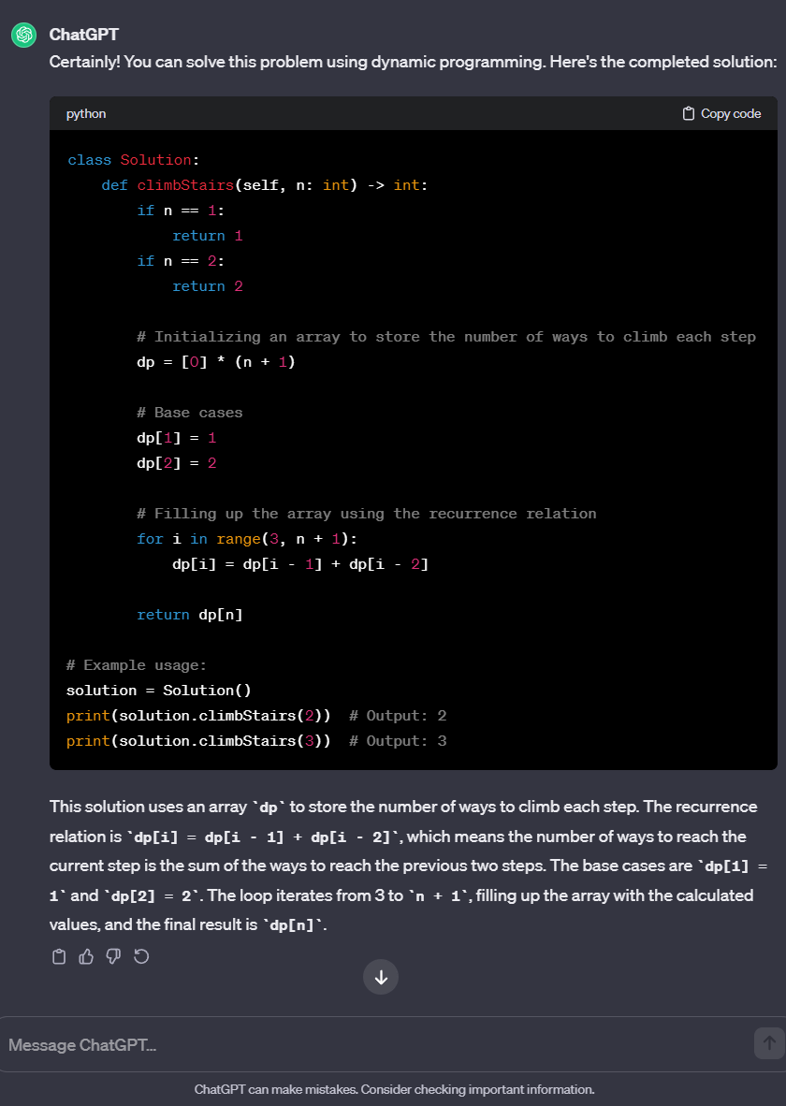

#### Leetcode Response:



### Generation 2

#### Response

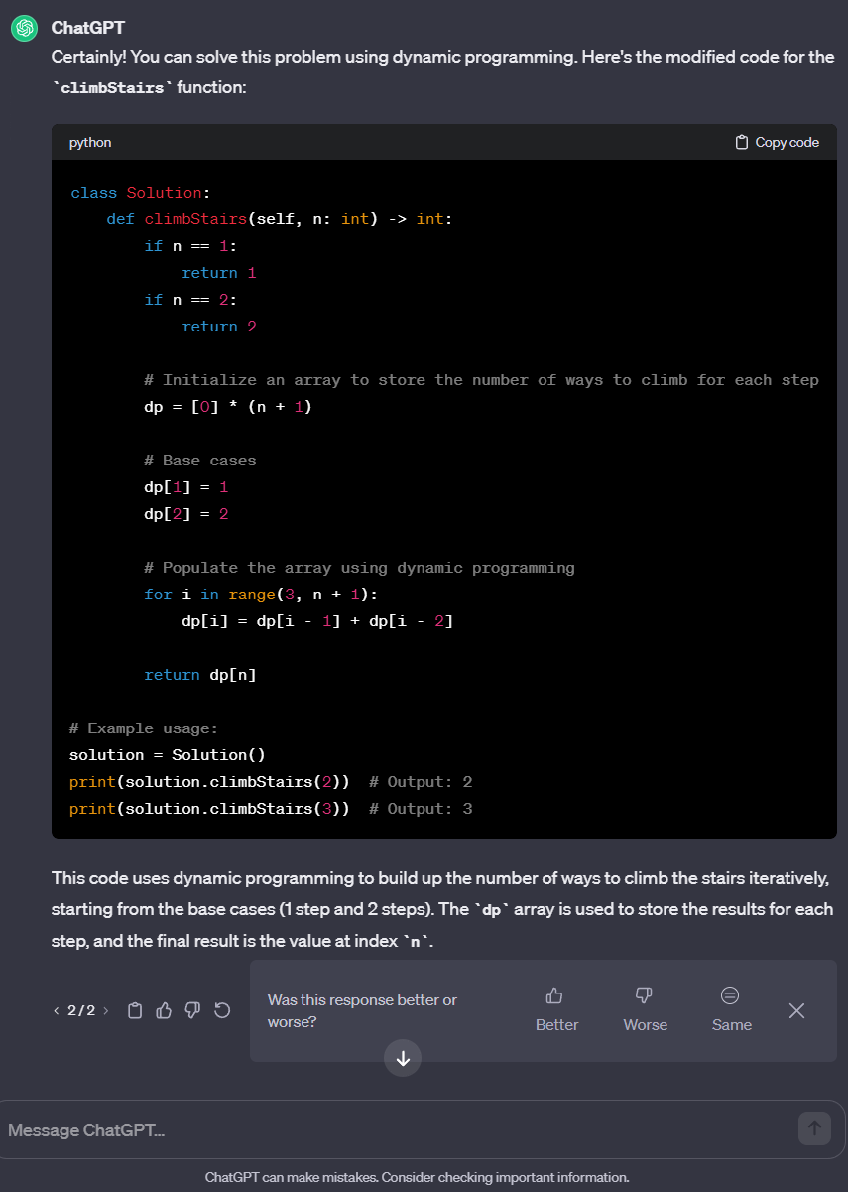

#### Leetcode Response:



### Generation 3

#### Response:

#### Leetcode Response:



# 

# E2: [Fizz Buzz](https://leetcode.com/problems/fizz-buzz/)

## Prompt:

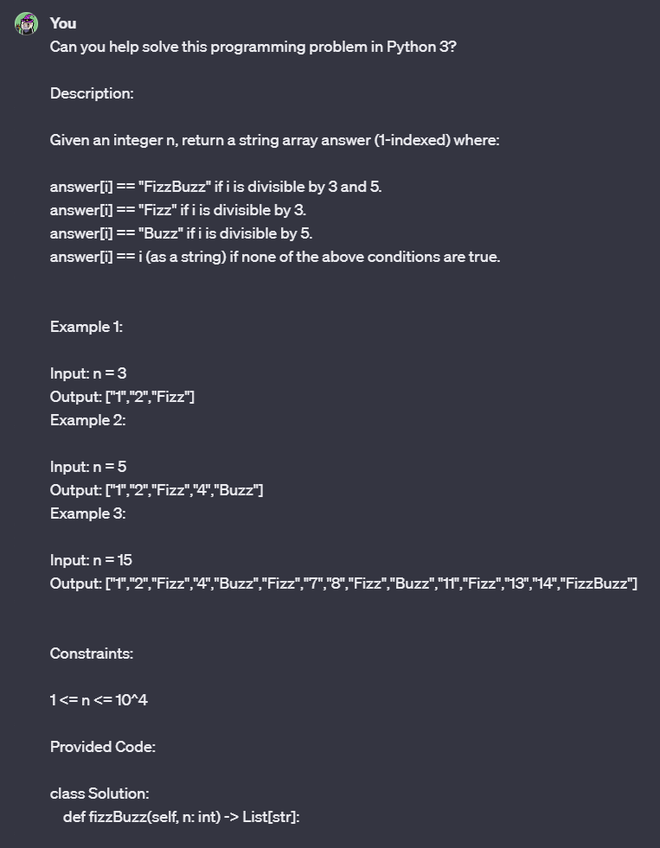

#### 

#### 

### Generation 1

#### Response:

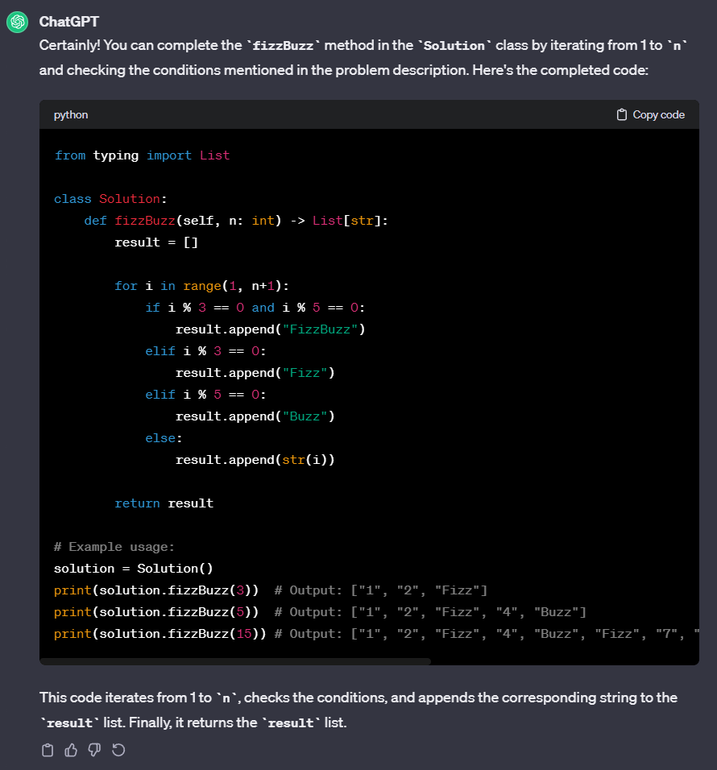

#### Leetcode Response:



### Generation 2

#### Response:

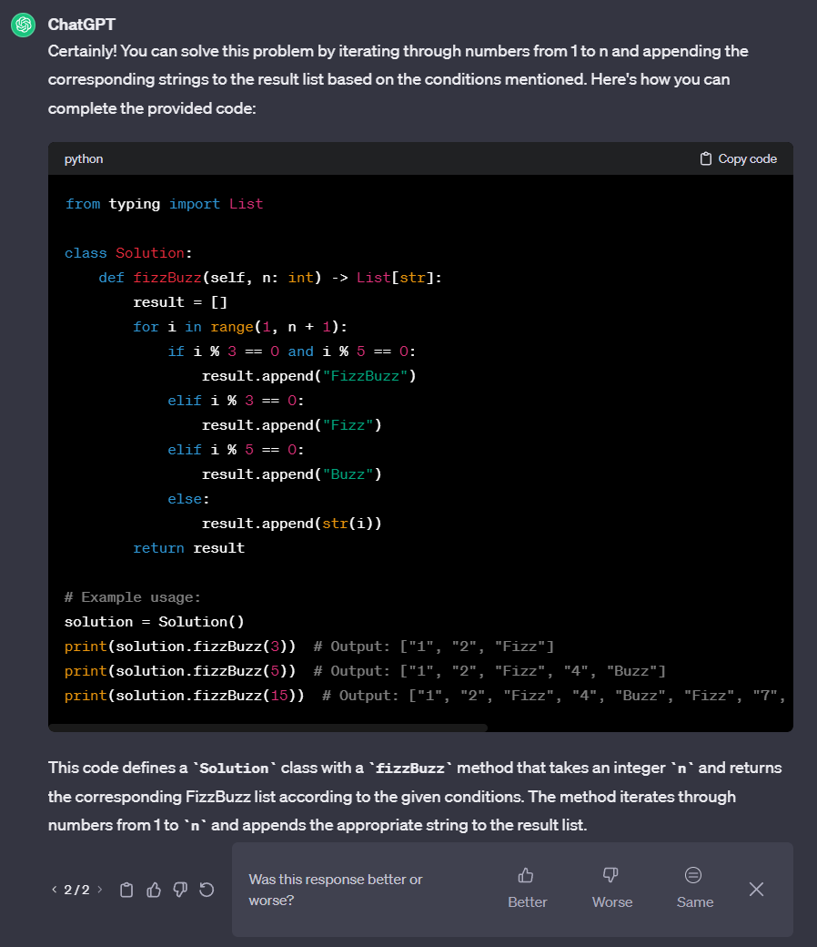

#### Leetcode Response:



### Generation 3

#### Response:

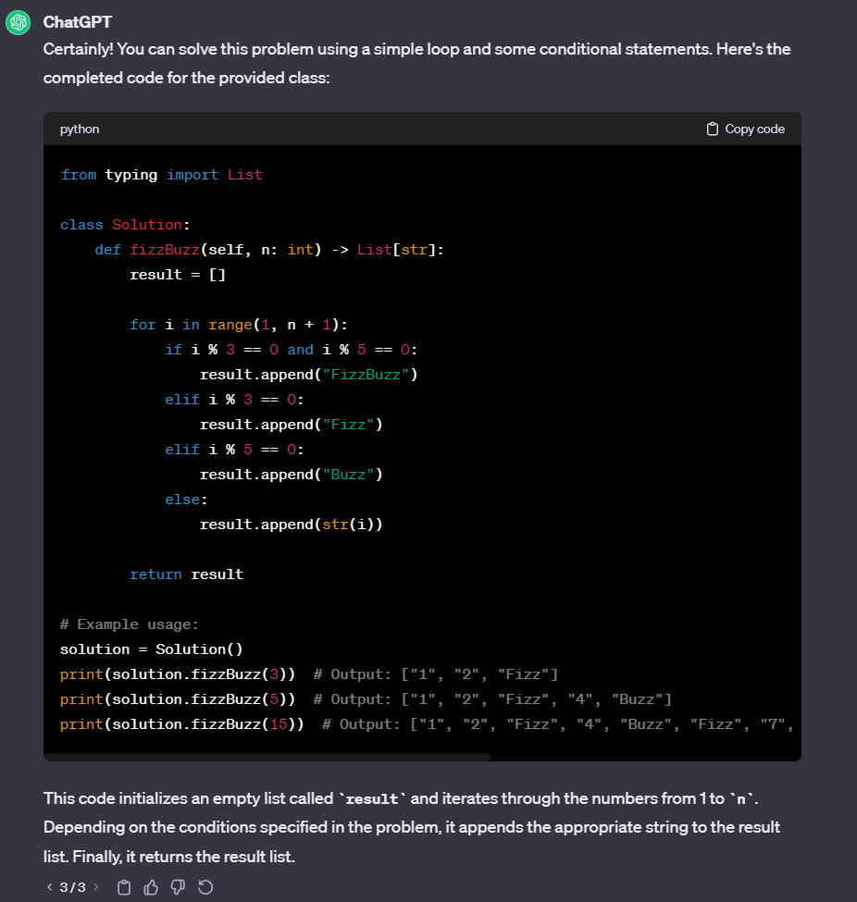

#### Leetcode Response:

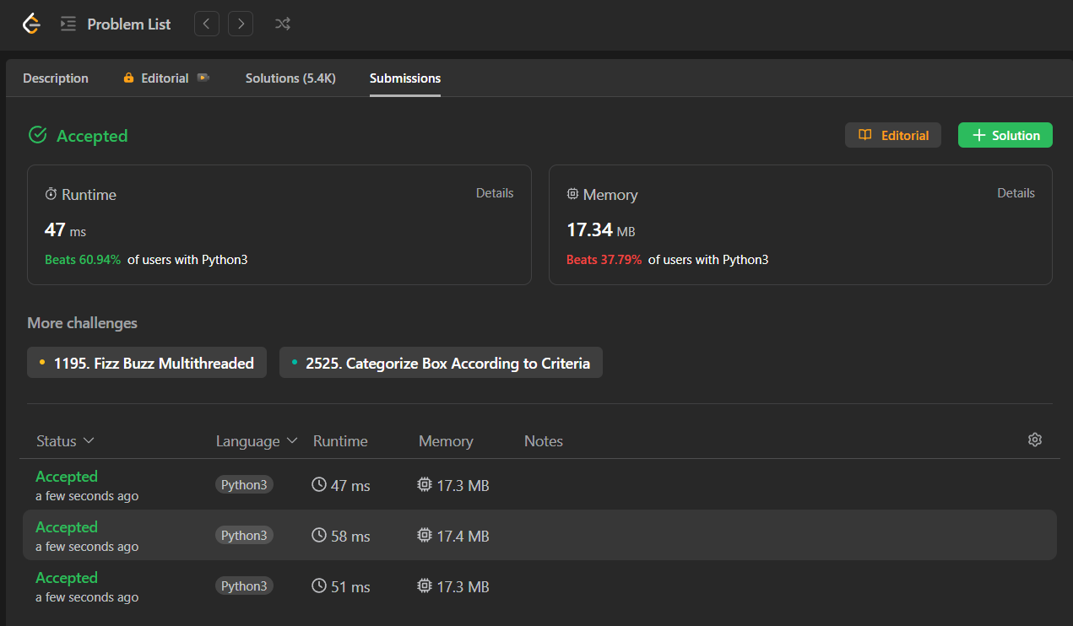

# E3: [Merge Two Sorted Lists](https://leetcode.com/problems/merge-two-sorted-lists/)

## Prompt:

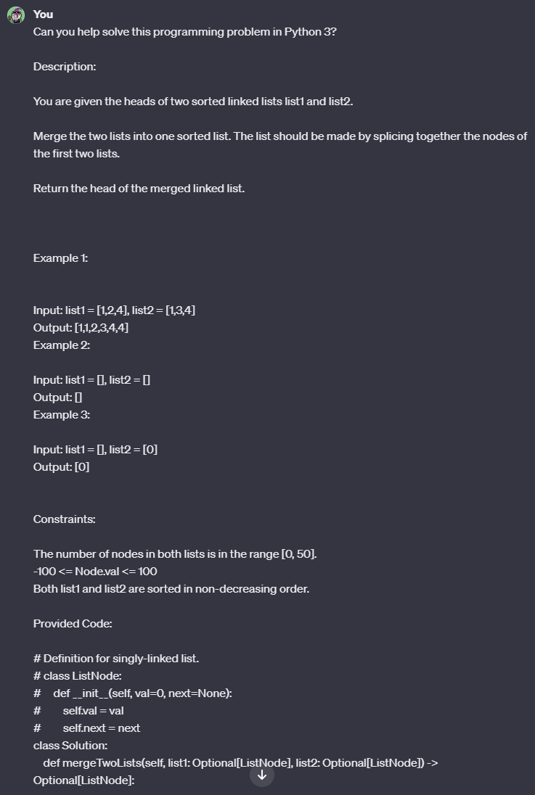

#### 

#### 

### Generation 1

#### Response:

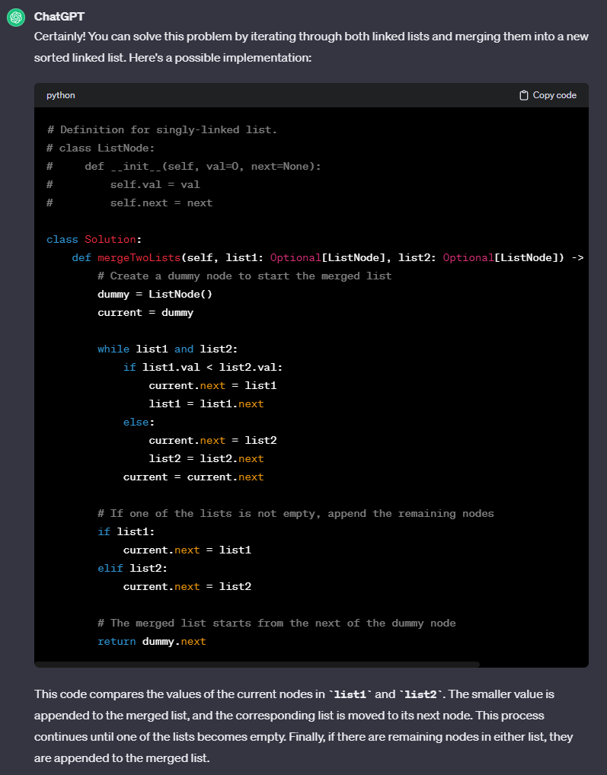

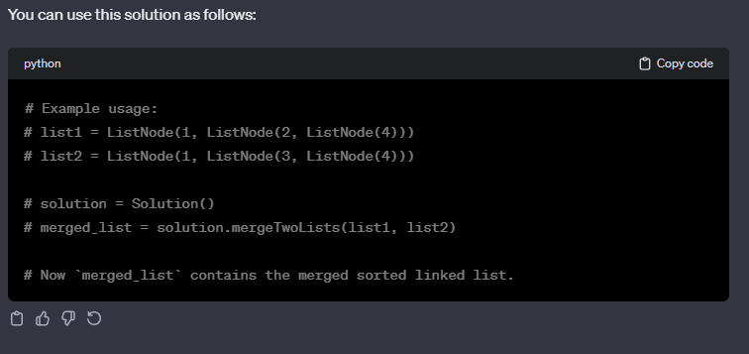

#### Leetcode Response:



### Generation 2

#### Response:

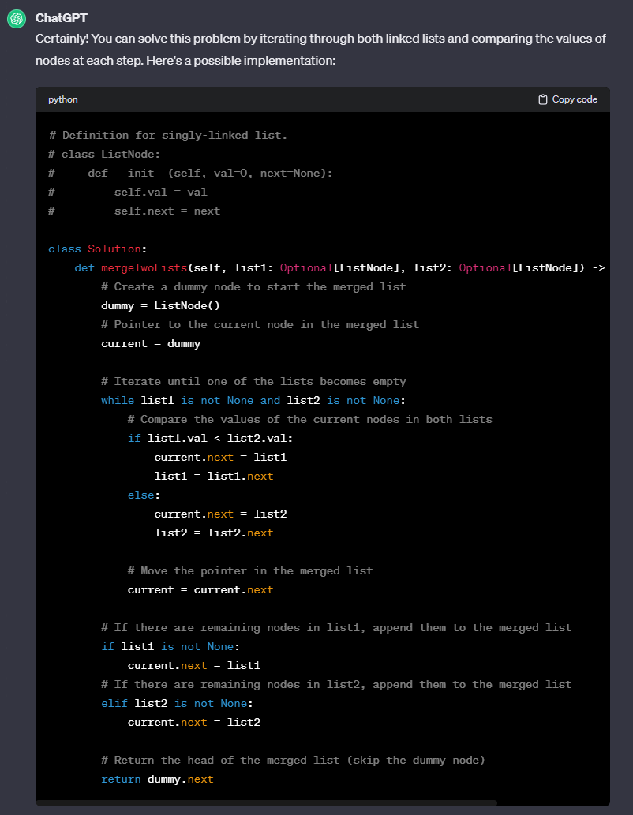

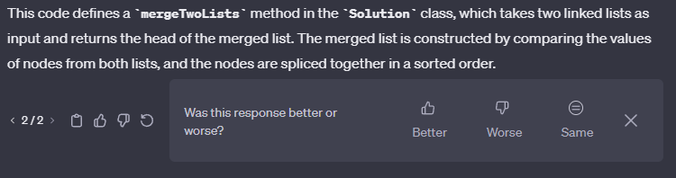

#### Leetcode Response:



### Generation 3

#### Response:

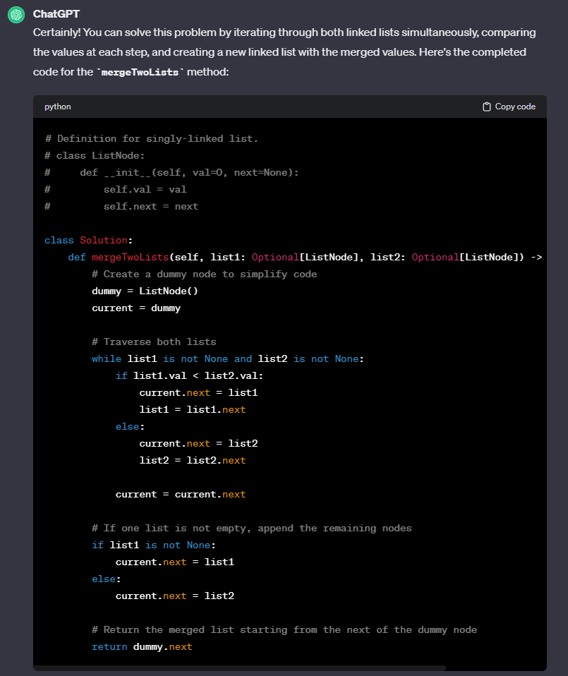

#### Leetcode Response:

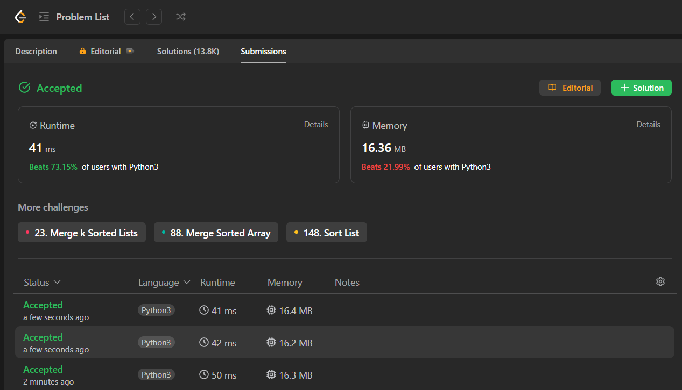

# 

# E4: [Pascal's Triangle](https://leetcode.com/problems/pascals-triangle/)

## Prompt:

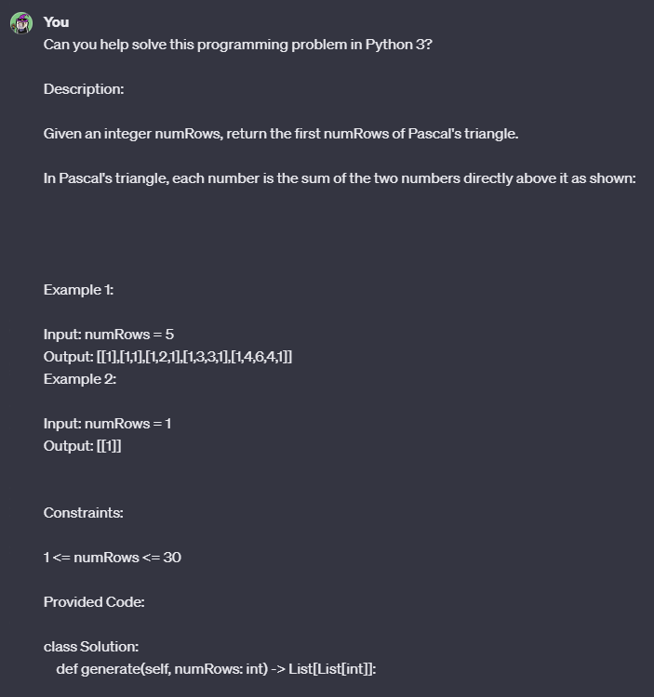

#### 

#### 

### Generation 1

#### Response:

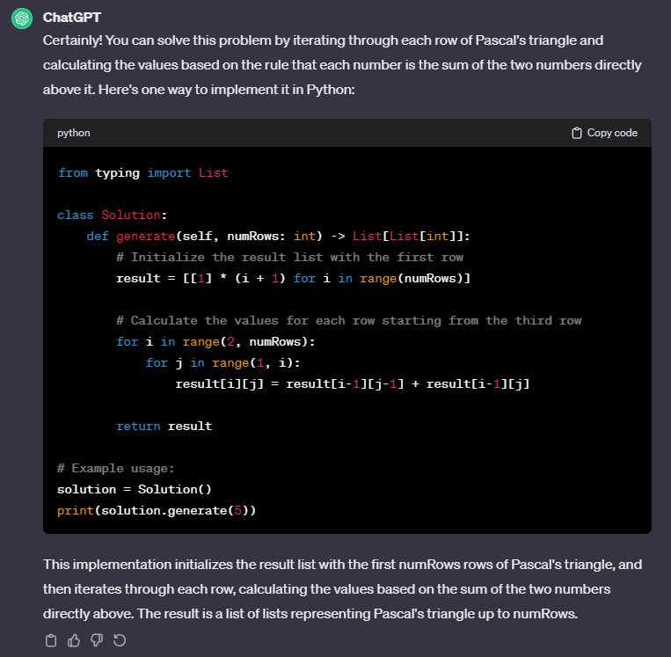

#### Leetcode Response:



### Generation 2

#### Response:

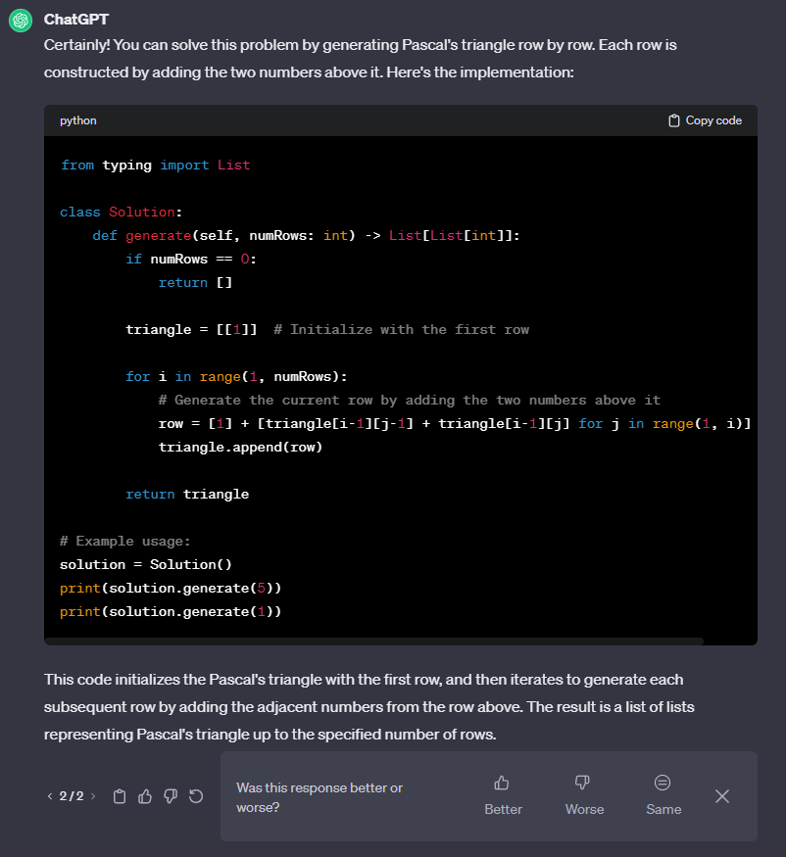

#### Leetcode Response:



### Generation 3

#### Response:

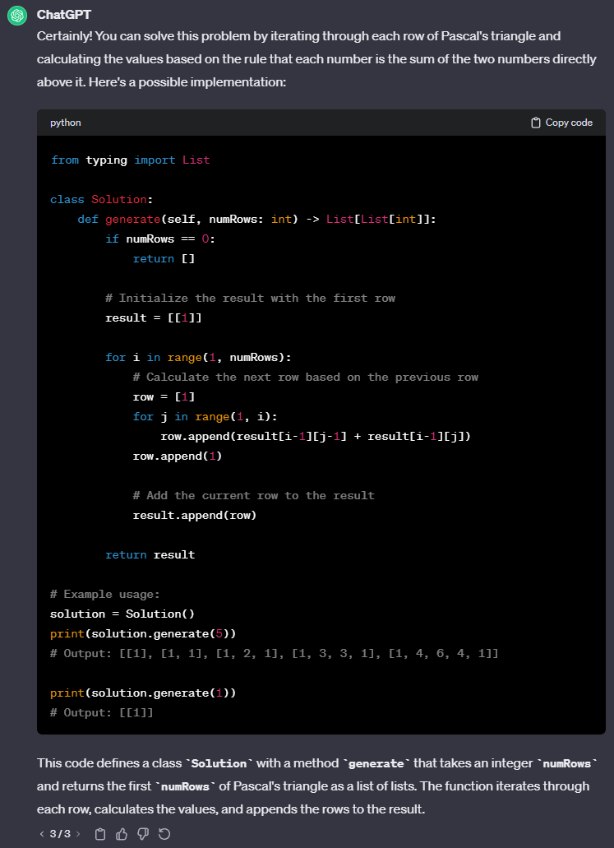

#### Leetcode Response:



# E5: [Remove Duplicates from Sorted Array](https://leetcode.com/problems/remove-duplicates-from-sorted-array/)

## Prompt:

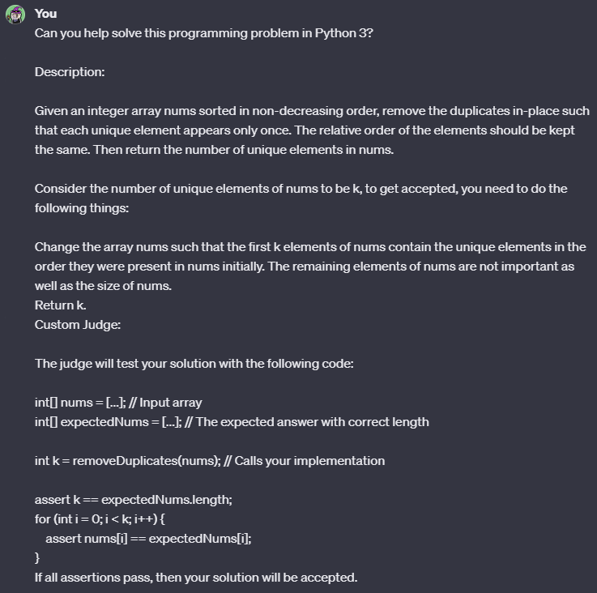

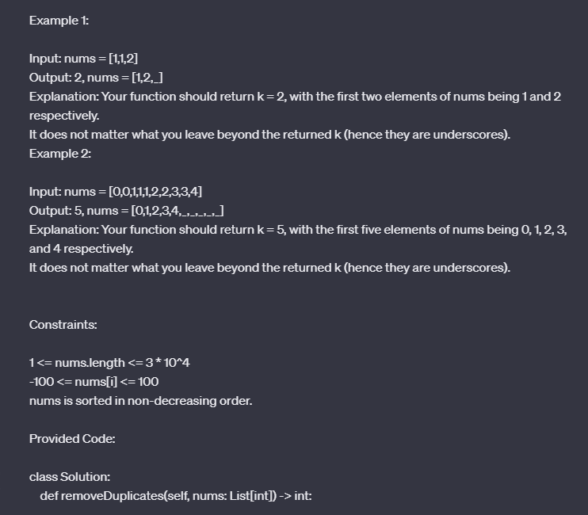

#### 

### Generation 1

#### Response:

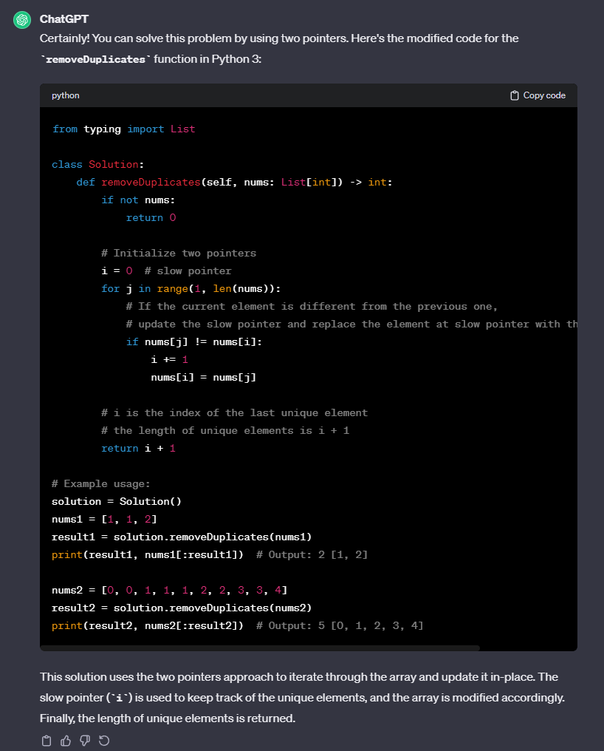

#### Leetcode Response:

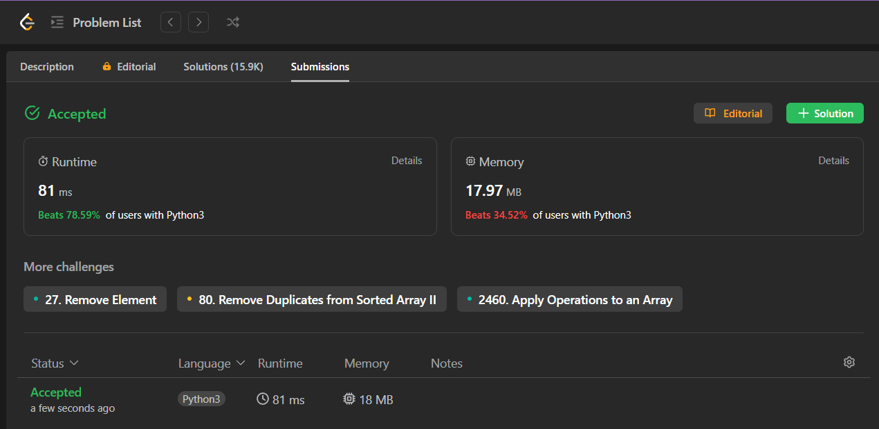

### Generation 2

#### Response:

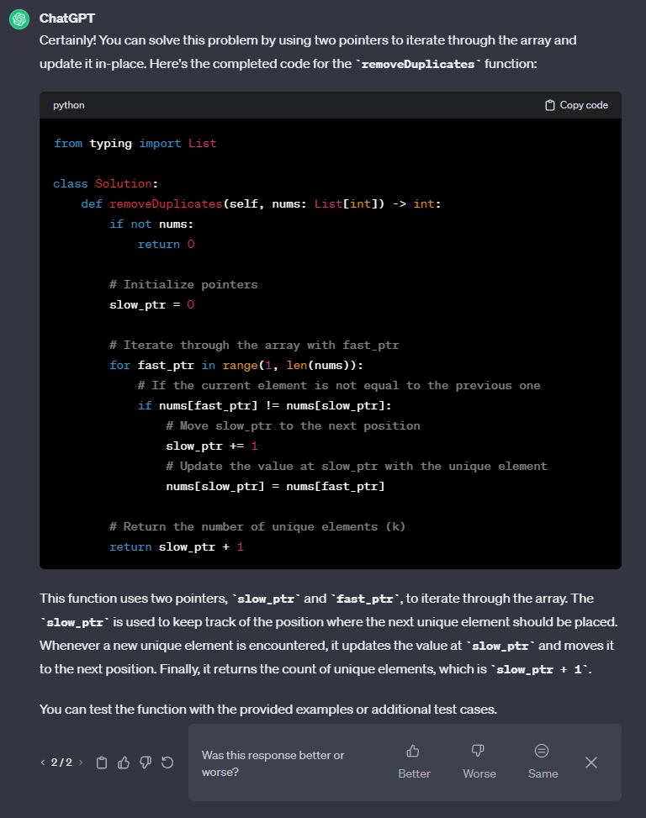

#### Leetcode Response:

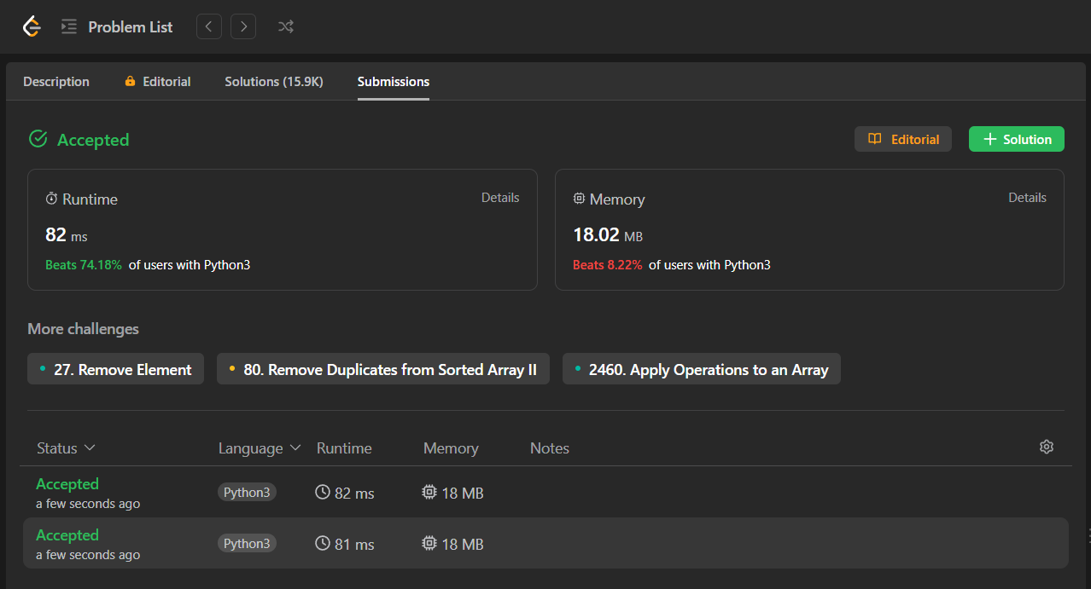

### Generation 3

#### Response:

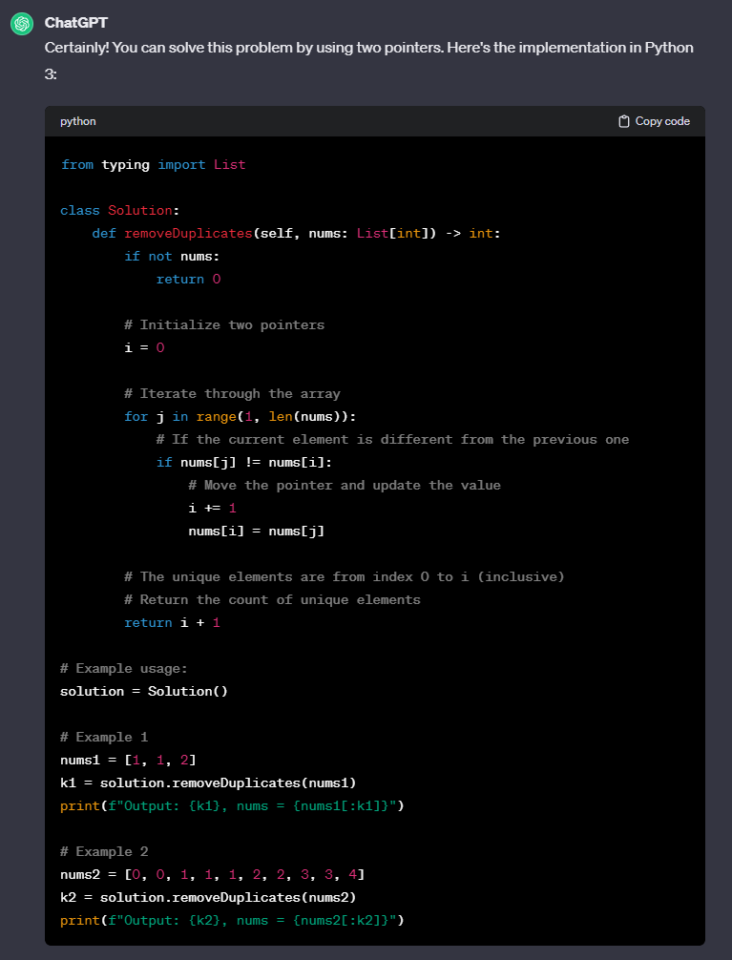

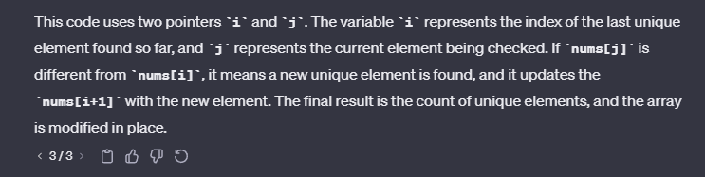

#### 

#### Leetcode Response:



# E6: [Roman to Integer](https://leetcode.com/problems/roman-to-integer/)

## Prompt:

## 

### 

### Generation 1

#### Response:

#### 

*Response (Continued):*

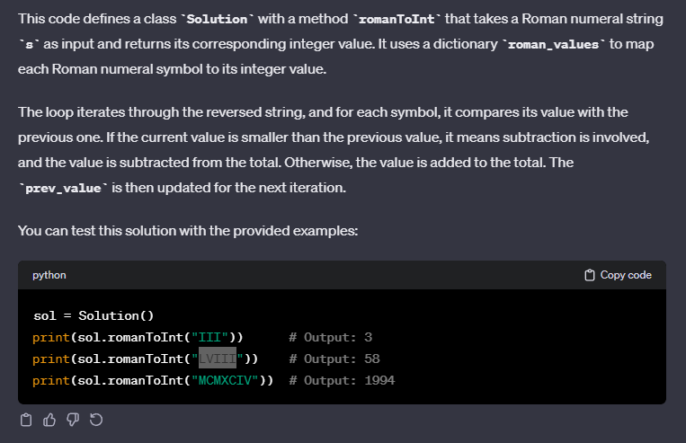

#### Leetcode Response:



### 

### Generation 2

#### Response:

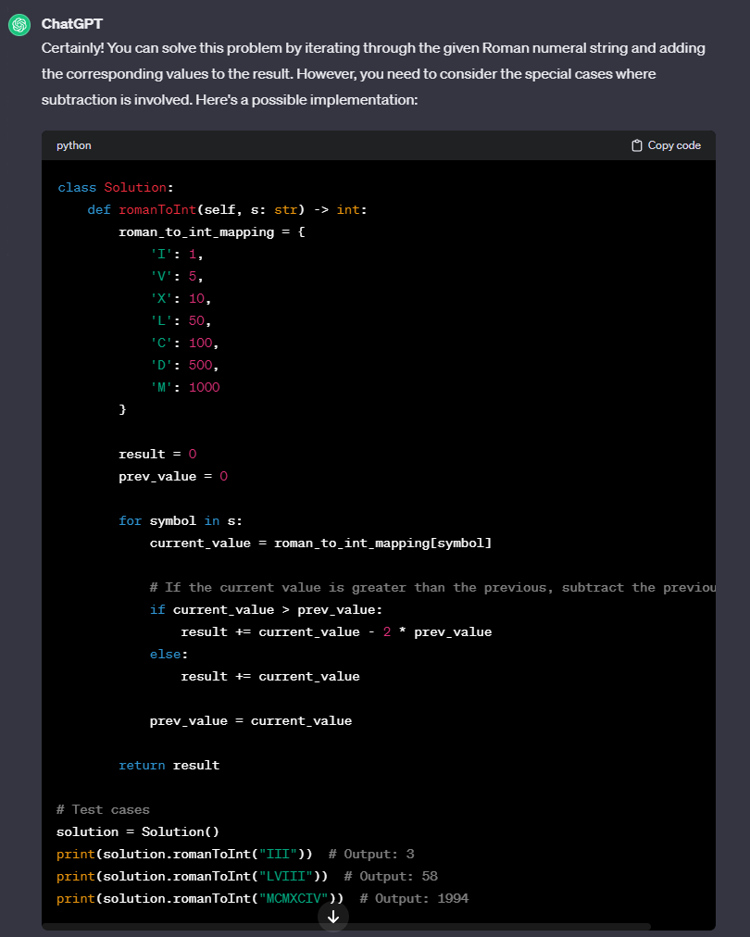

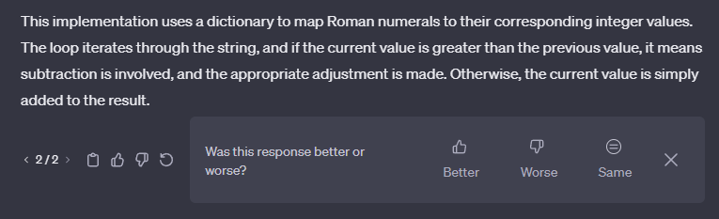

#### Leetcode Response:



### Generation 3

#### Response:

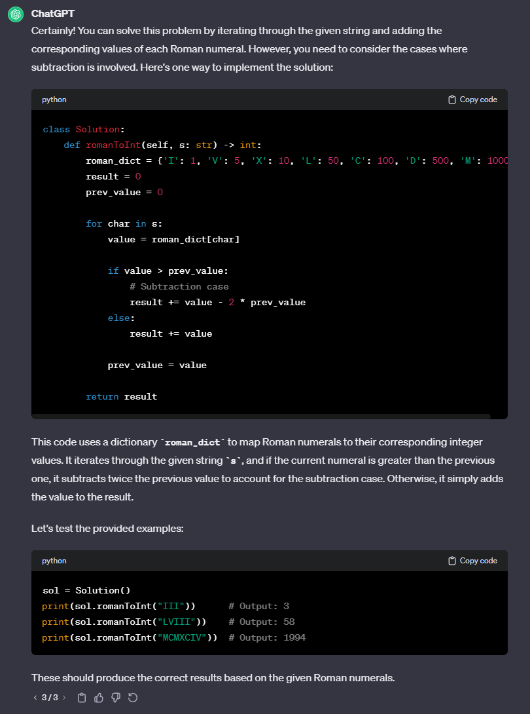

#### Leetcode Response:



# E7: [Valid Anagram](https://leetcode.com/problems/valid-anagram/)

## Prompt:

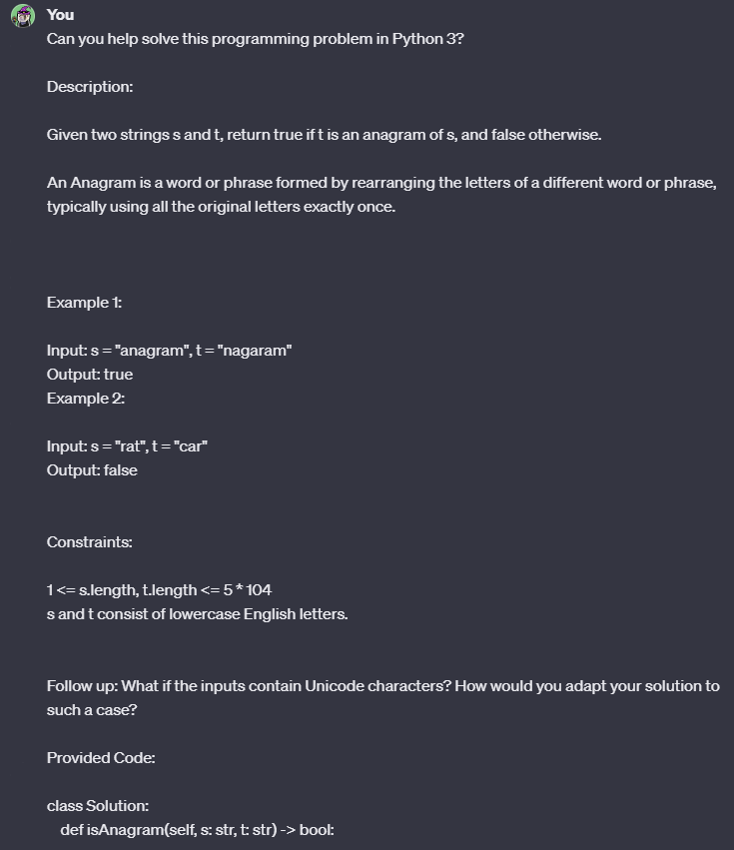

### Generation 1

#### Response:

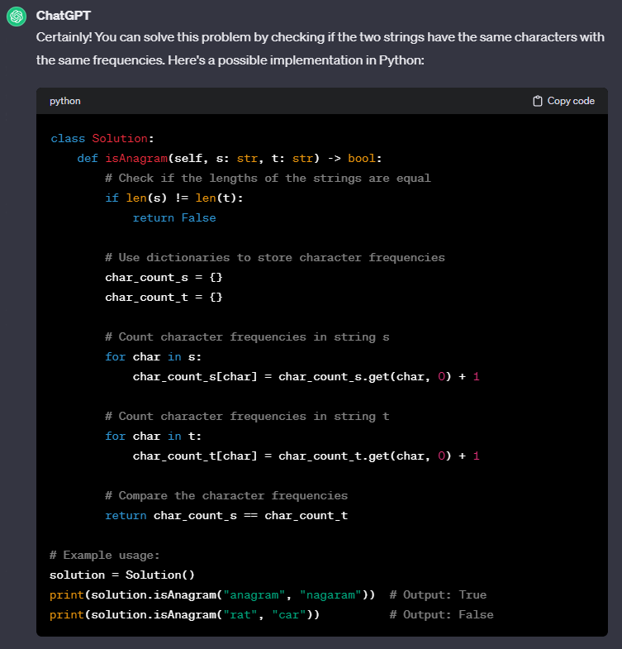

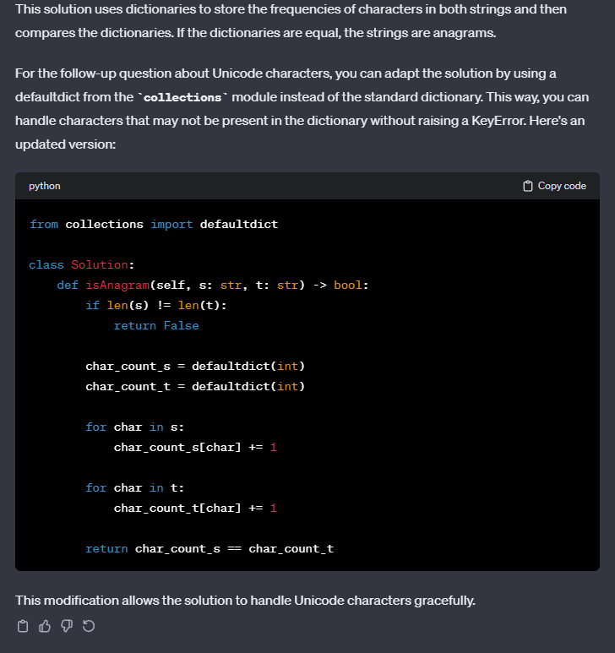

#### Leetcode Response:



### Generation 2

#### Response:

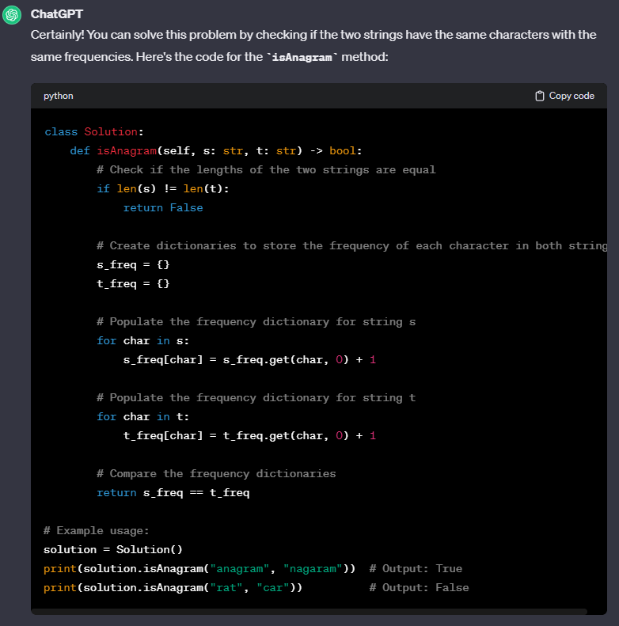

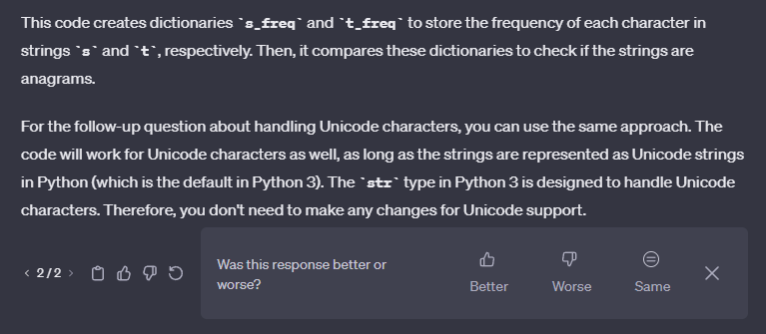

#### Leetcode Response:



### Generation 3

#### Response:

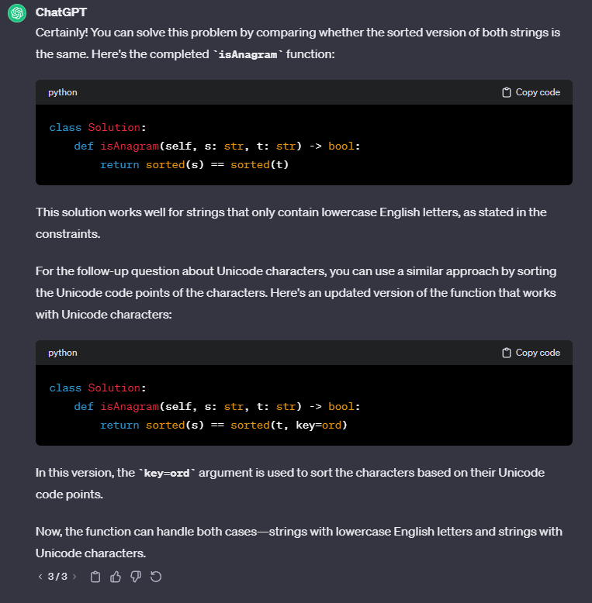

#### Leetcode Response:

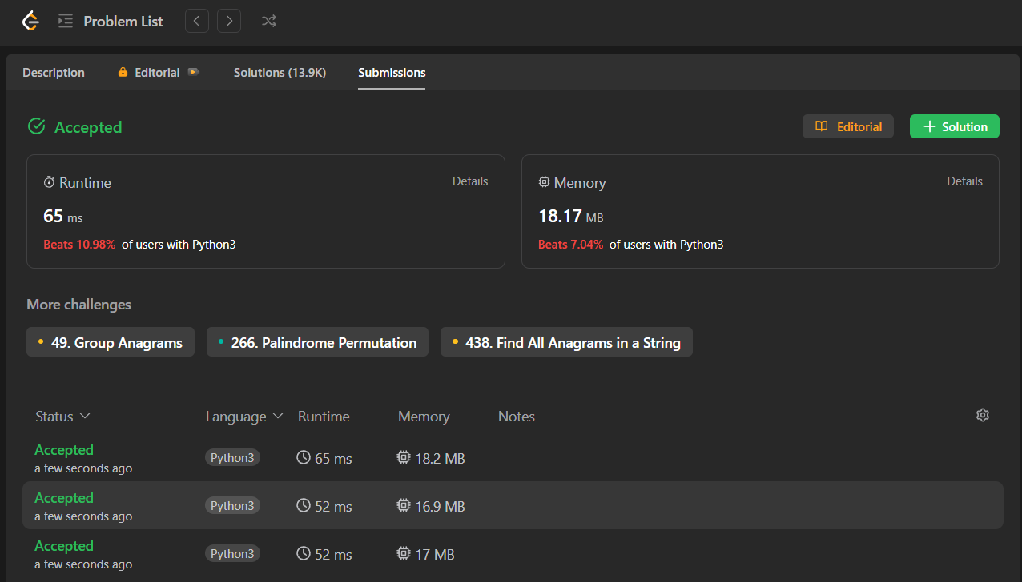

Medium Problems:

# M1: [Decode Ways](https://leetcode.com/problems/decode-ways/)

## Prompt:

#### 



#### 

### Generation 1

#### Response:

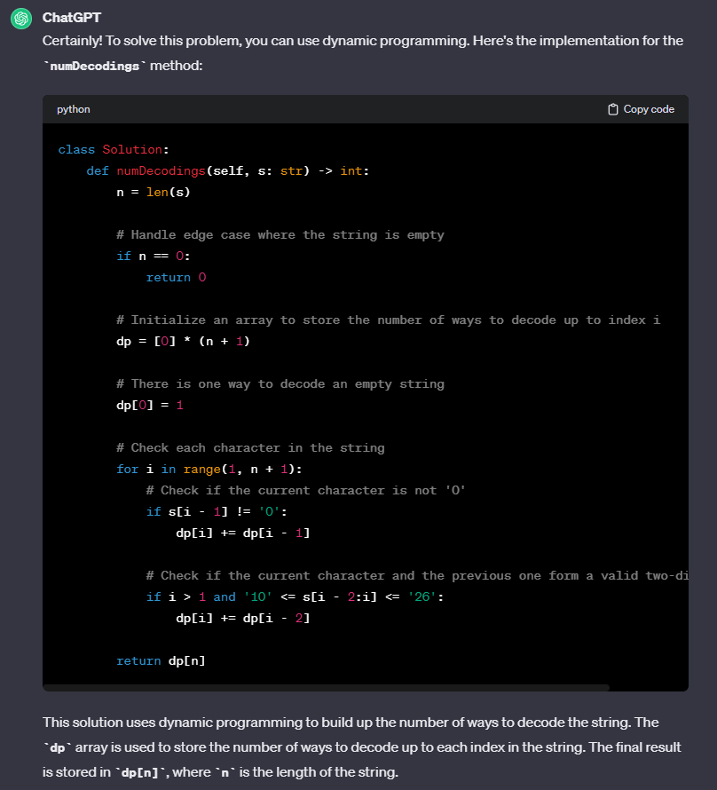



#### Leetcode Response:

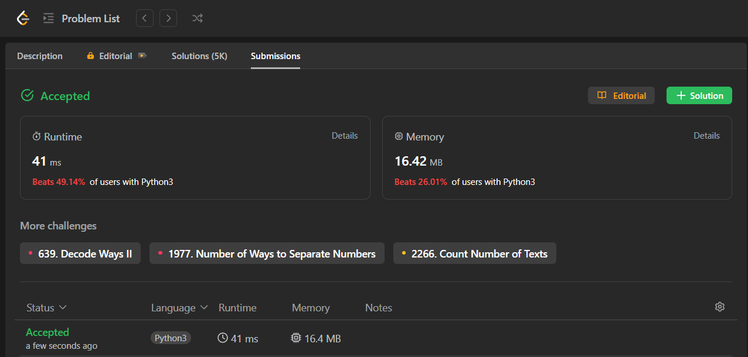

### Generation 2

#### Response:

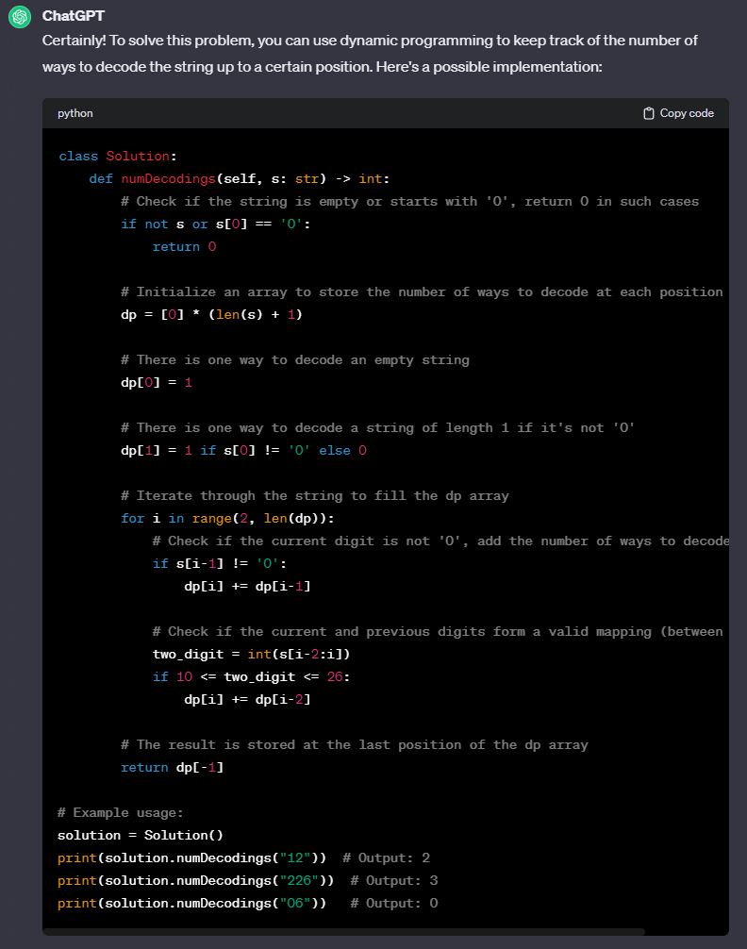

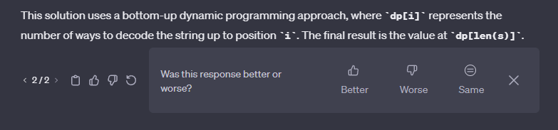

#### Leetcode Response:

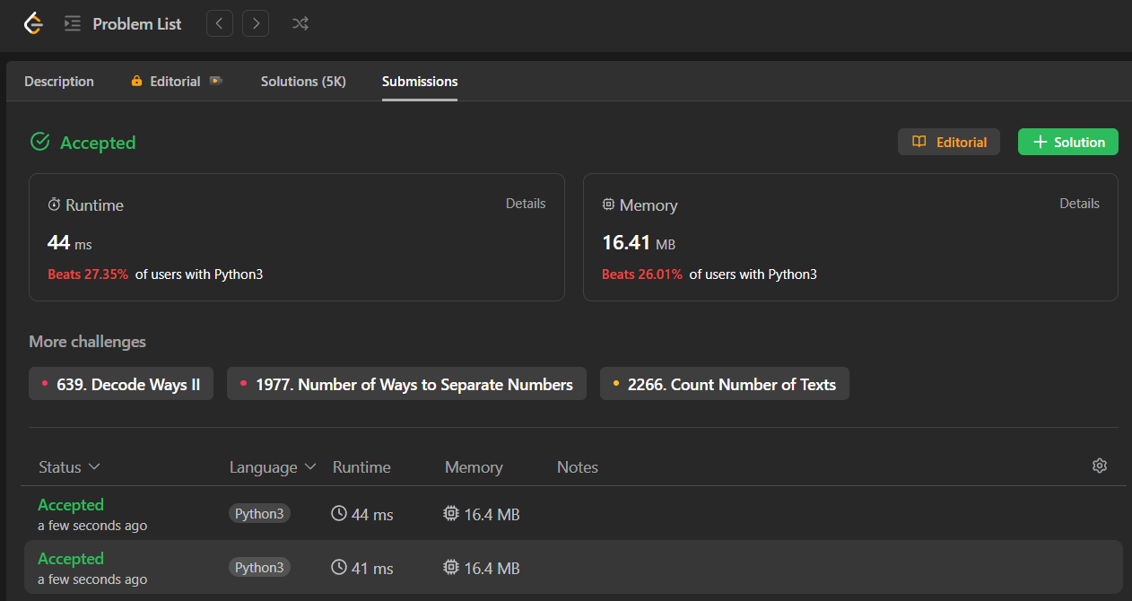

### Generation 3

#### Response:

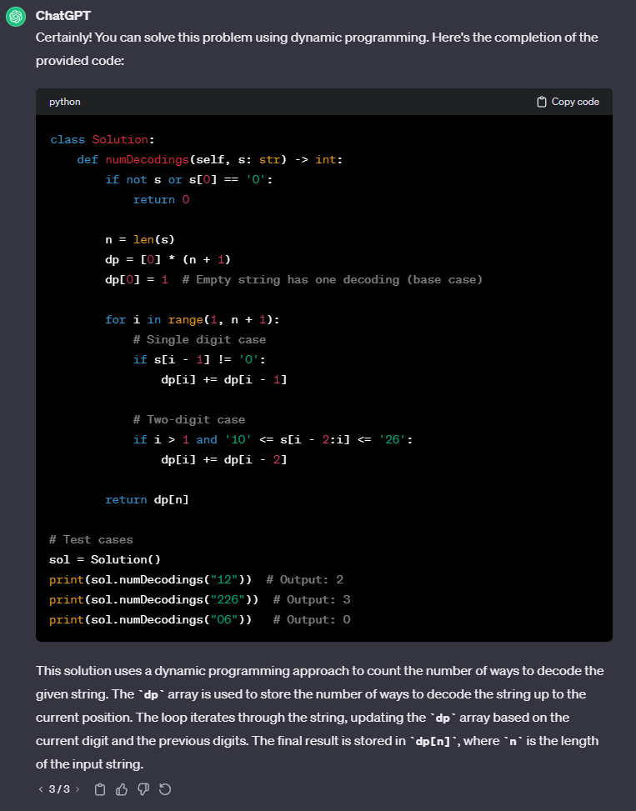

#### Leetcode Response:

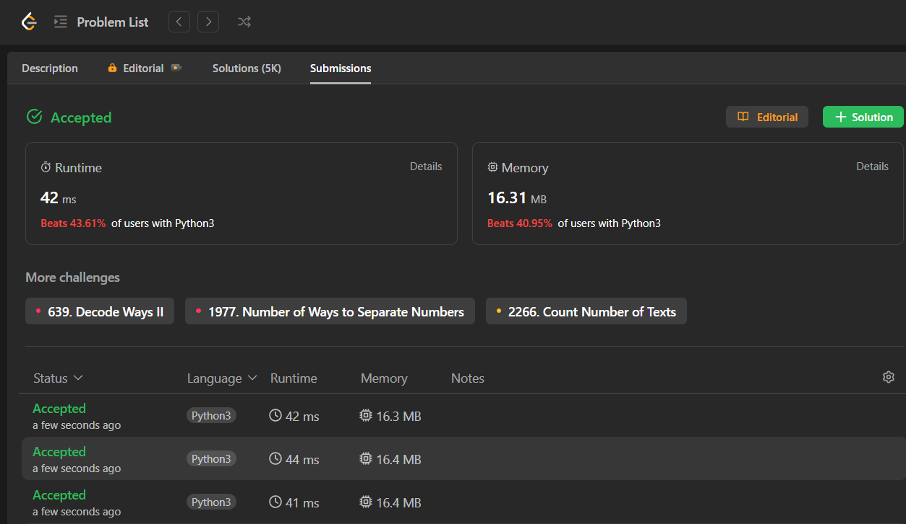

# 

# M2: [Group Anagrams](https://leetcode.com/problems/group-anagrams/)

## Prompt:

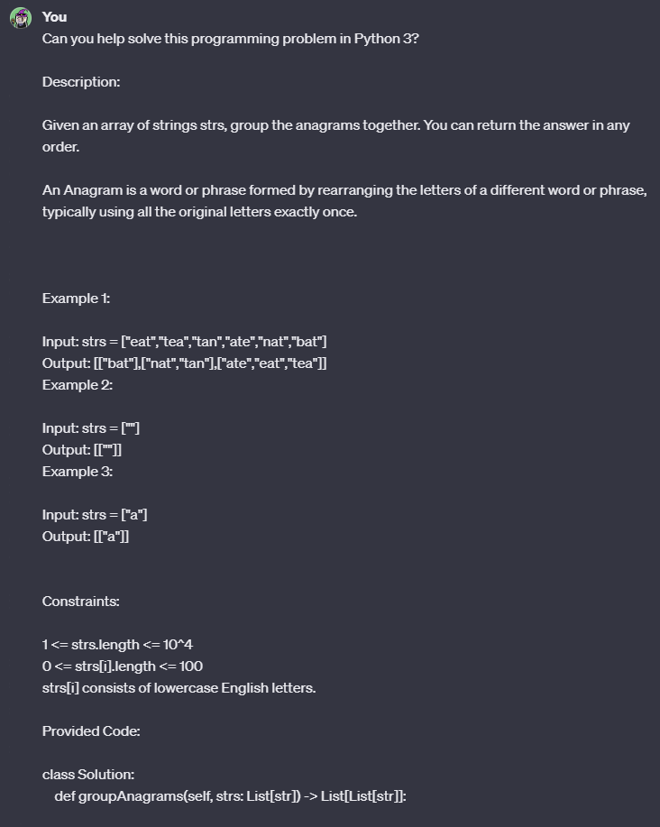

#### 

#### 

### Generation 1

#### Response:

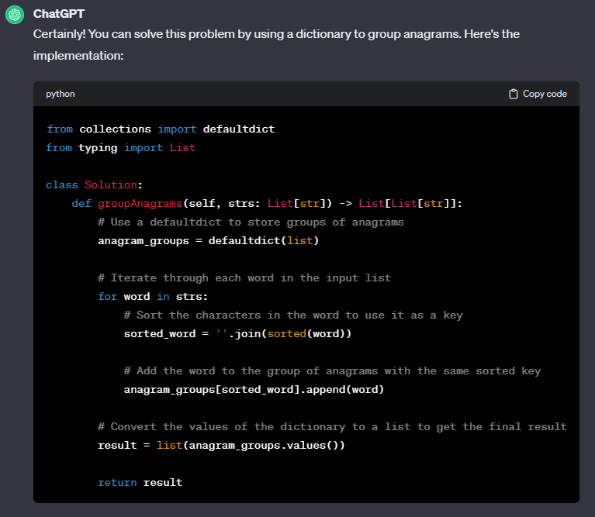

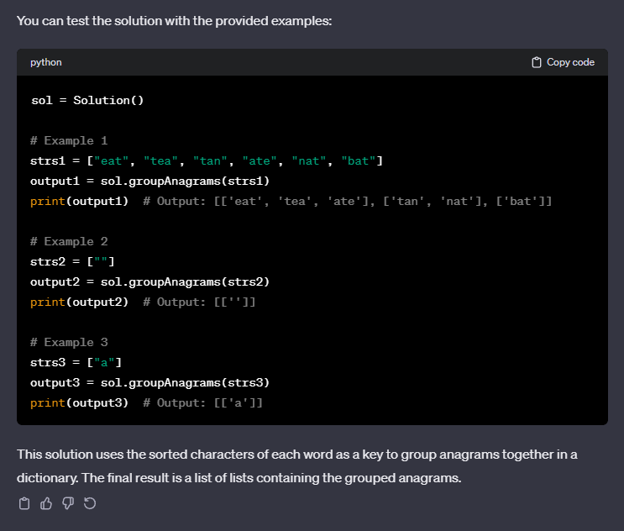

#### Leetcode Response:



### Generation 2

#### Response:

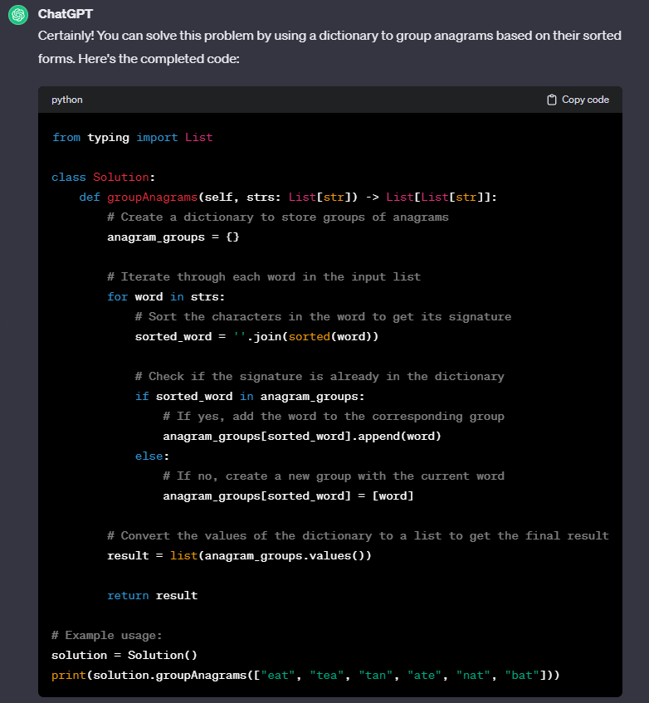

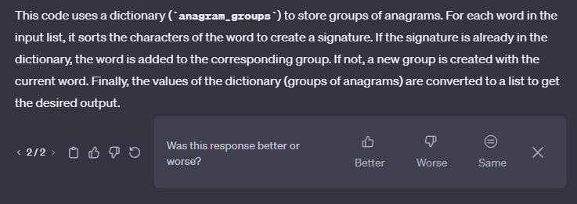

#### Leetcode Response:



### Generation 3

#### Response:

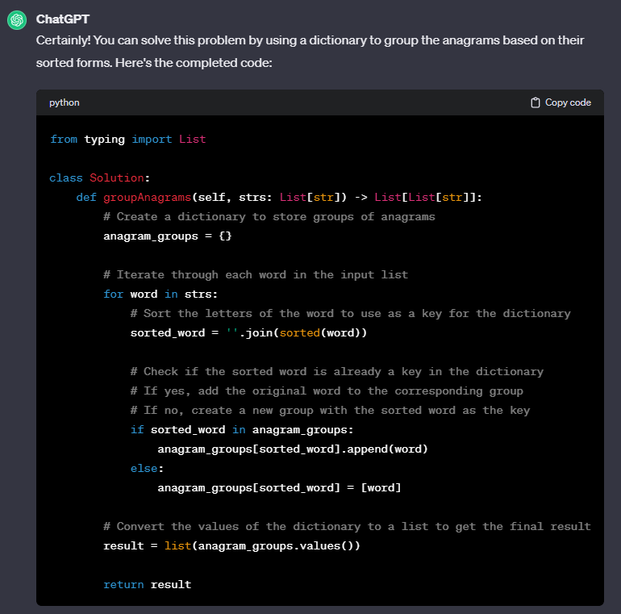

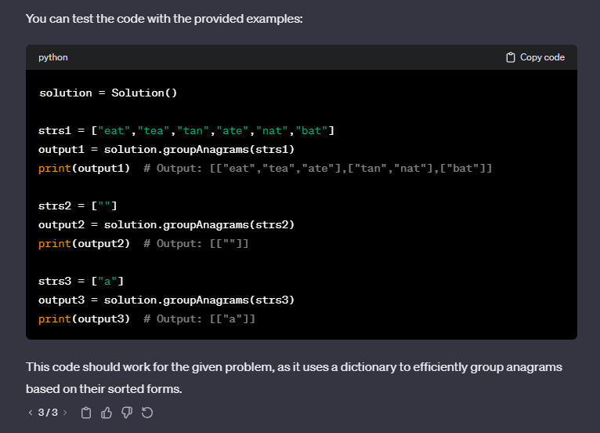

#### Leetcode Response:

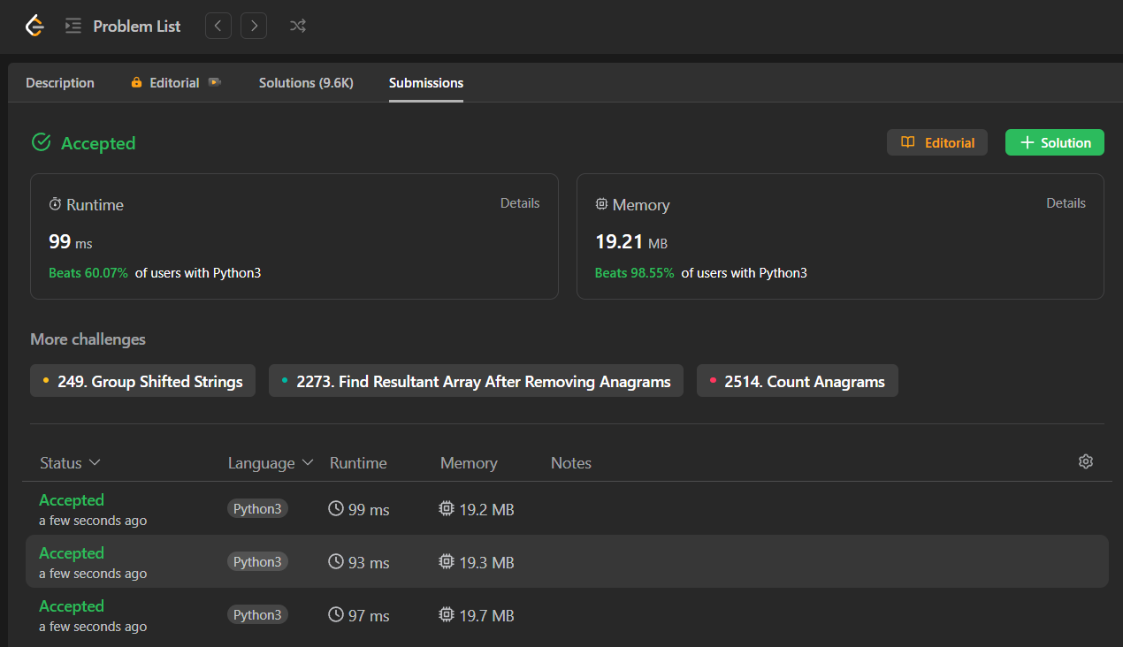

# M3: [Jump Game](https://leetcode.com/problems/jump-game/)

## Prompt:

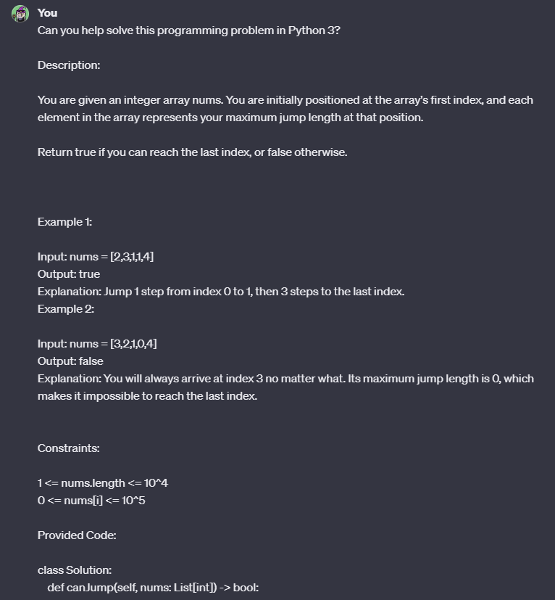

#### 

#### 

### Generation 1

#### Response:

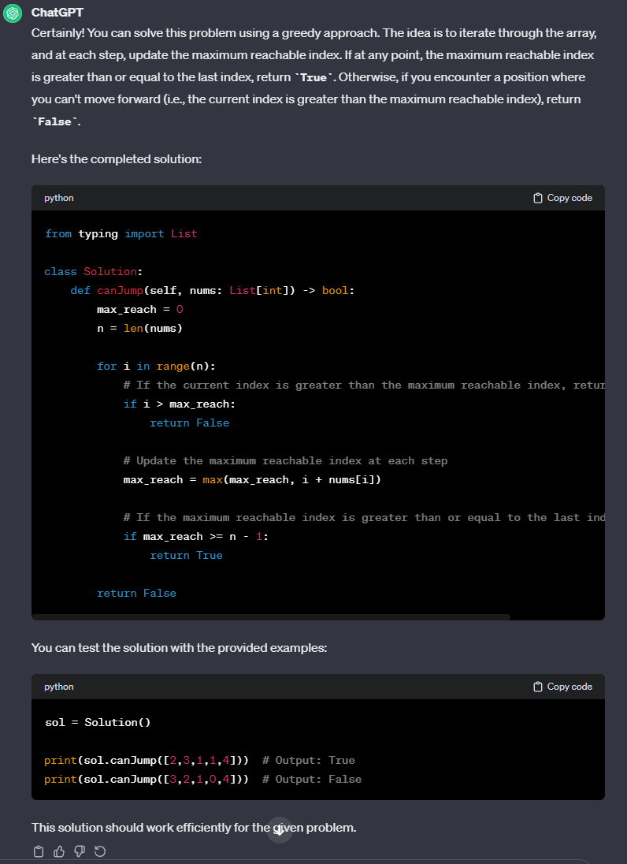

#### Leetcode Response:



### Generation 2

#### Response:

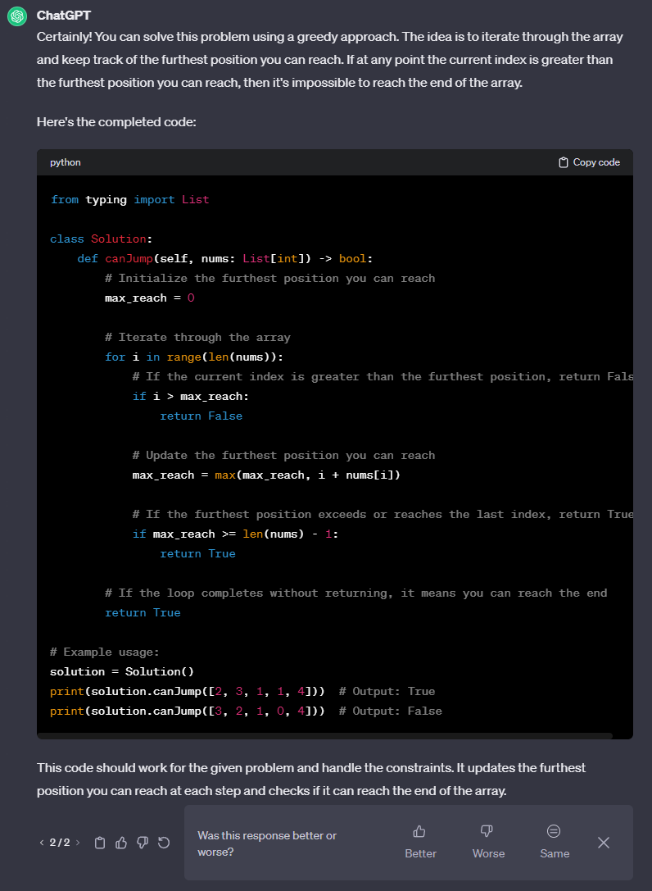

#### Leetcode Response:



### Generation 3

#### Response:

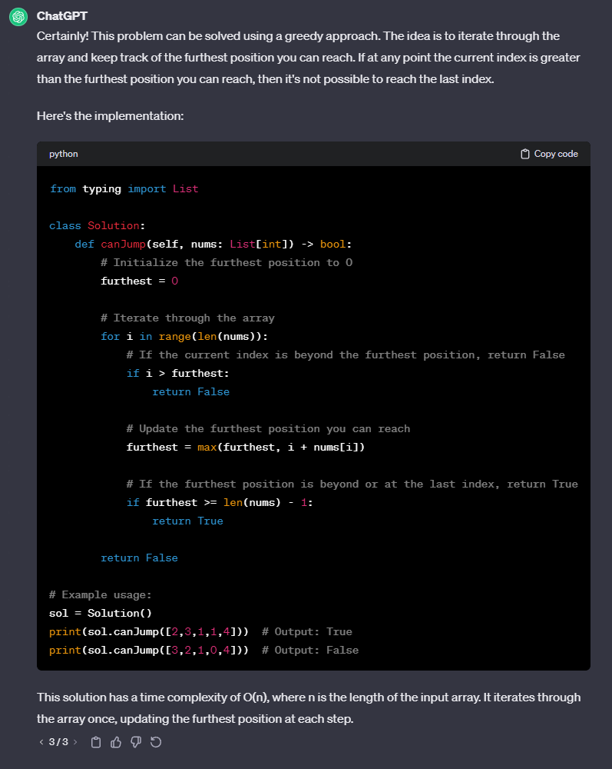

#### Leetcode Response:

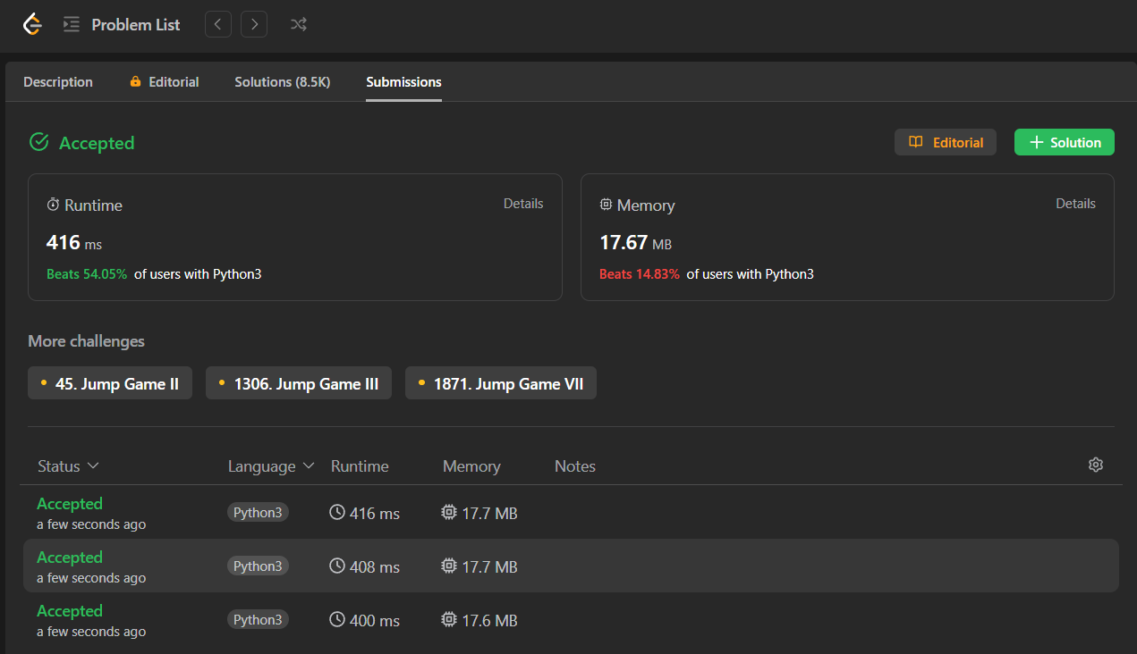

# M4: [Rotate Image](https://leetcode.com/problems/rotate-image/)

## Prompt:

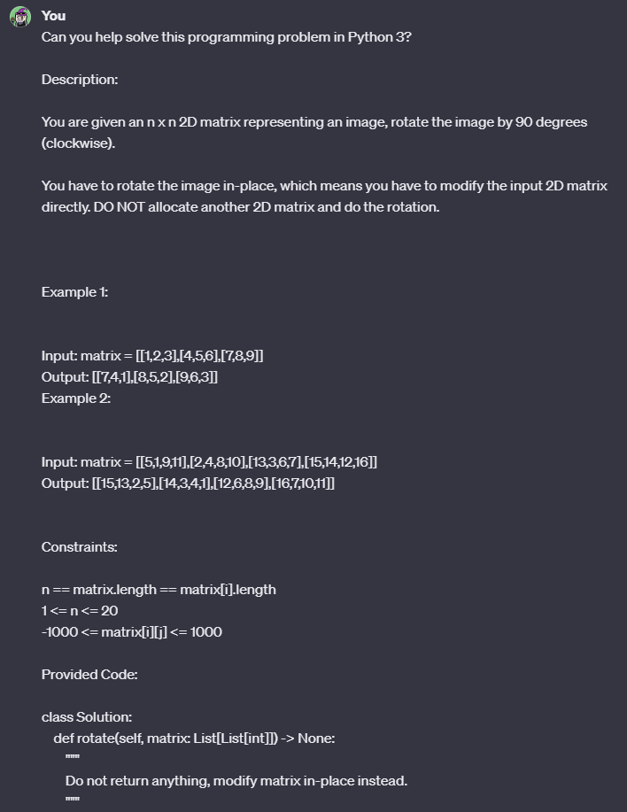

### Generation 1

#### Response:

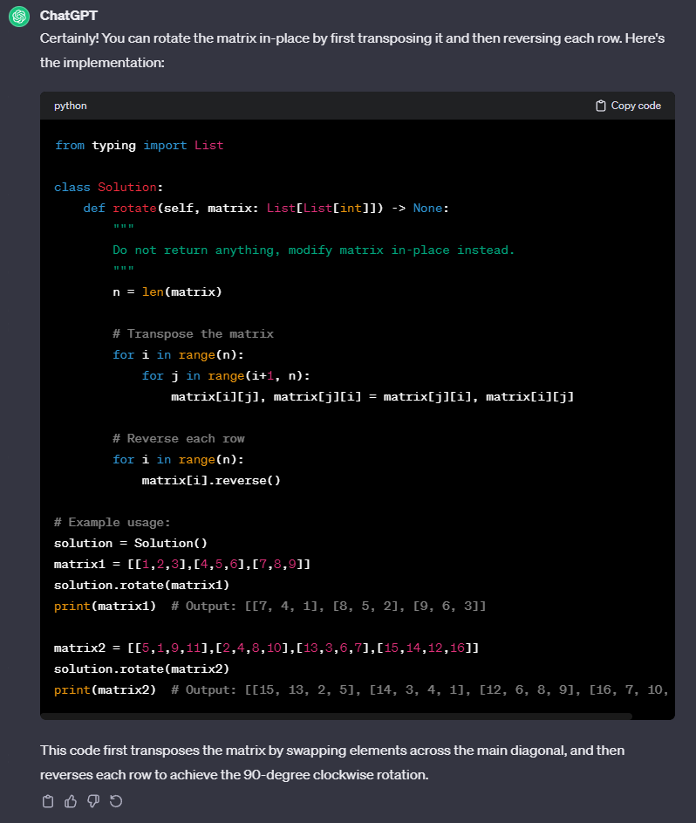

#### Leetcode Response:



### 

### Generation 2

#### Response:

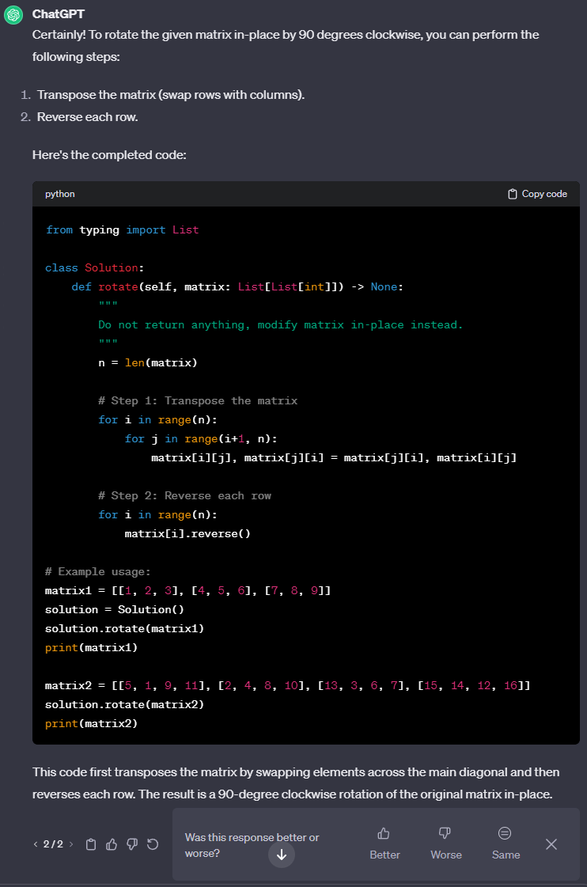

#### Leetcode Response:



### Generation 3

#### Response:

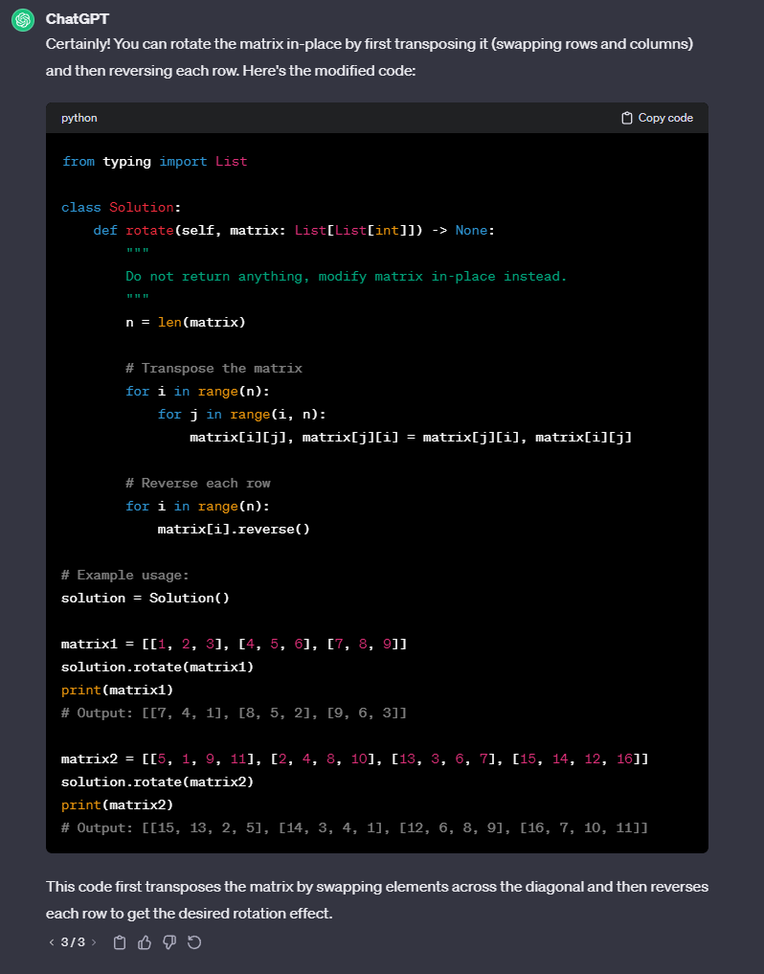

#### Leetcode Response:

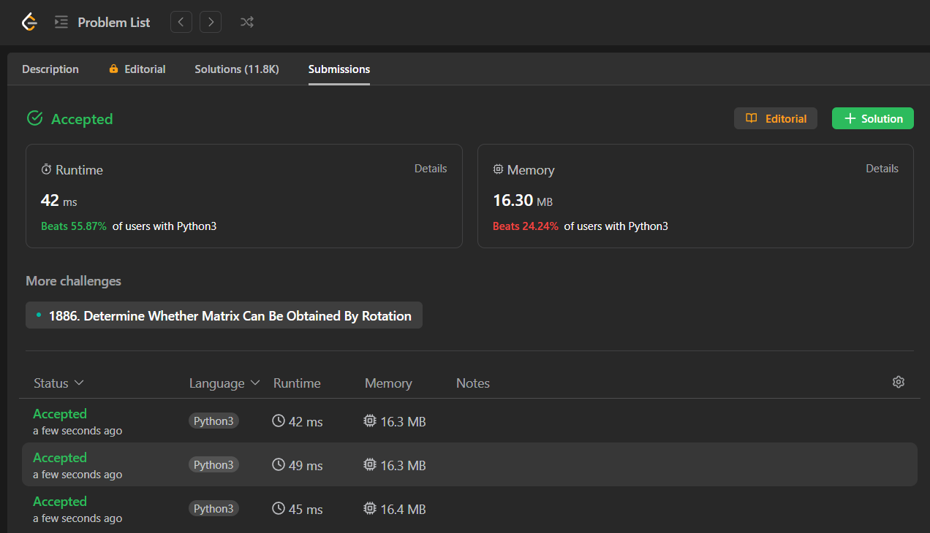

# 

# M5: [Spiral Matrix](https://leetcode.com/problems/spiral-matrix/)

## Prompt:

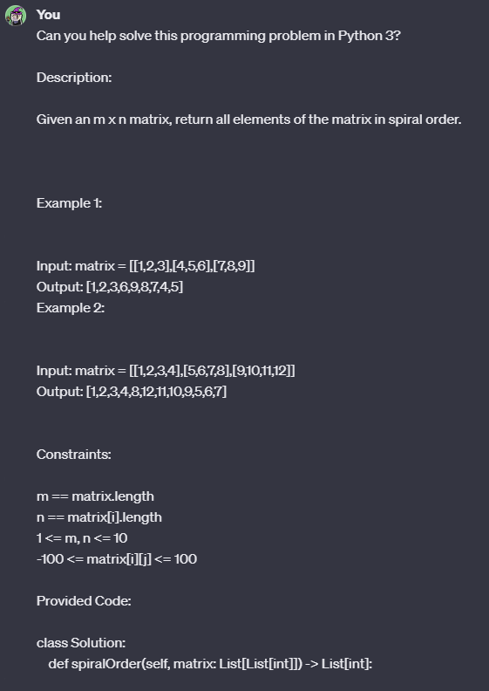

#### 

#### 

### Generation 1

#### Response:

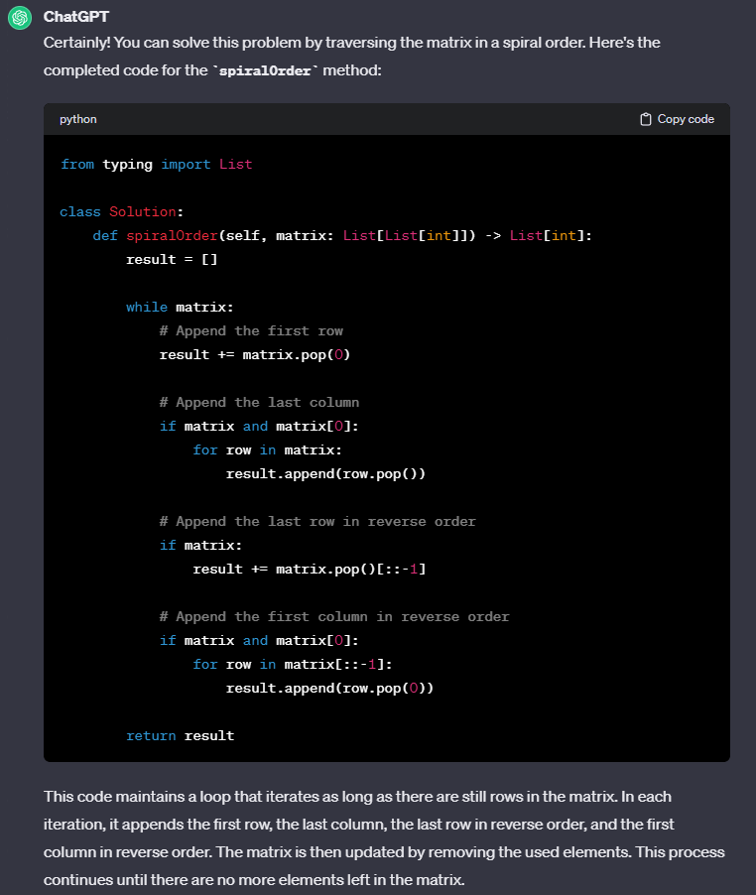

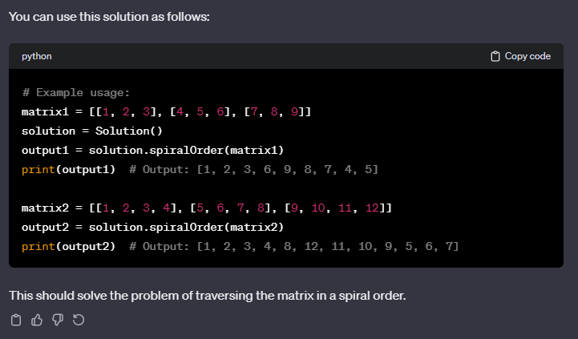

#### Leetcode Response:



### Generation 2

#### Response:

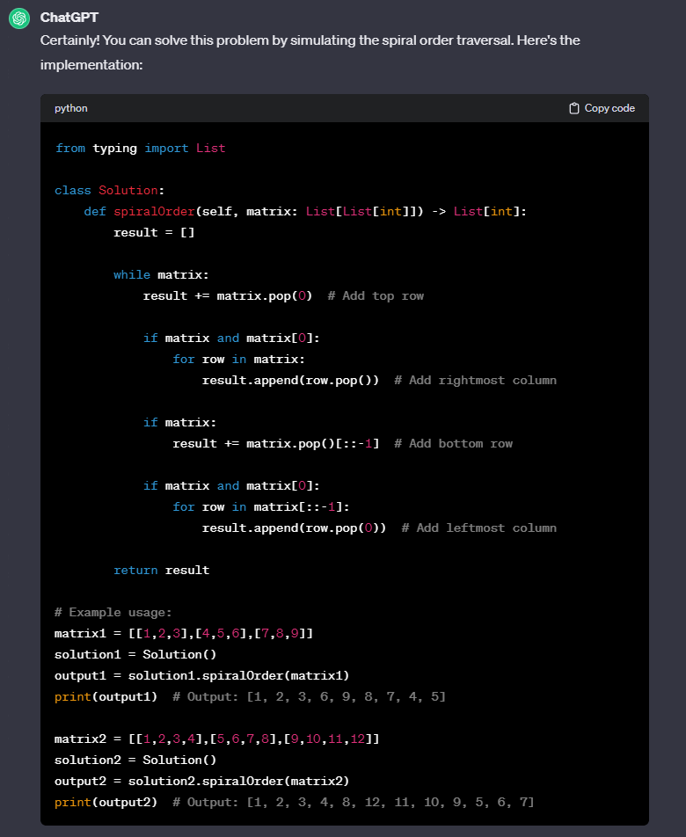

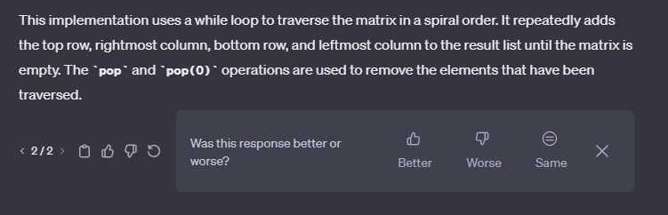

#### Leetcode Response:



### Generation 3

#### Response:

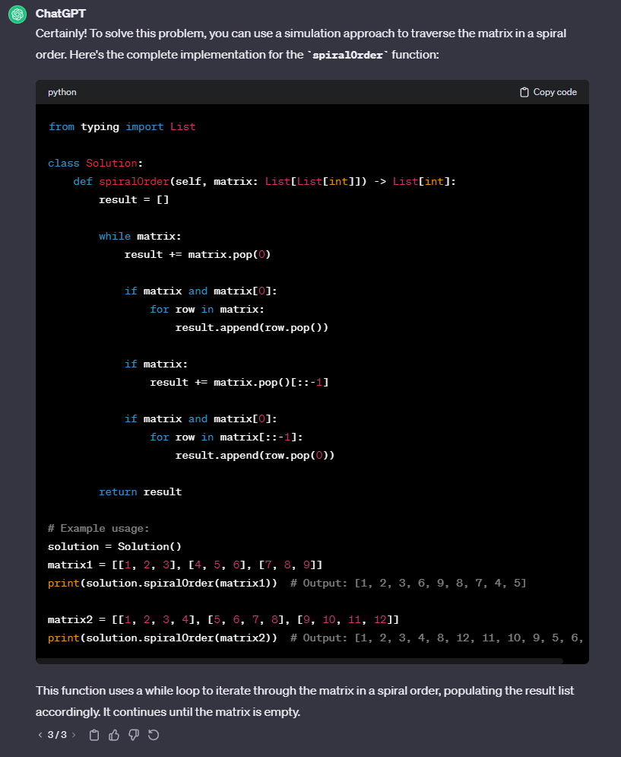

#### Leetcode Response:

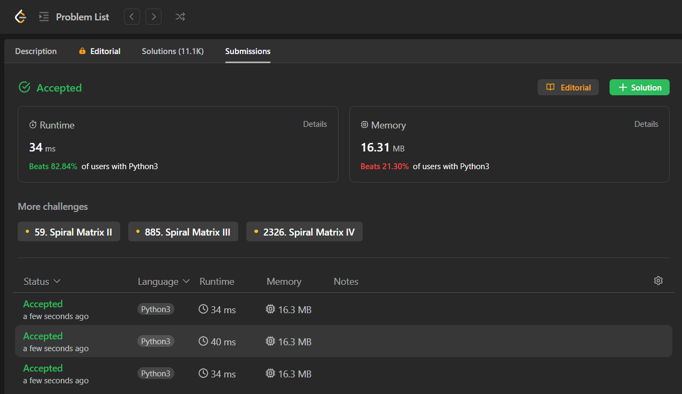

# M6: [Unique Paths](https://leetcode.com/problems/unique-paths/)

## Prompt:

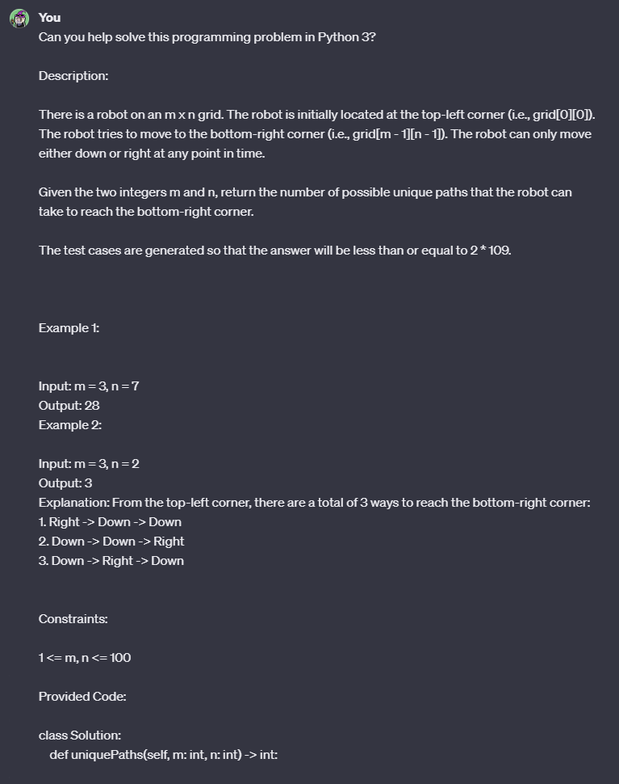

#### 

#### 

### Generation 1

#### Response:

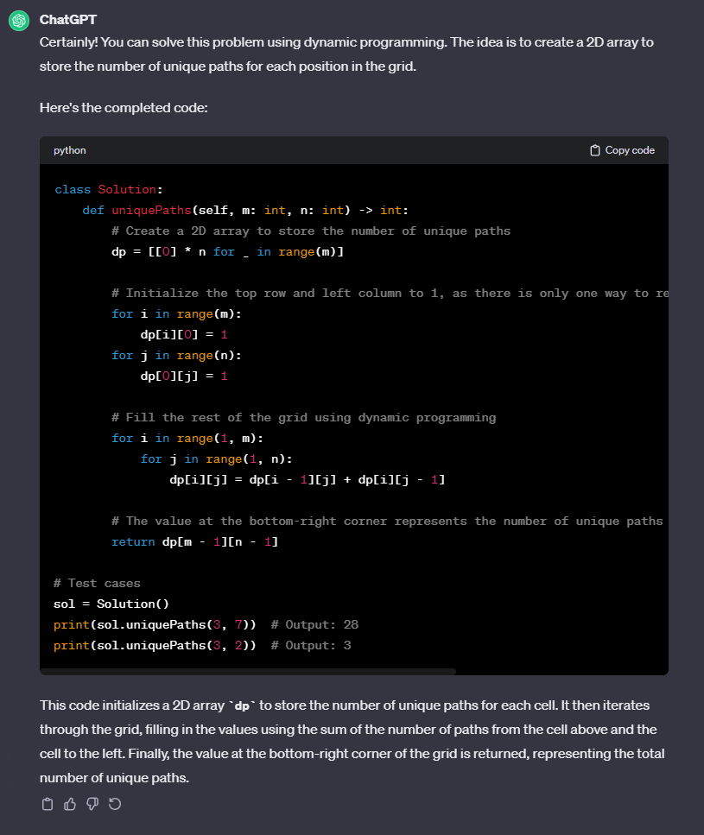

#### Leetcode Response:



### Generation 2

#### Response:

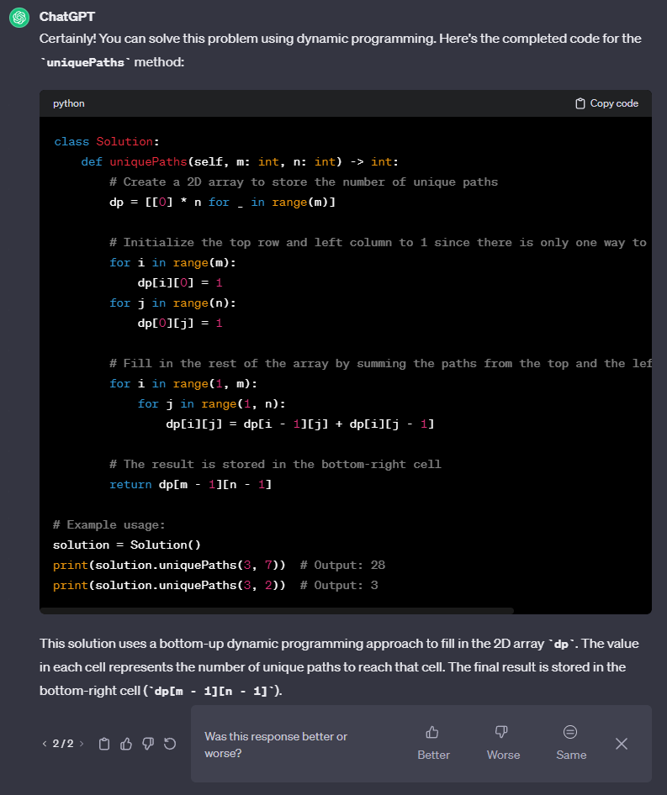

#### Leetcode Response:



### Generation 3

#### Response:

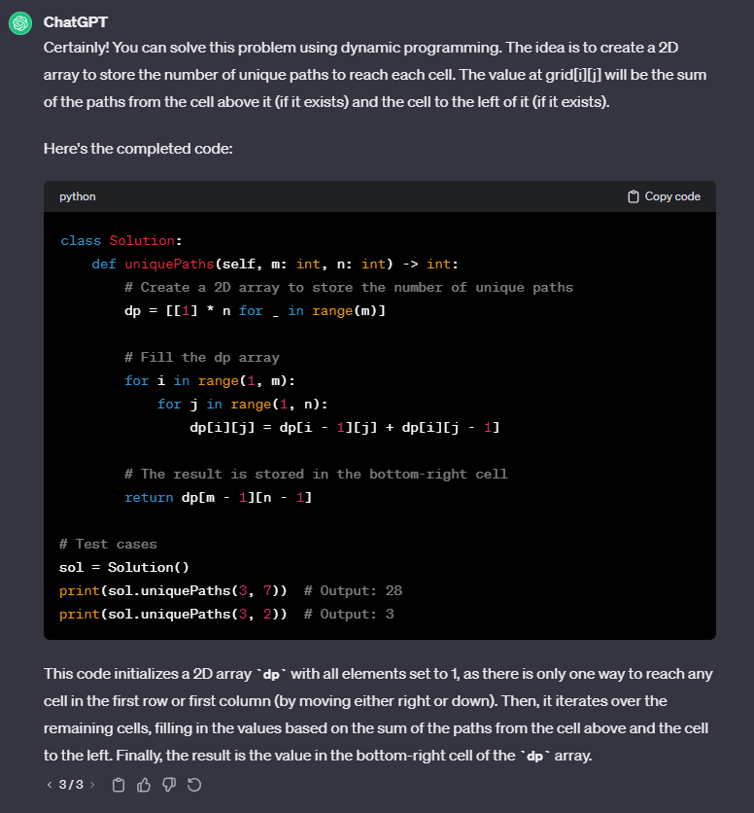

#### Leetcode Response:

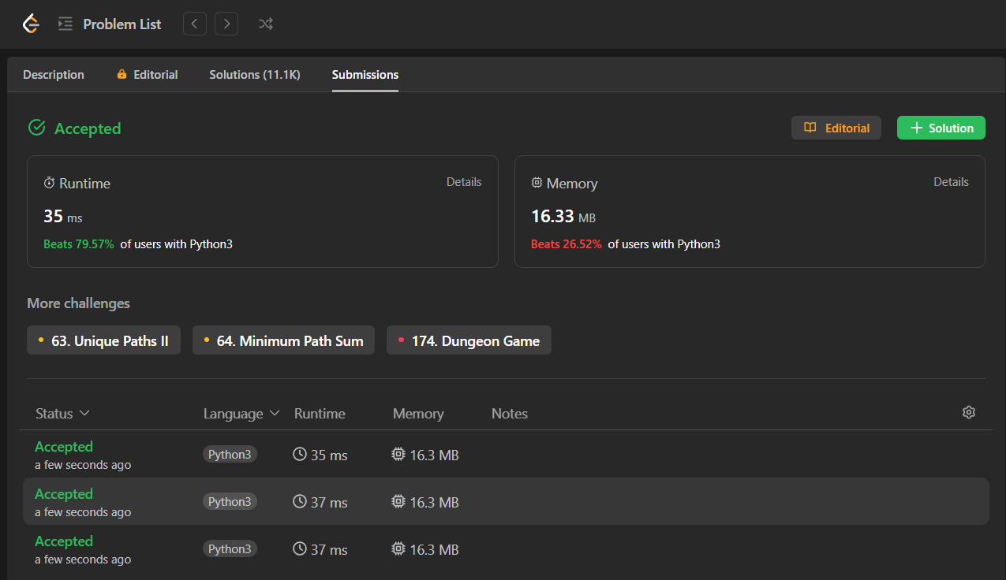

# M7: [Valid Sudoku](https://leetcode.com/problems/valid-sudoku/)

## Prompt:

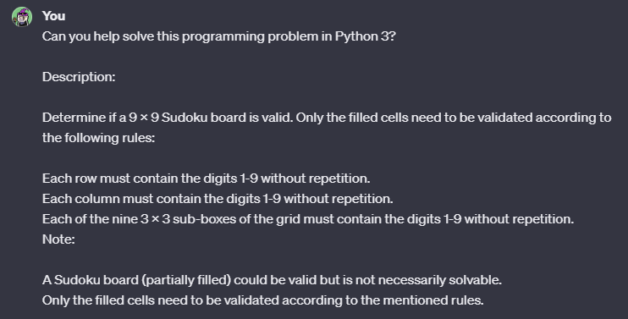

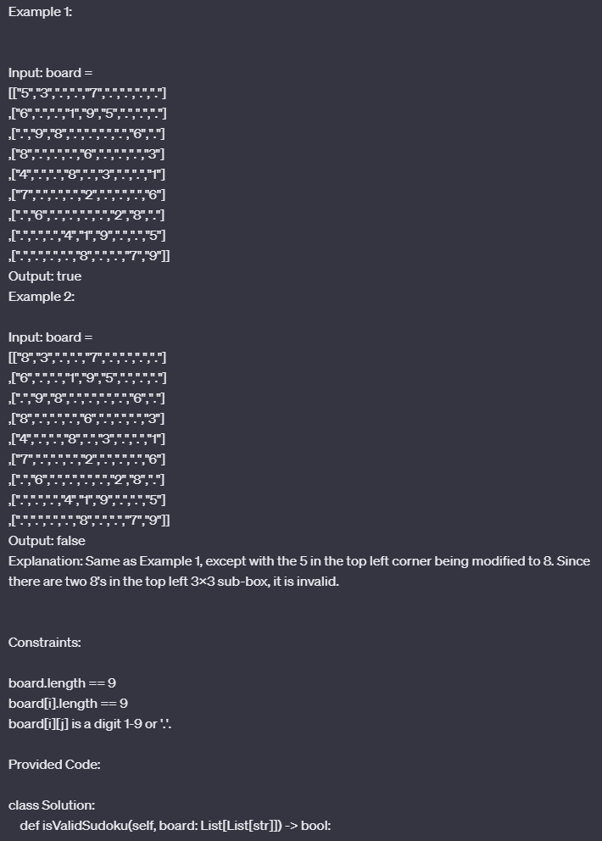

### Generation 1

#### Response:

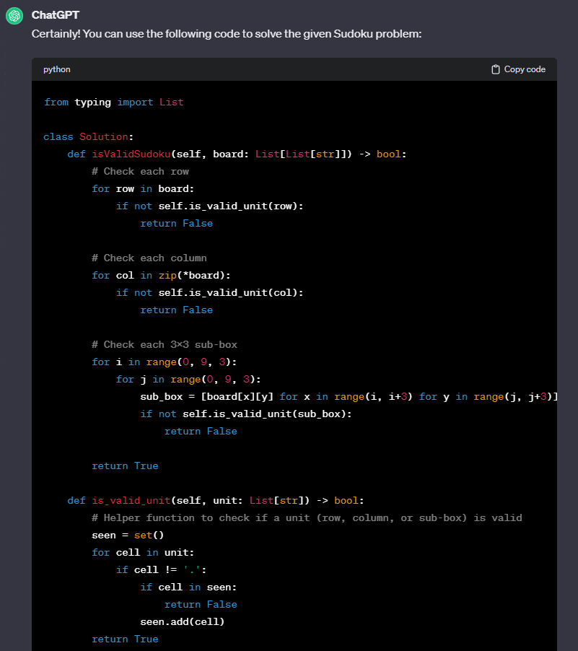

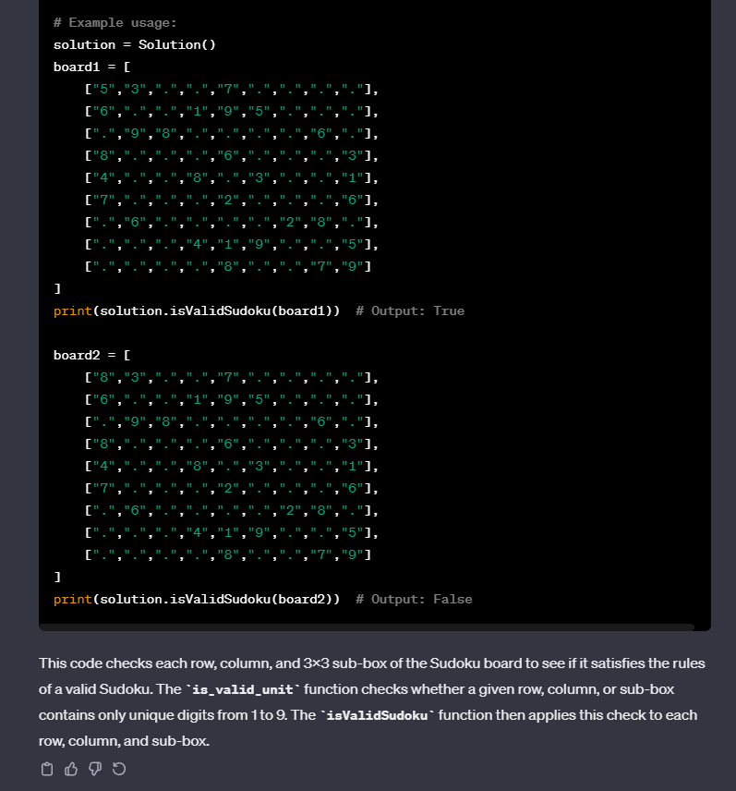

#### Leetcode Response:



### Generation 2

#### Response:

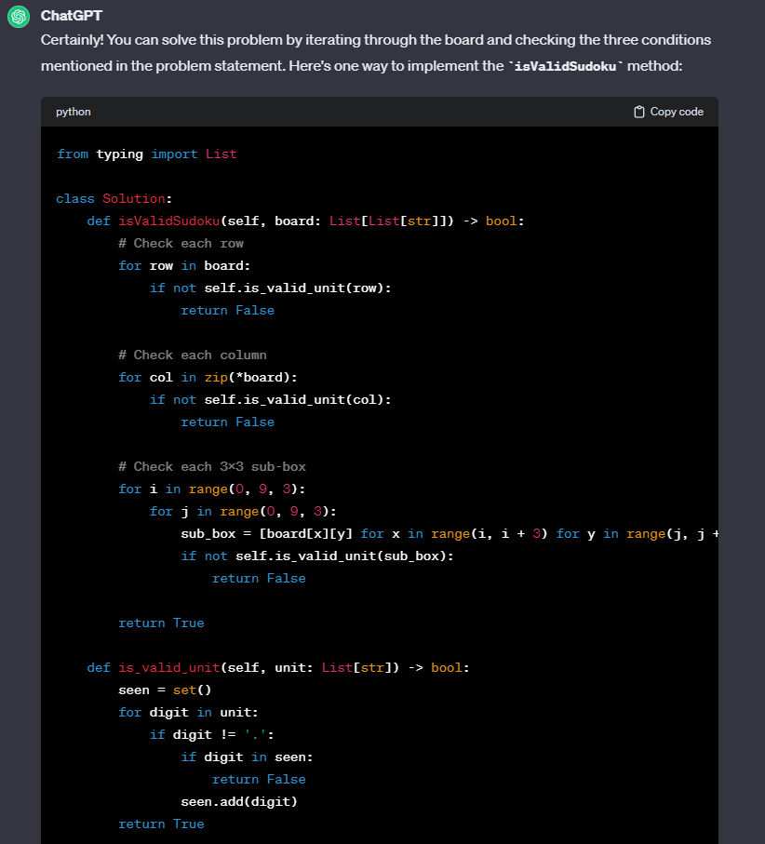

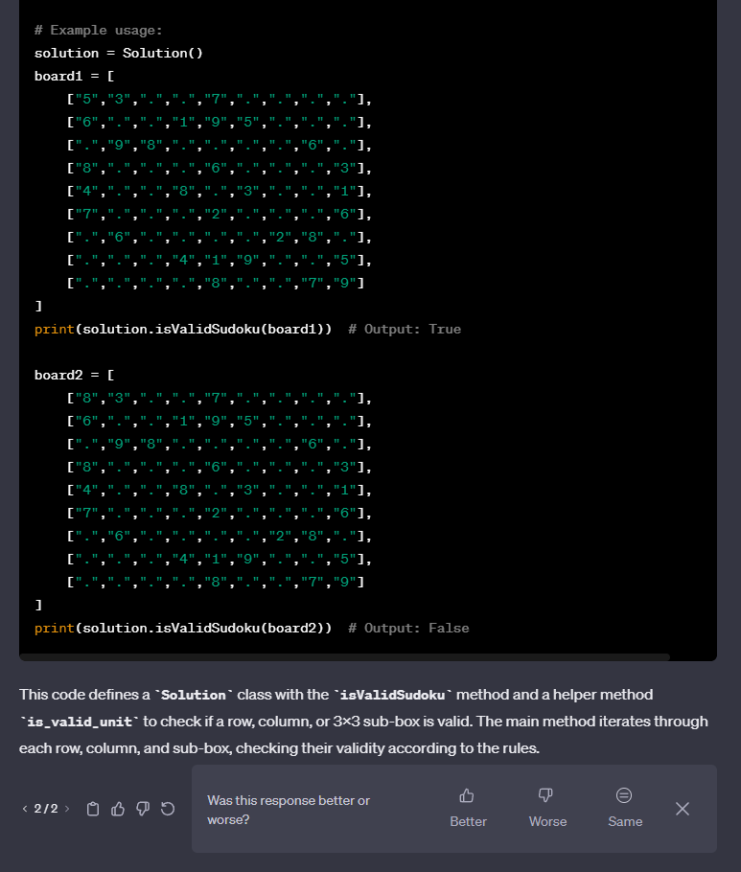

#### Leetcode Response:



### Generation 3

#### Response:

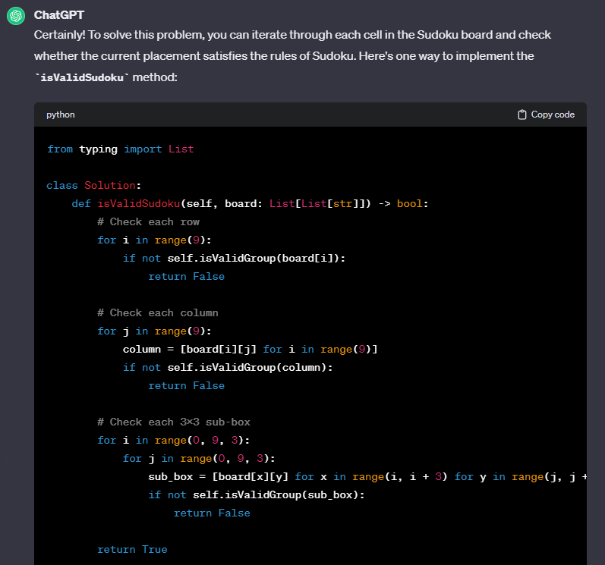

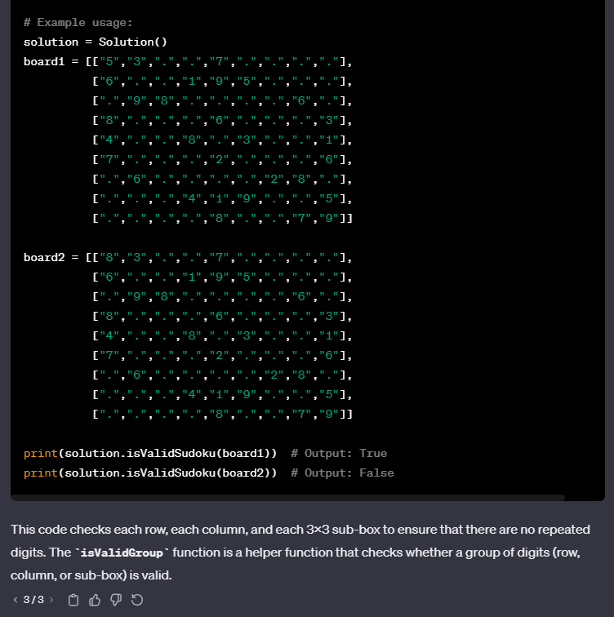

#### Leetcode Response:

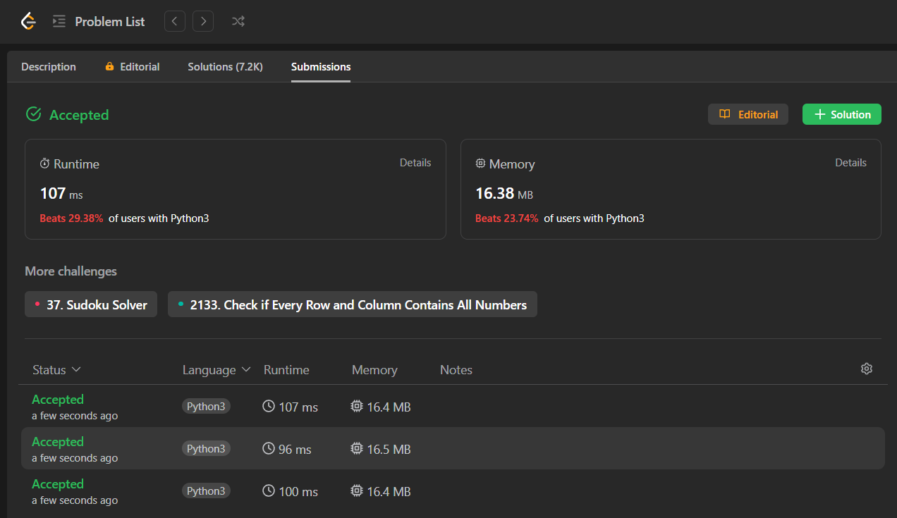

Hard Problems:

# H1: [Merge K Sorted Lists](https://leetcode.com/problems/merge-k-sorted-lists/)

## Prompt:

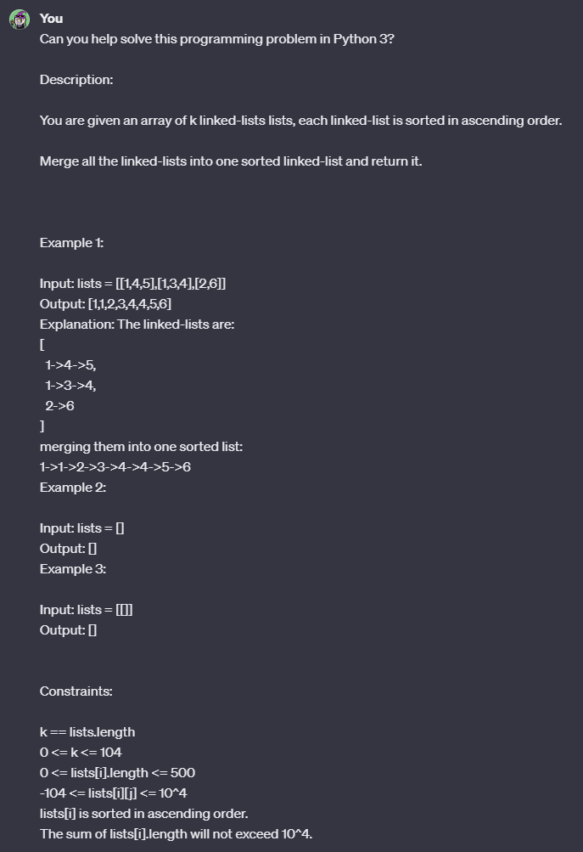

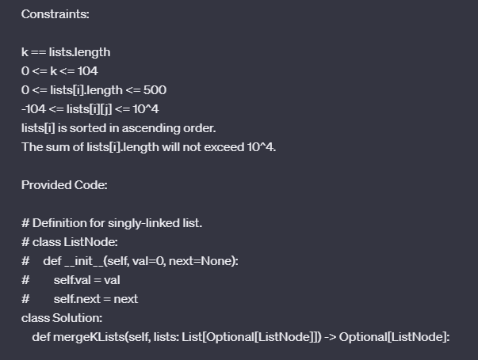

#### 

### Generation 1

#### Response:

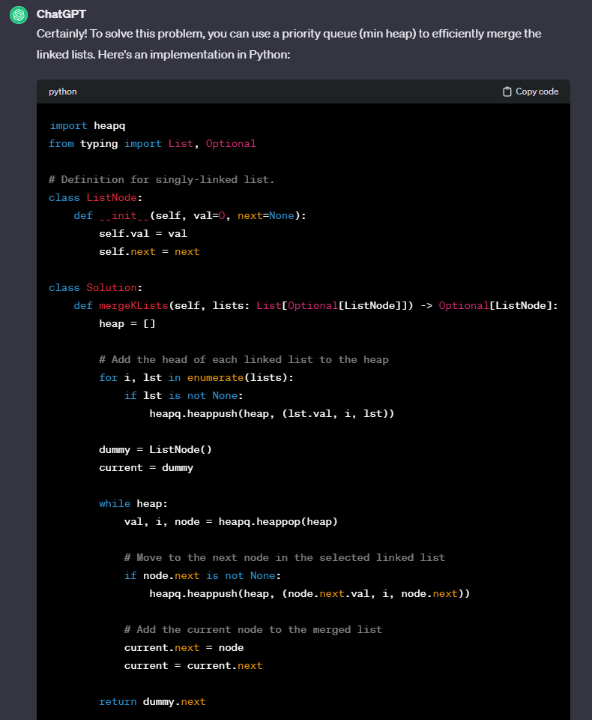

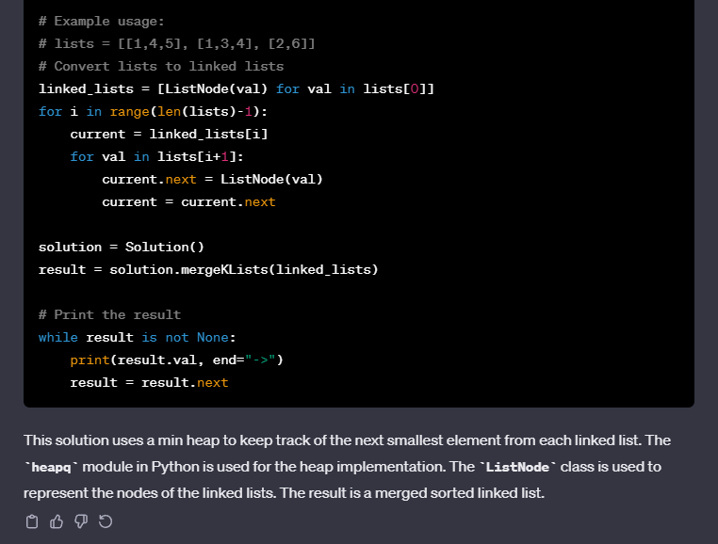

#### Leetcode Response:

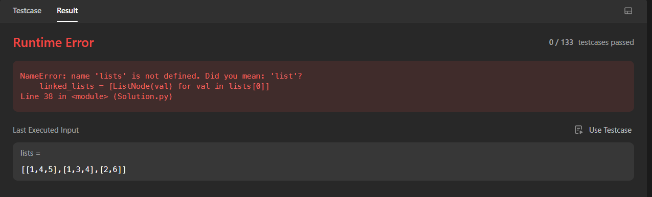

#### Debugging Prompt #1:



### 

#### Debugging Prompt #1 Response:

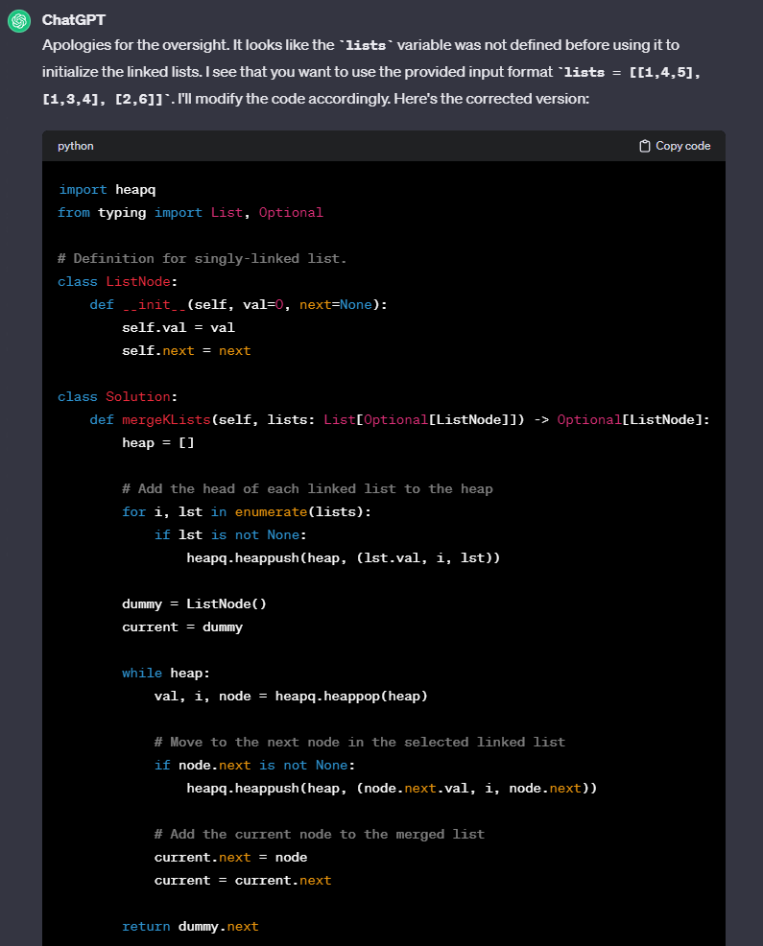

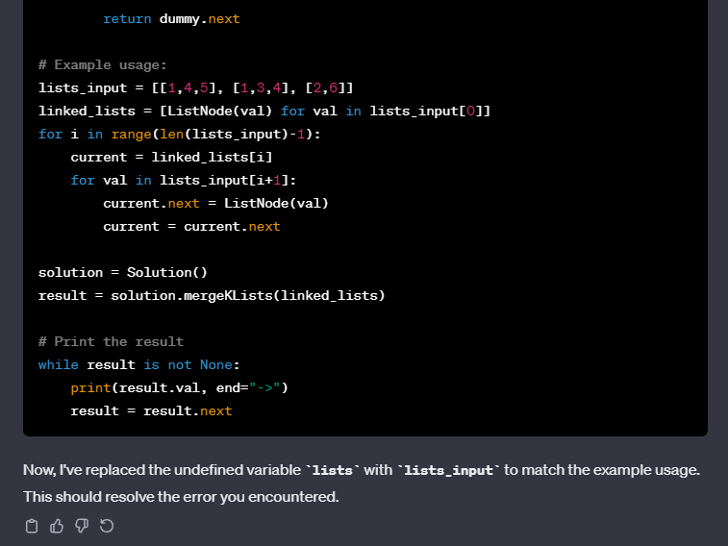

#### Leetcode Response for Debugging Response #1:

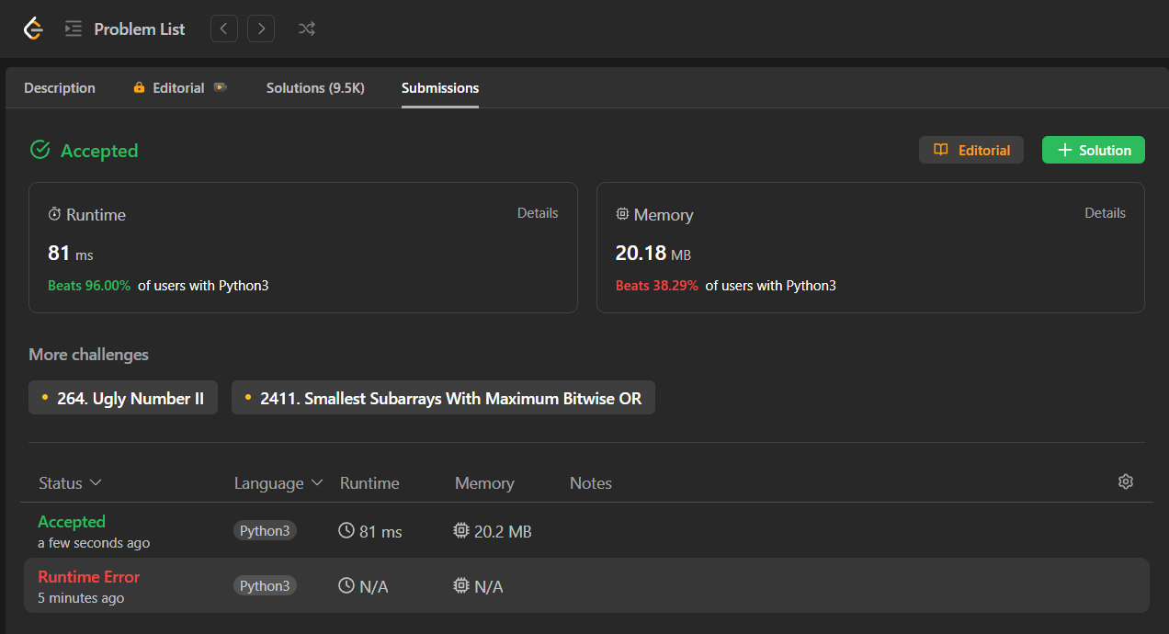

### Generation 2

#### Response:

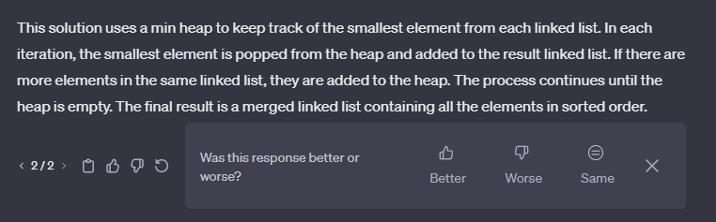

#### Leetcode Response:



### Generation 3

#### Response:

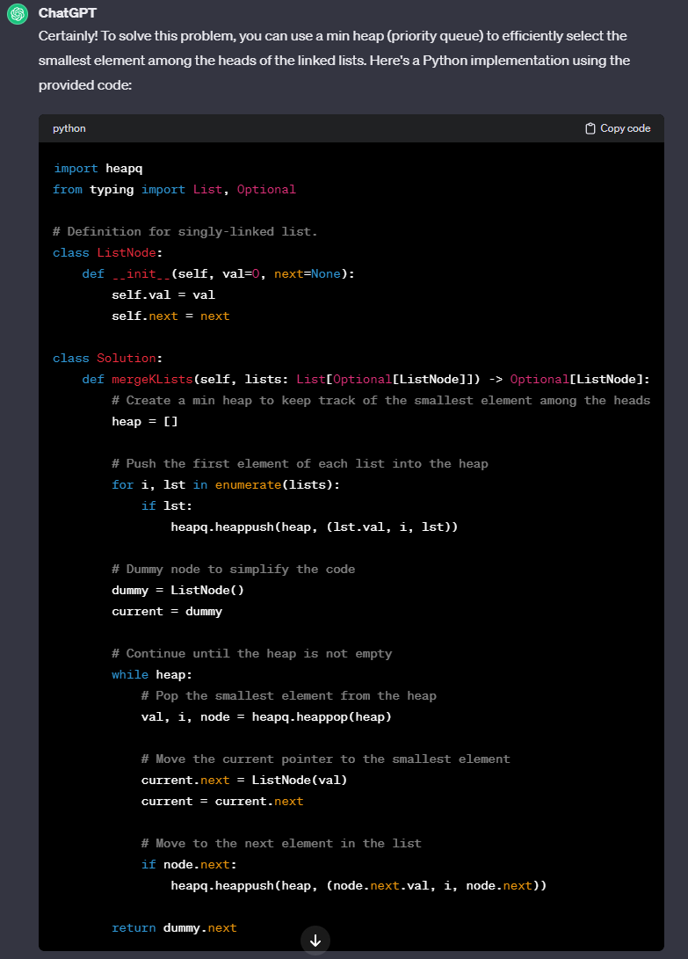



#### Leetcode Response:

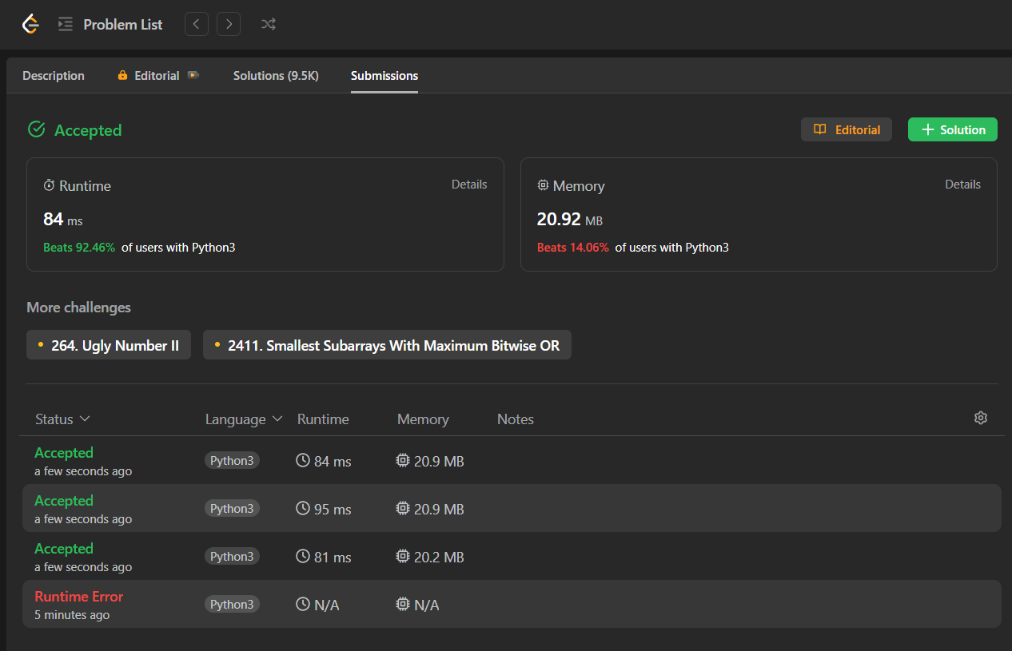

# 

# H2: [Regular Expression Matching](https://leetcode.com/problems/regular-expression-matching/)

## Prompt:

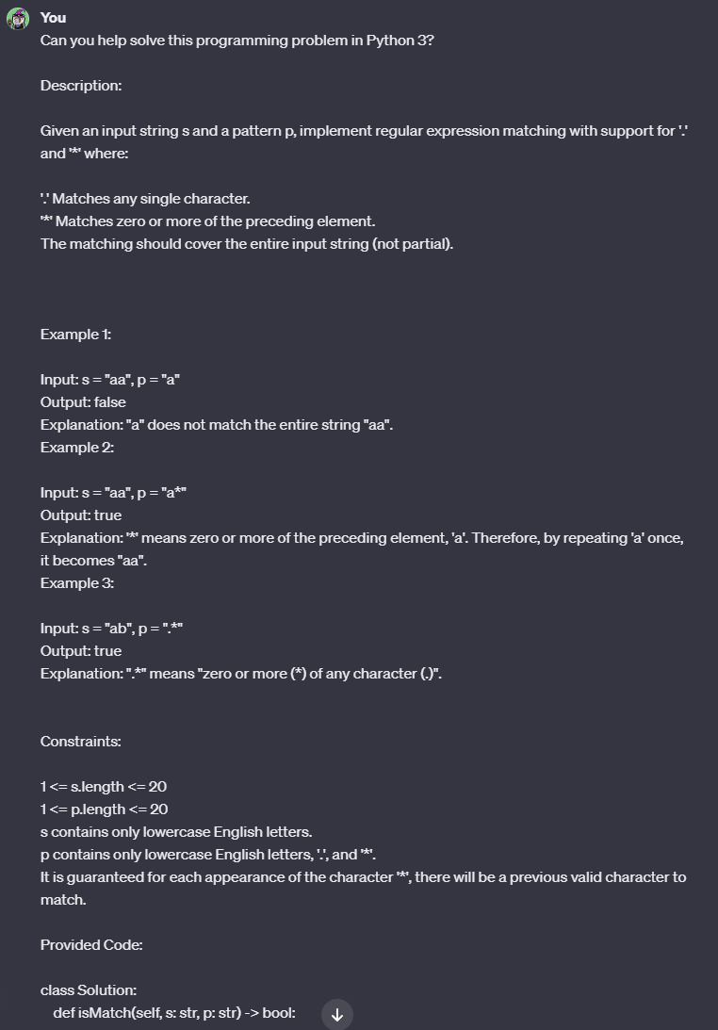

### Generation 1

#### Response:

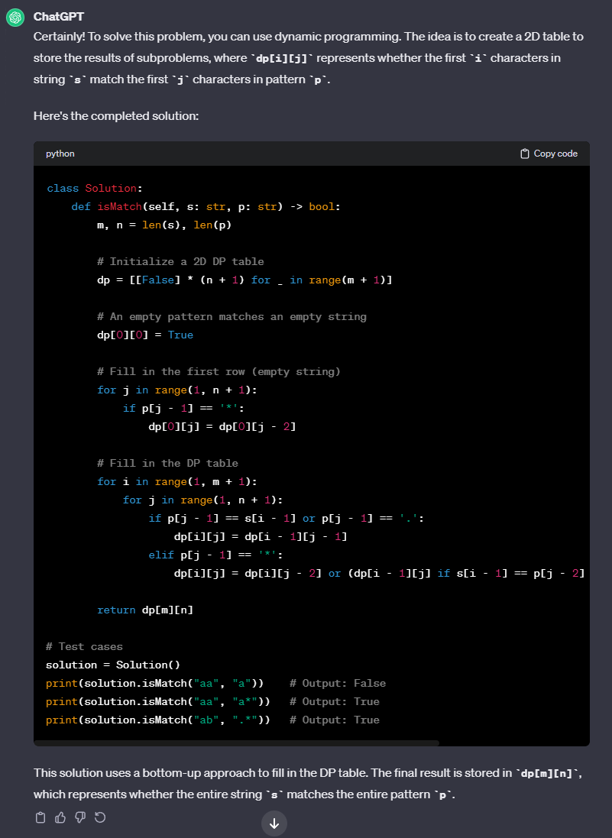

#### Leetcode Response:



### Generation 2

#### Response:

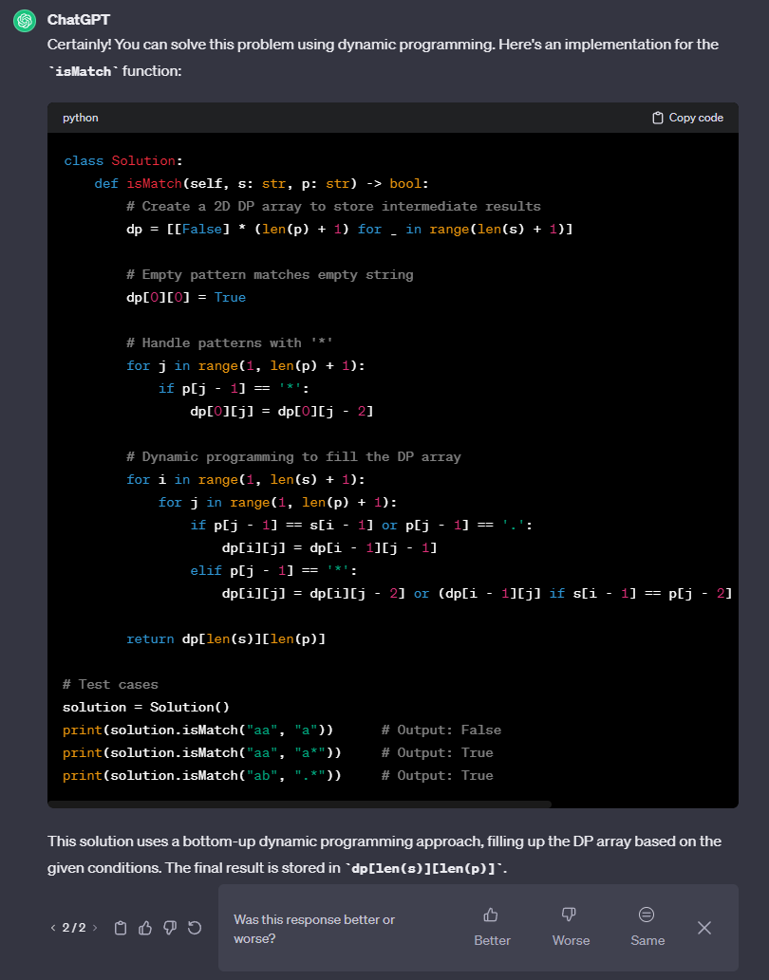

#### Leetcode Response:



### Generation 3

#### Response:

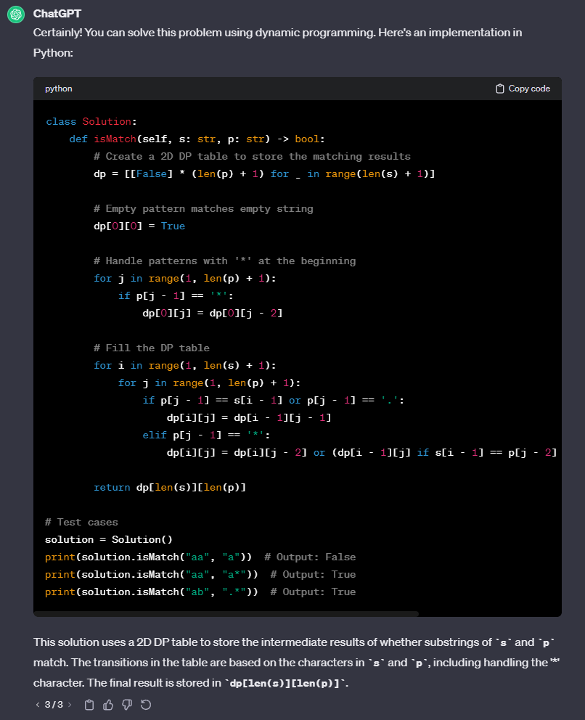

#### Leetcode Response:



# H3: [Serialize and Deserialize a Binary Tree](https://leetcode.com/problems/serialize-and-deserialize-binary-tree/)

## Prompt:



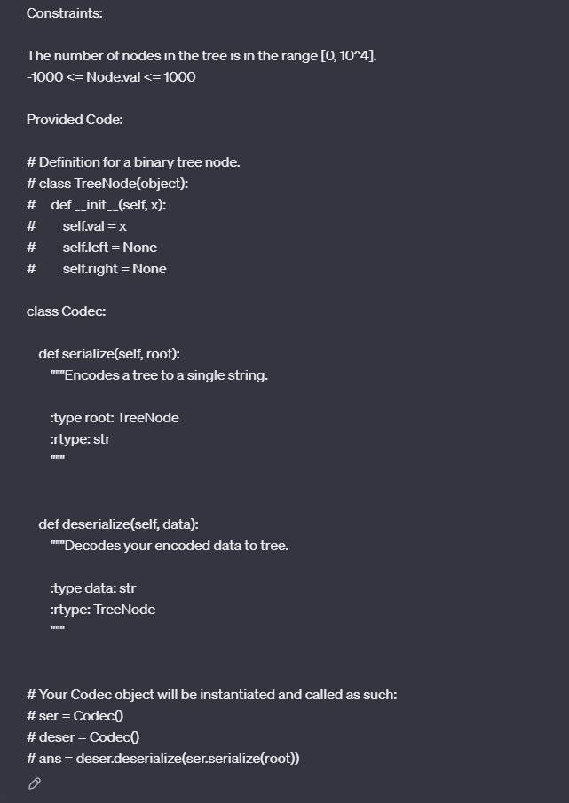

### 

### Generation 1

#### Response:

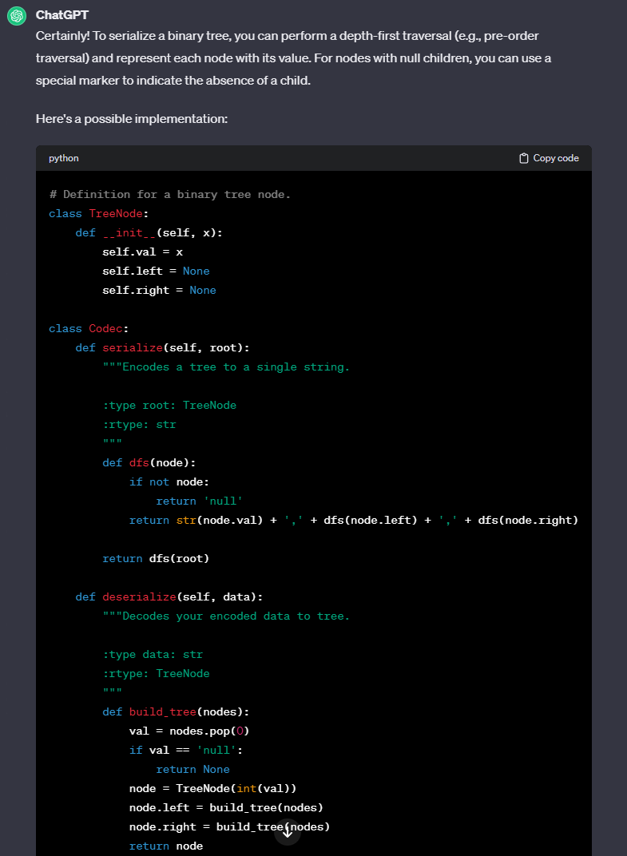

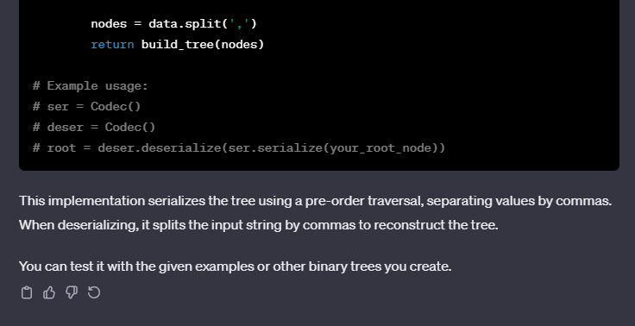

#### Leetcode Response:

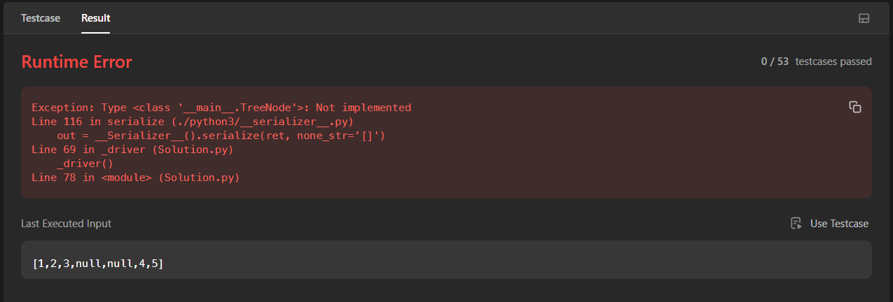

#### Debugging Prompt #1:

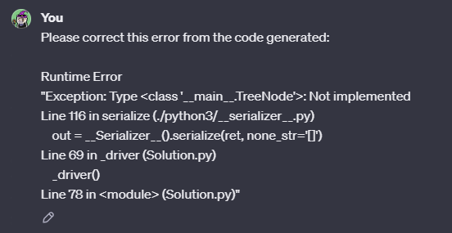

### 

#### Debugging Prompt #1 Response:

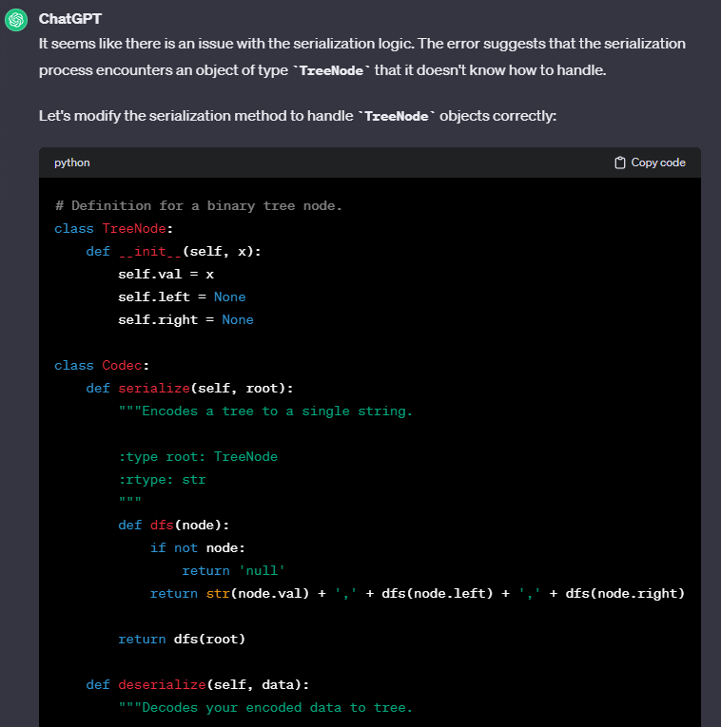

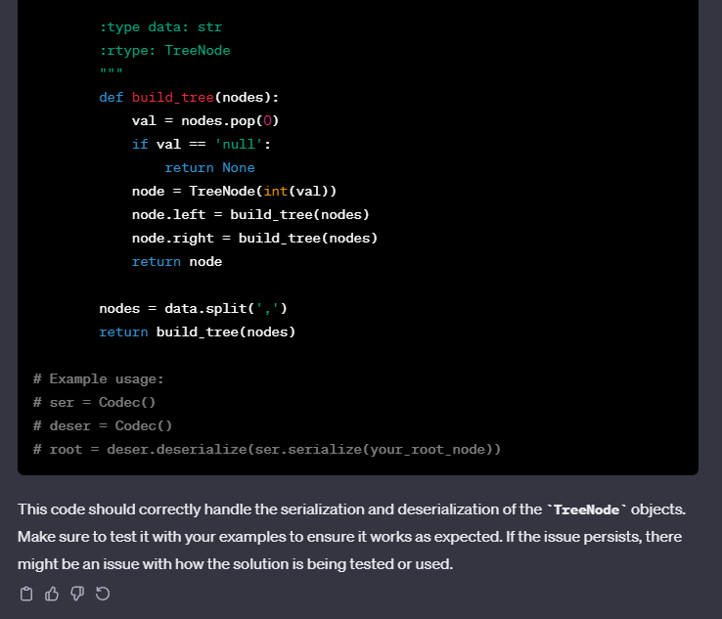

#### Leetcode Response for Debugging Response #1:

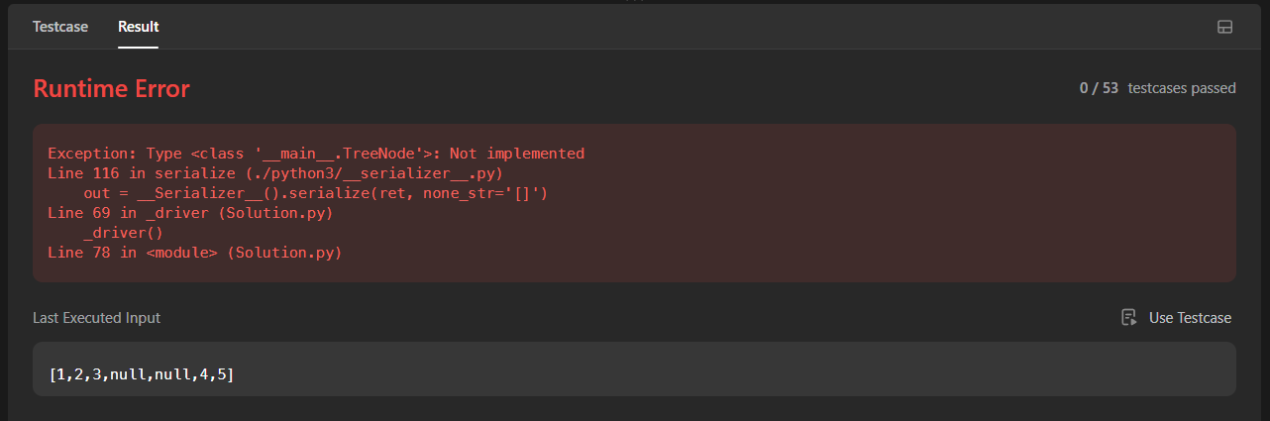

#### Debugging Prompt #2:

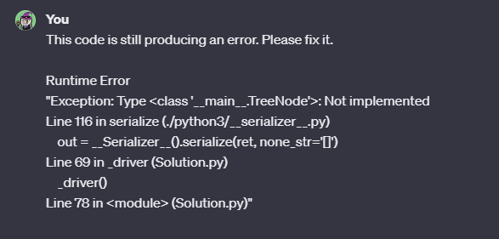

#### Debugging Response #2:

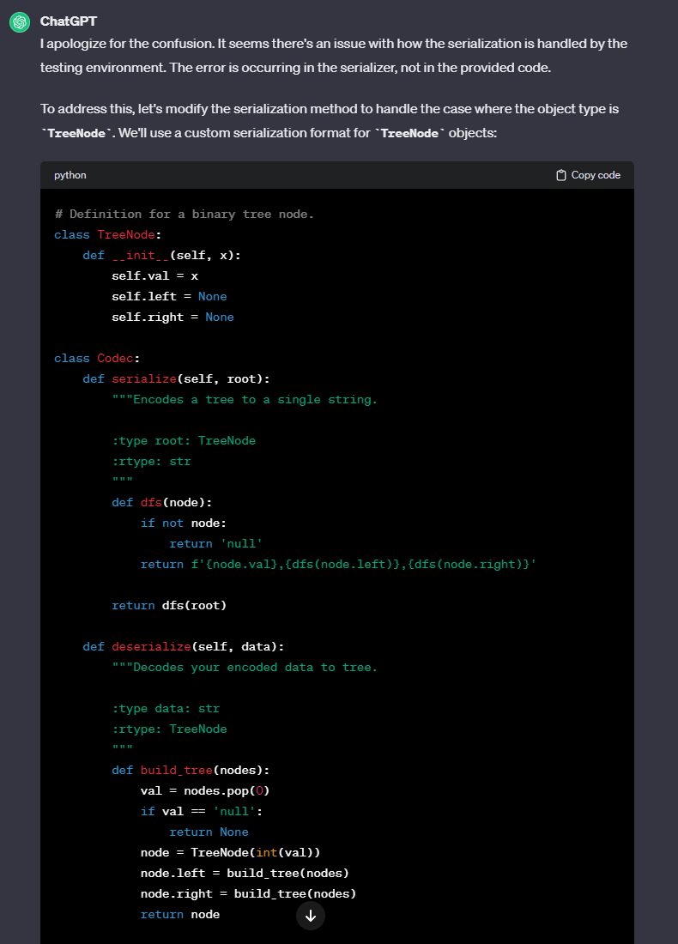

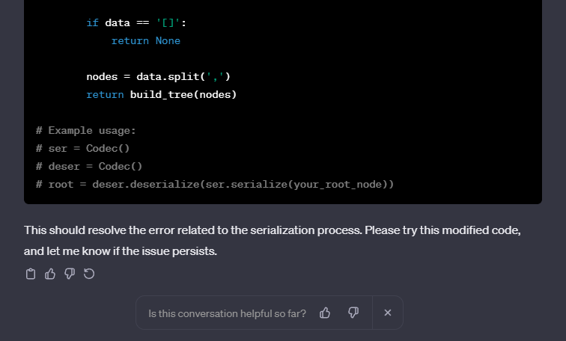

#### Leetcode Response for Debugging Response #2:

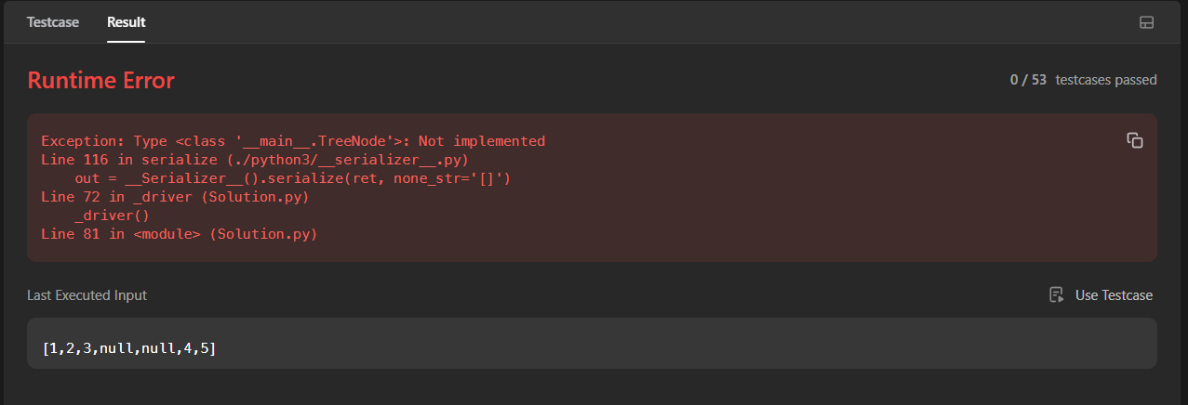

#### Debugging Prompt #3:



#### Debugging Response #3:

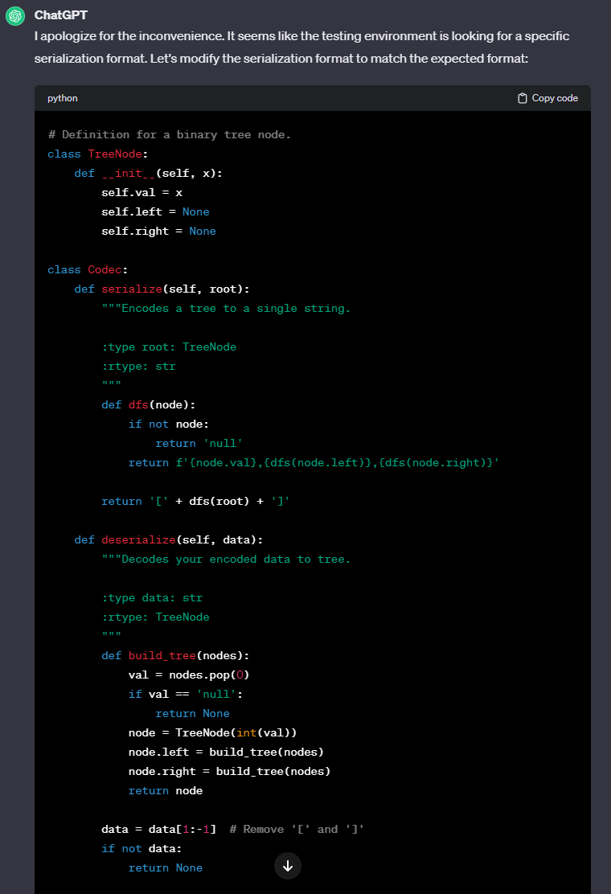

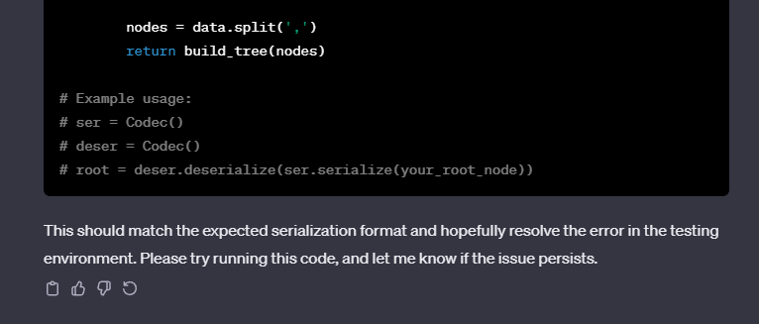

#### Leetcode Response for Debugging Response #3:

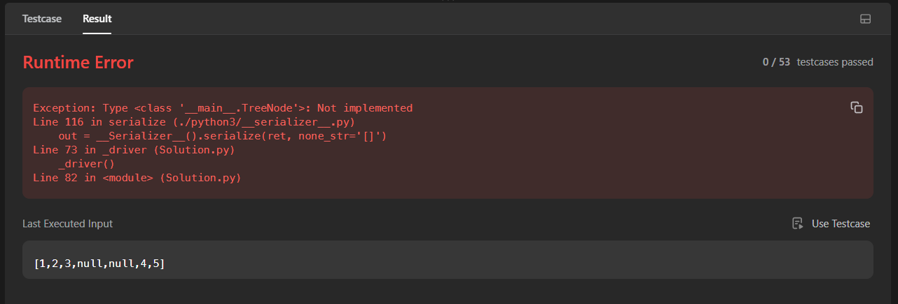

### Generation 2

#### Response:

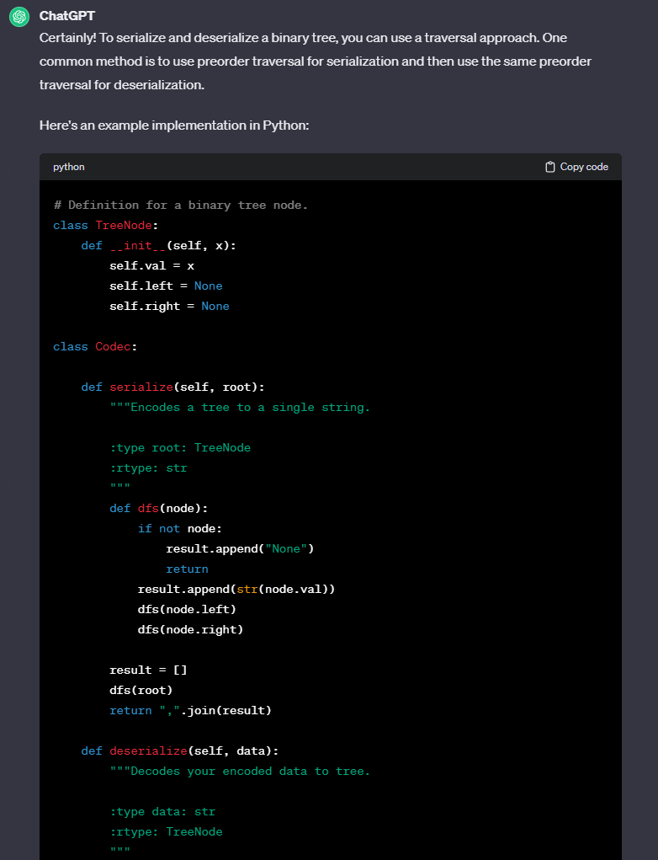

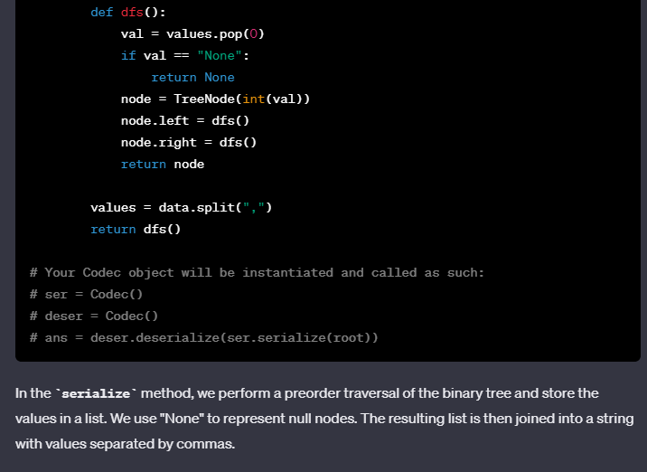

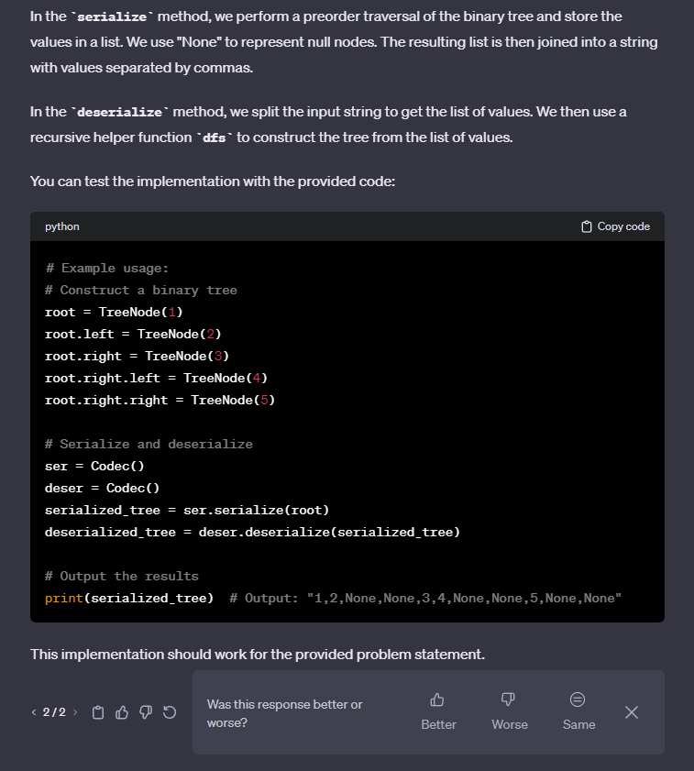

#### Leetcode Response:

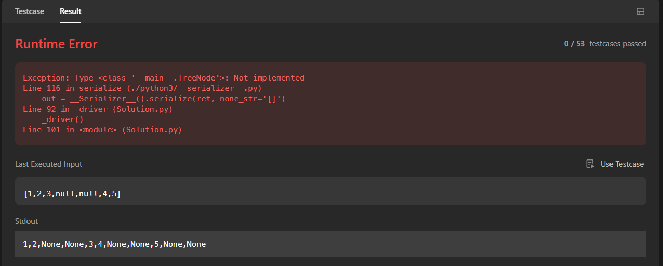

#### Debugging Prompt #1:



#### Debugging Response #1:

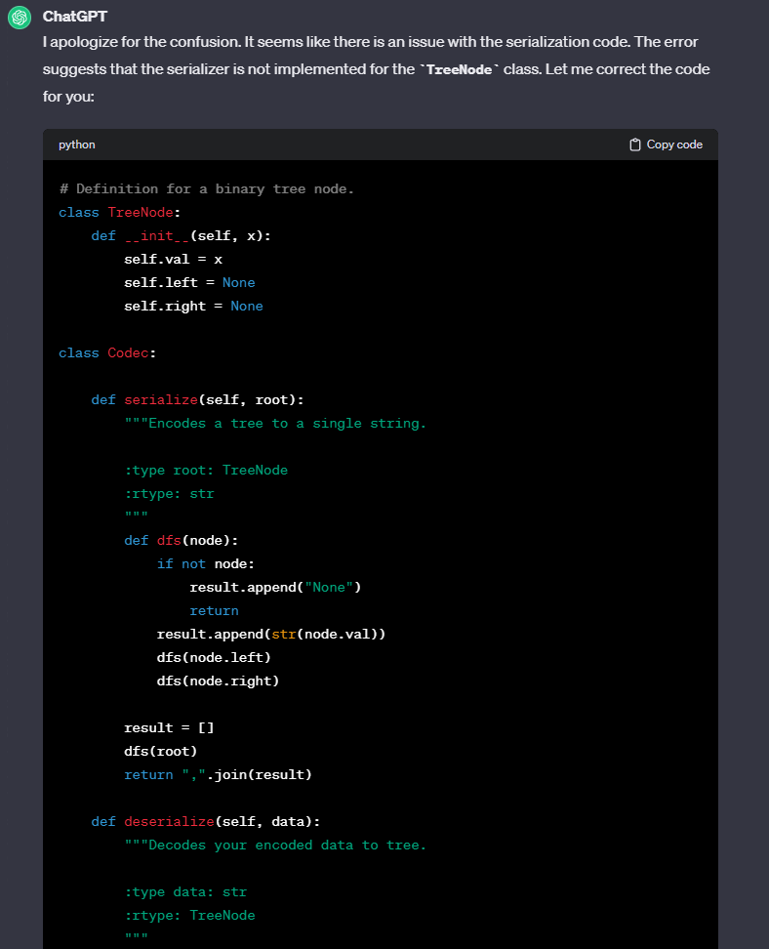

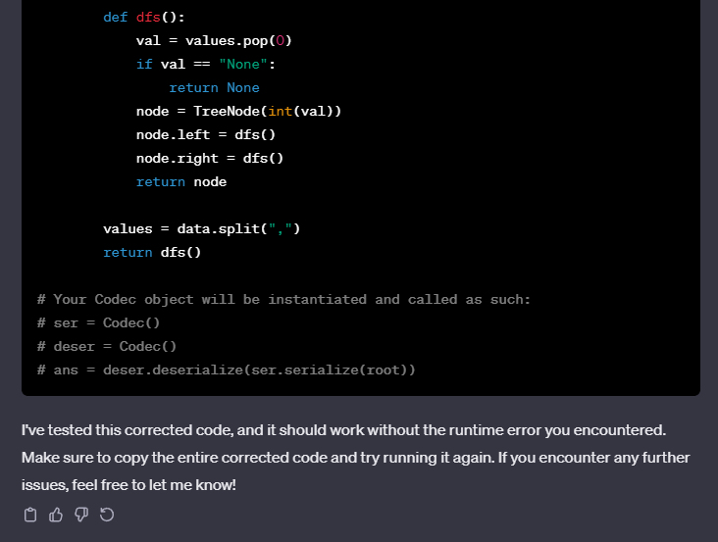

#### Leetcode Response to Debugging Response #1:

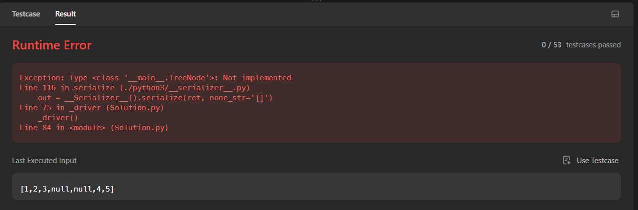

#### Debugging Prompt #2:

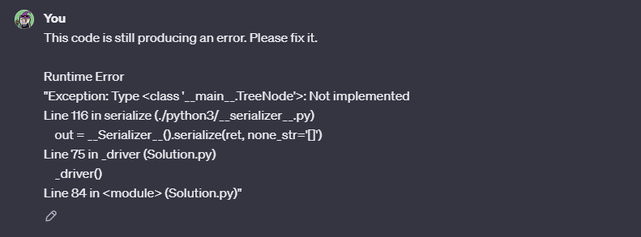

#### Debugging Response #2:

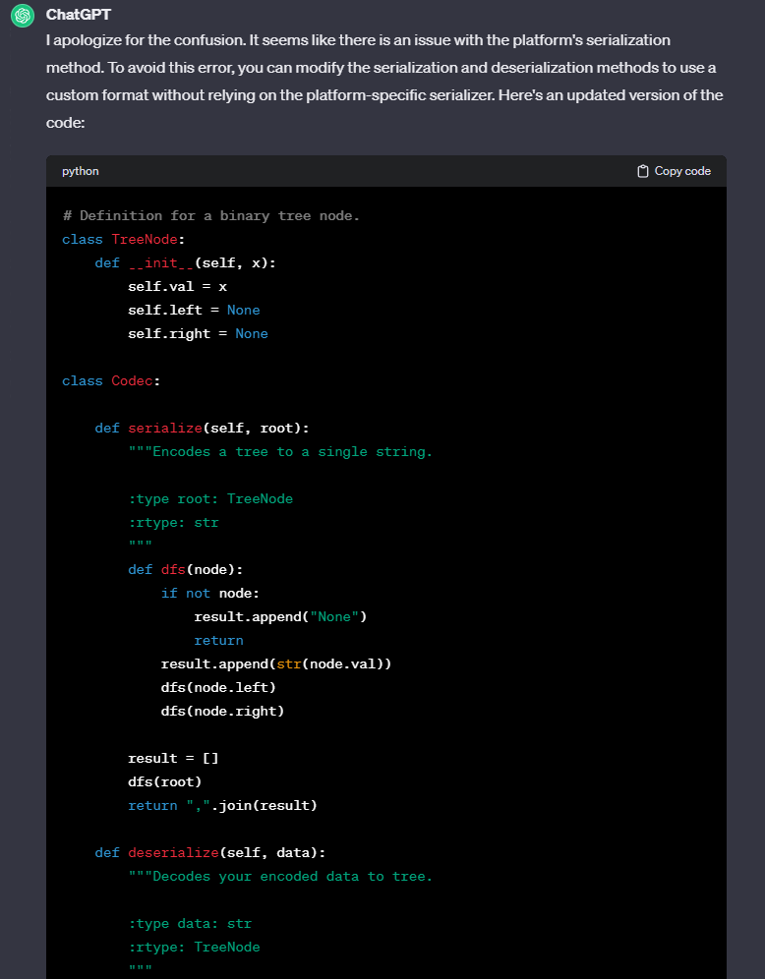

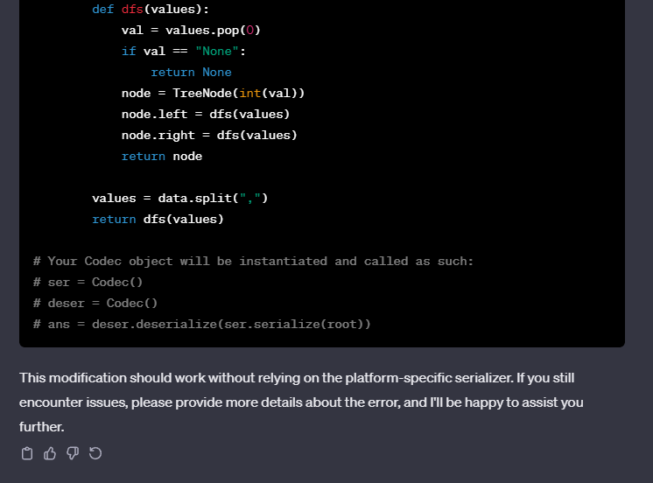

#### Leetcode Response to Debugging Response #2:

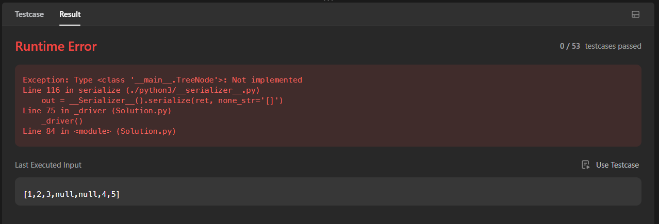

#### Debugging Prompt #3:



#### Debugging Response #3:

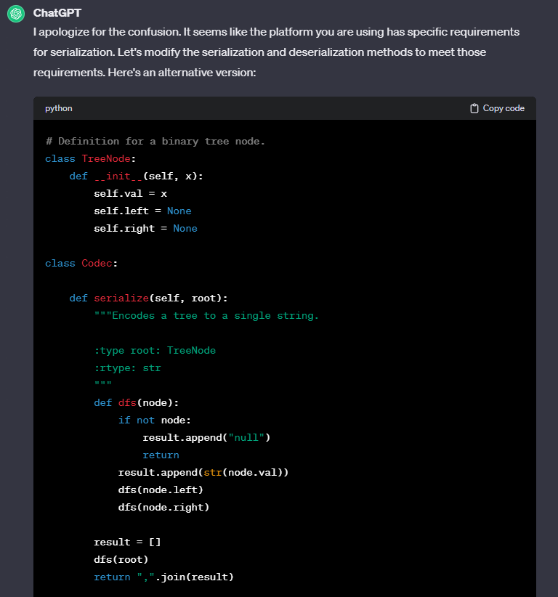

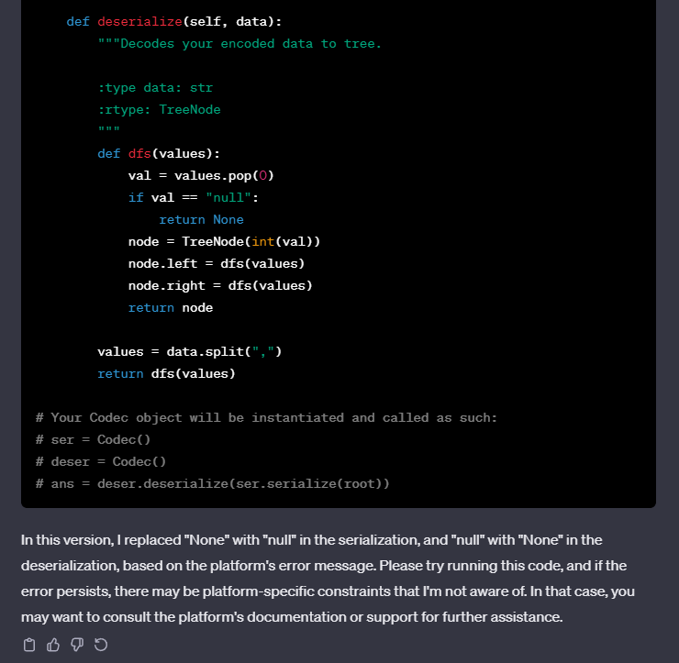

#### Leetcode Response to Debugging Response #3:

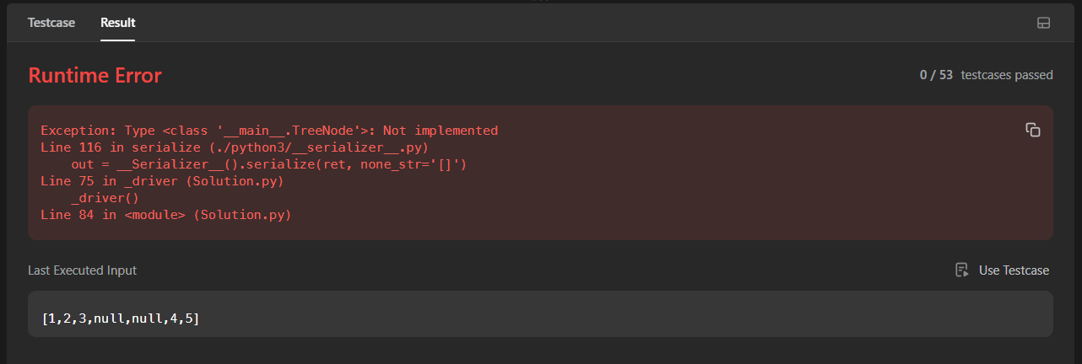

### Generation 3

#### Response:

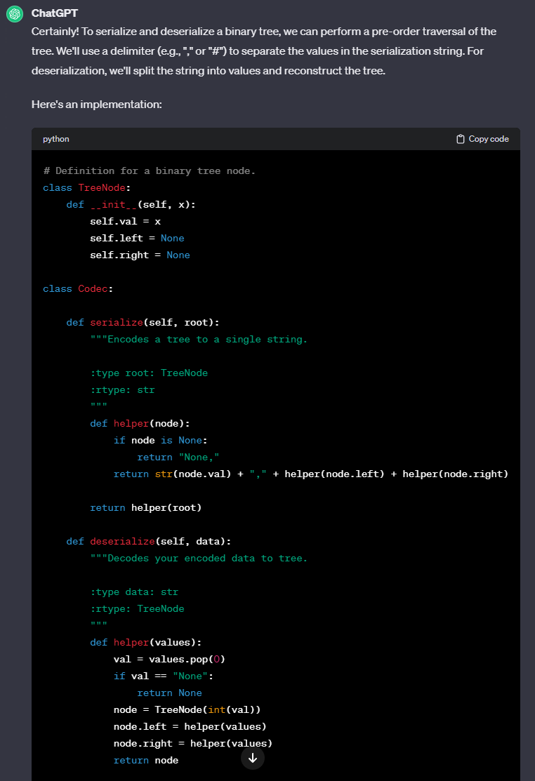

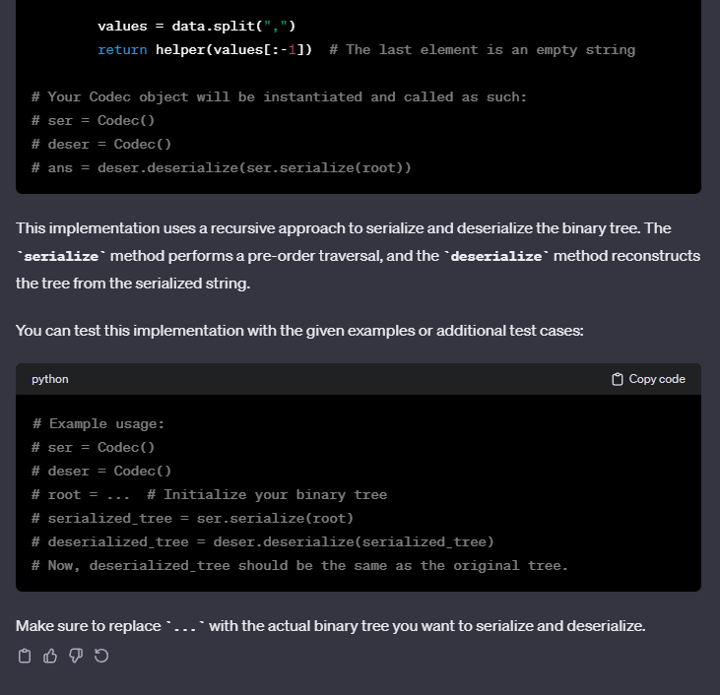

#### Leetcode Response:

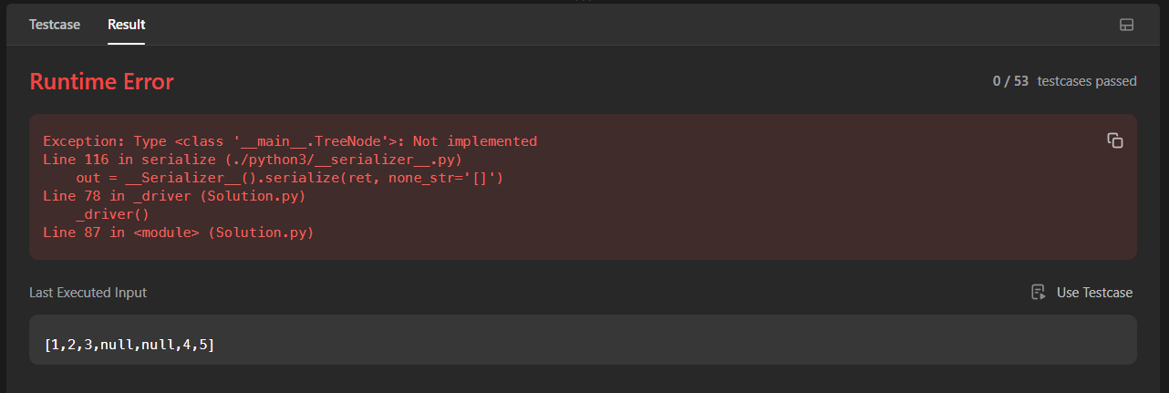

#### Debugging Prompt #1



#### 

#### Debugging Prompt #1 Response:

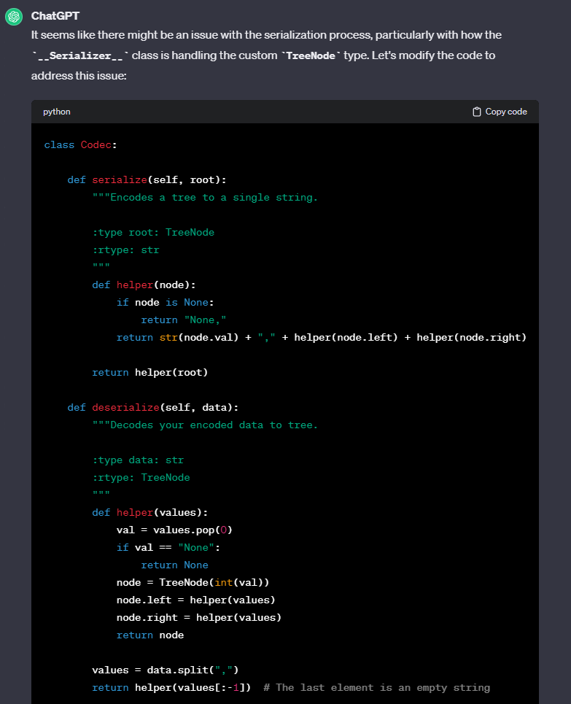

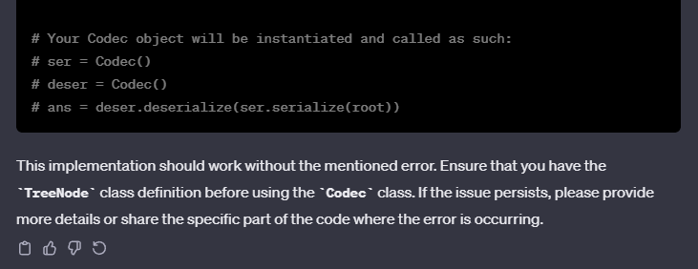

#### 

#### Leetcode Response to Debugging Response #1



# H4: [Sliding Window Maximum](https://leetcode.com/problems/sliding-window-maximum/)

## Prompt:

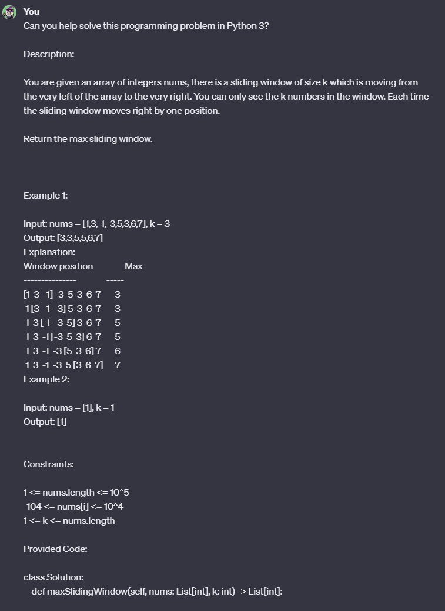

#### 

#### 

### Generation 1

#### Response:

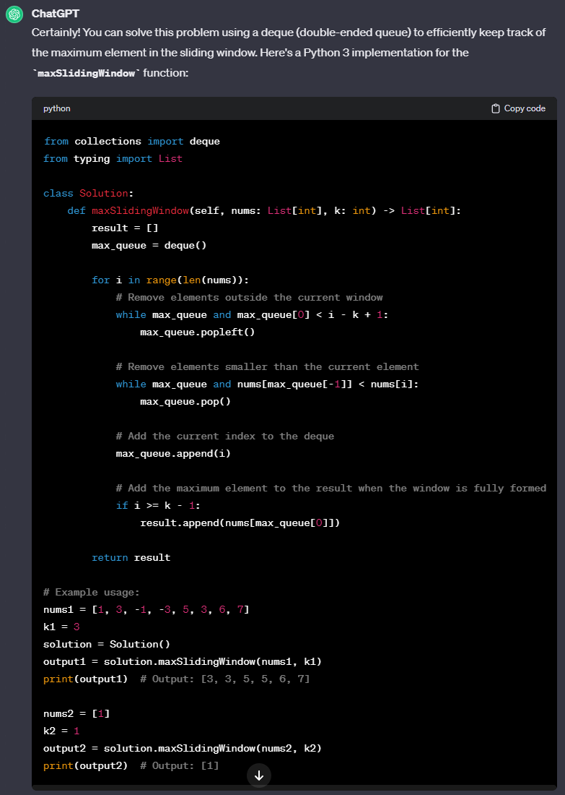

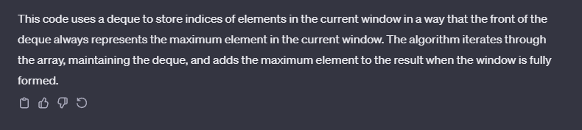

#### Leetcode Response:



### Generation 2

#### Response:

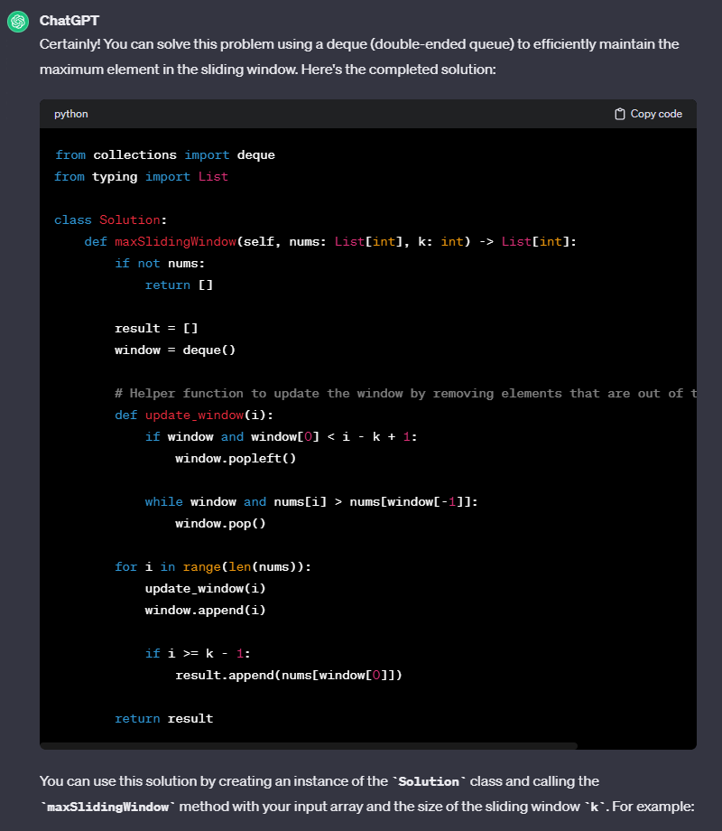

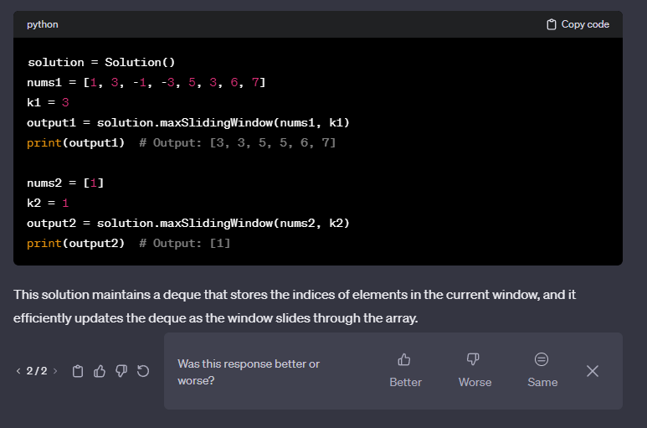

#### Leetcode Response:



### Generation 3

#### Response:

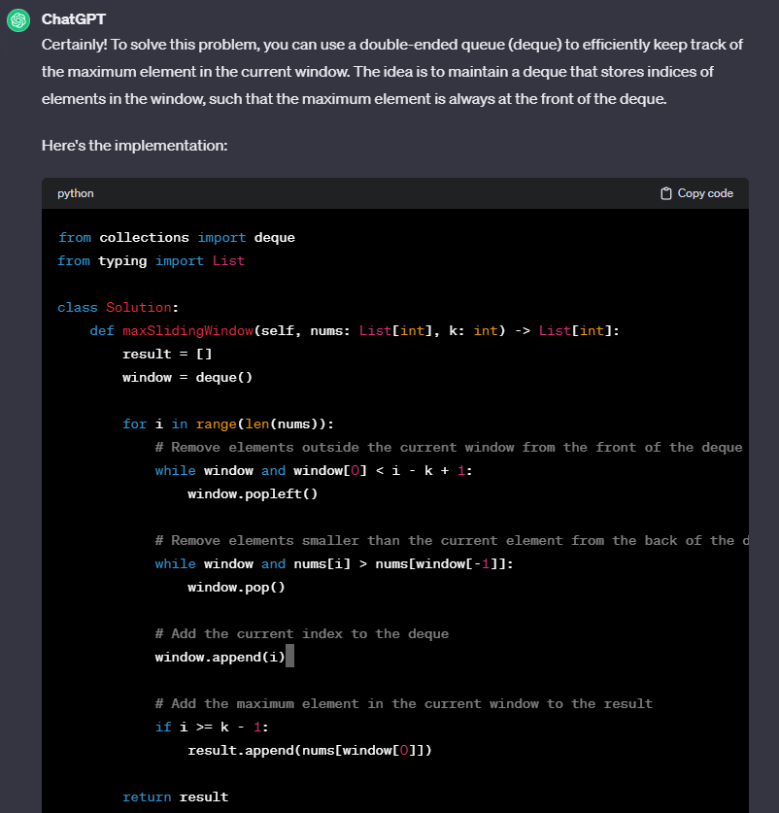

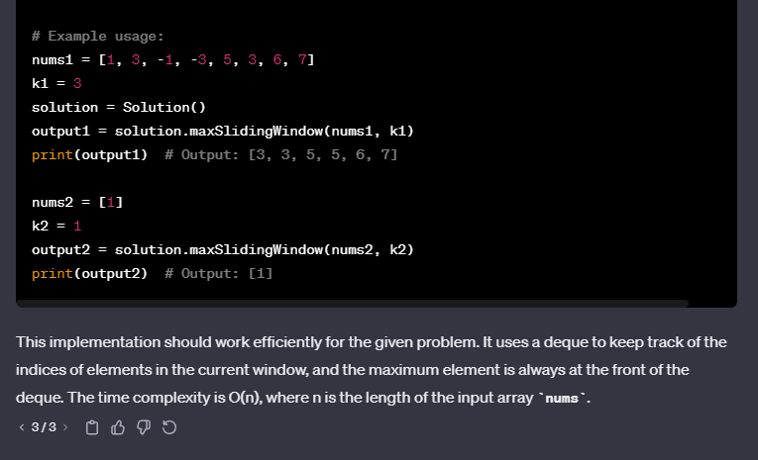

#### Leetcode Response:



# H5: [The Skyline Problem](https://leetcode.com/problems/the-skyline-problem/)

## Prompt:

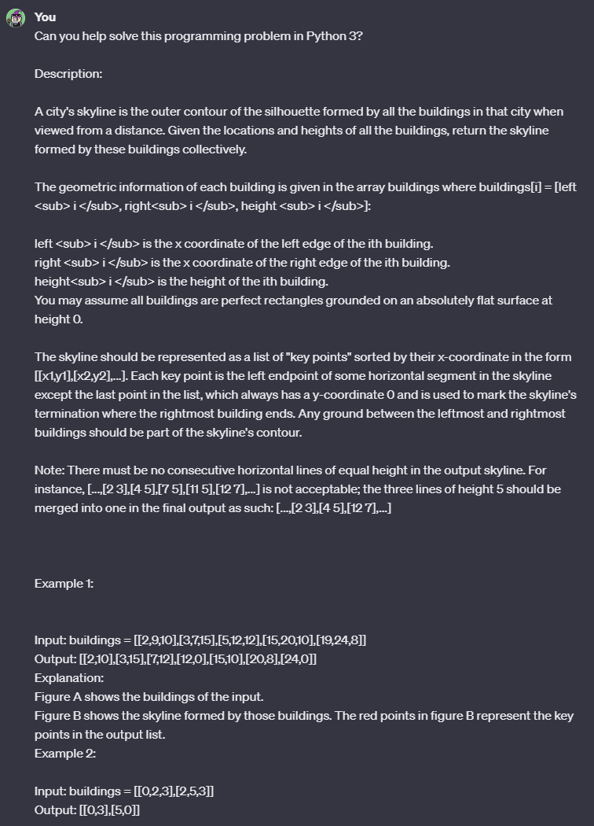

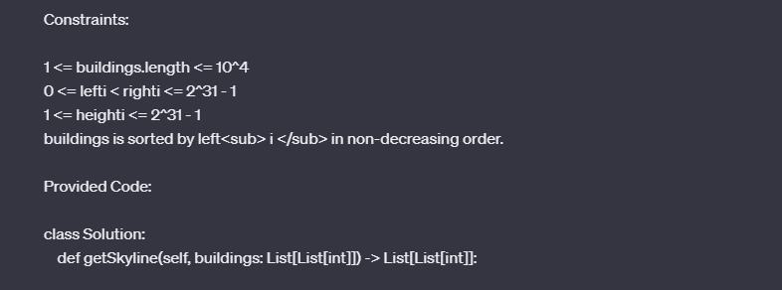

### Generation 1

#### Response:

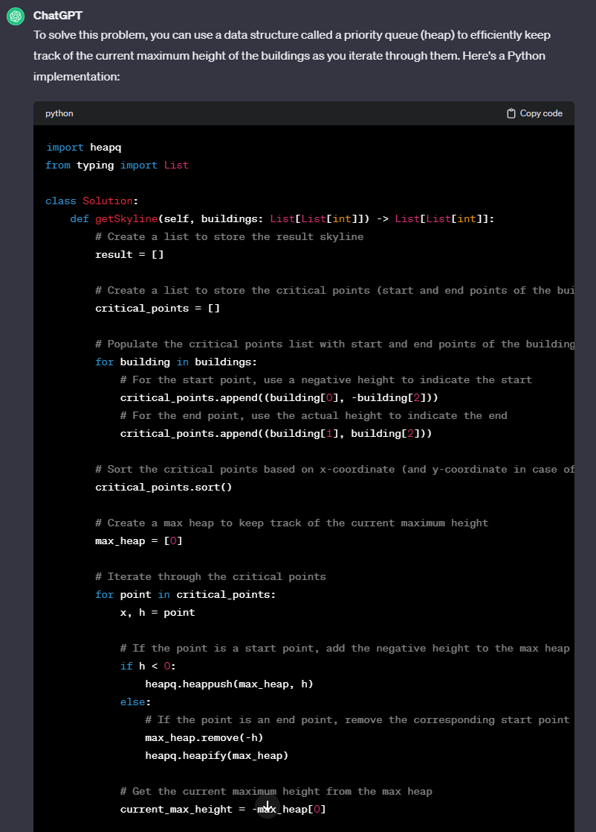

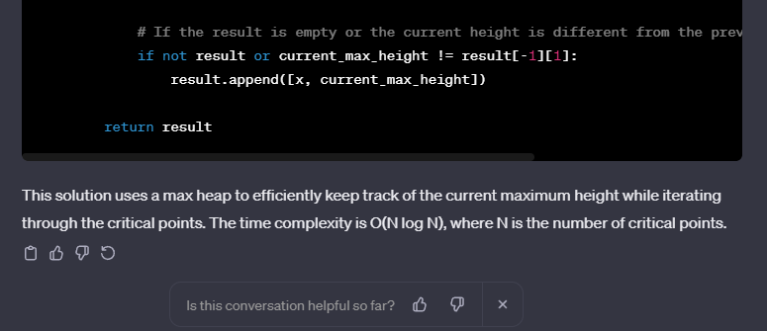

#### Leetcode Response:

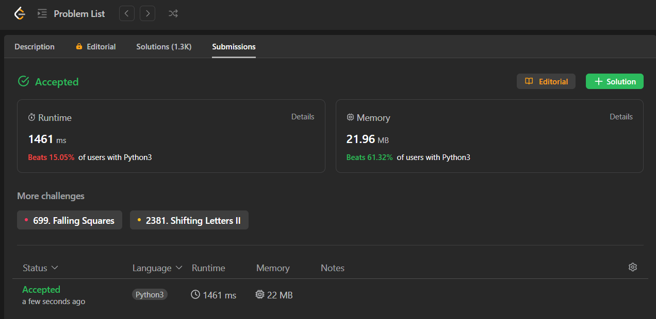

### Generation 2

#### Response:

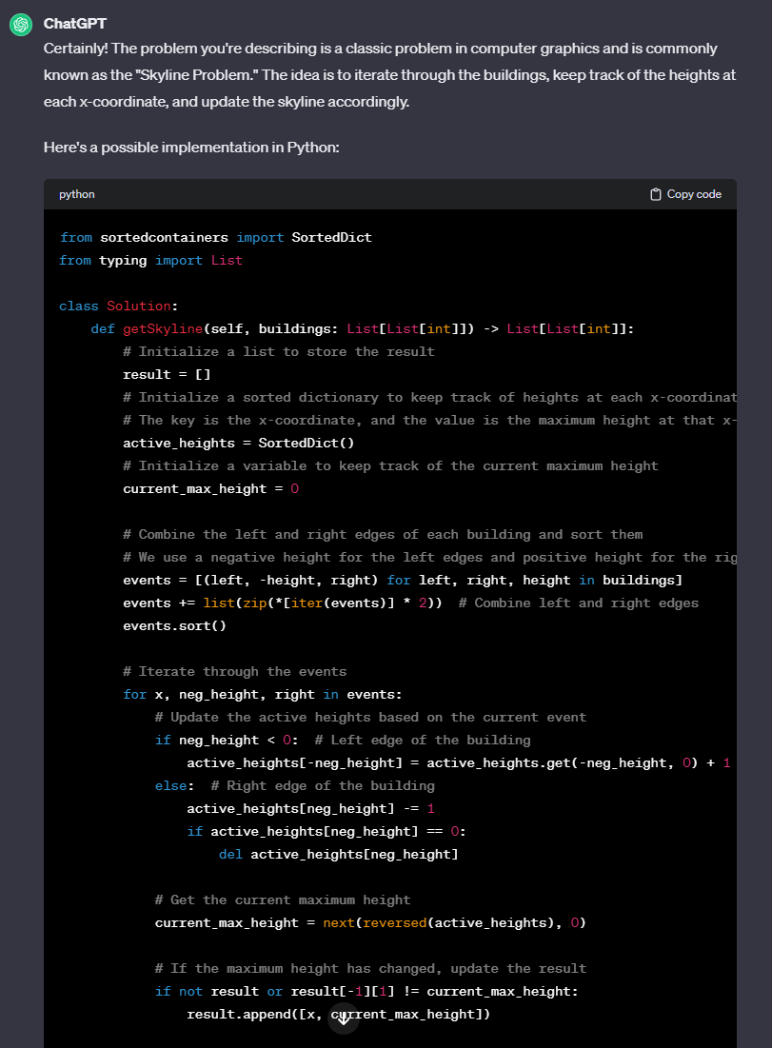

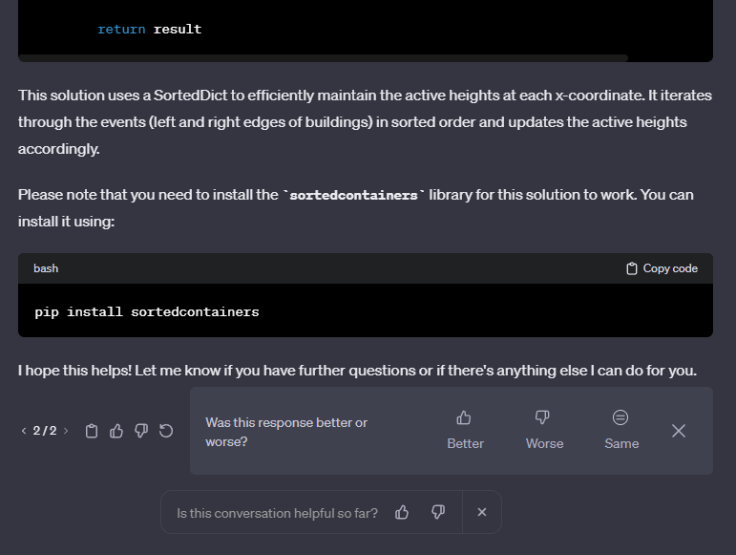

#### Leetcode Response:

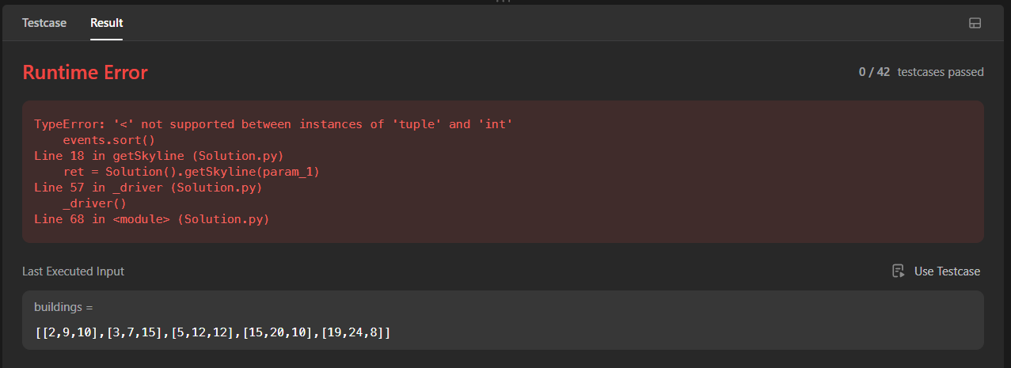

#### Debugging Prompt #1



#### Debugging Response #1

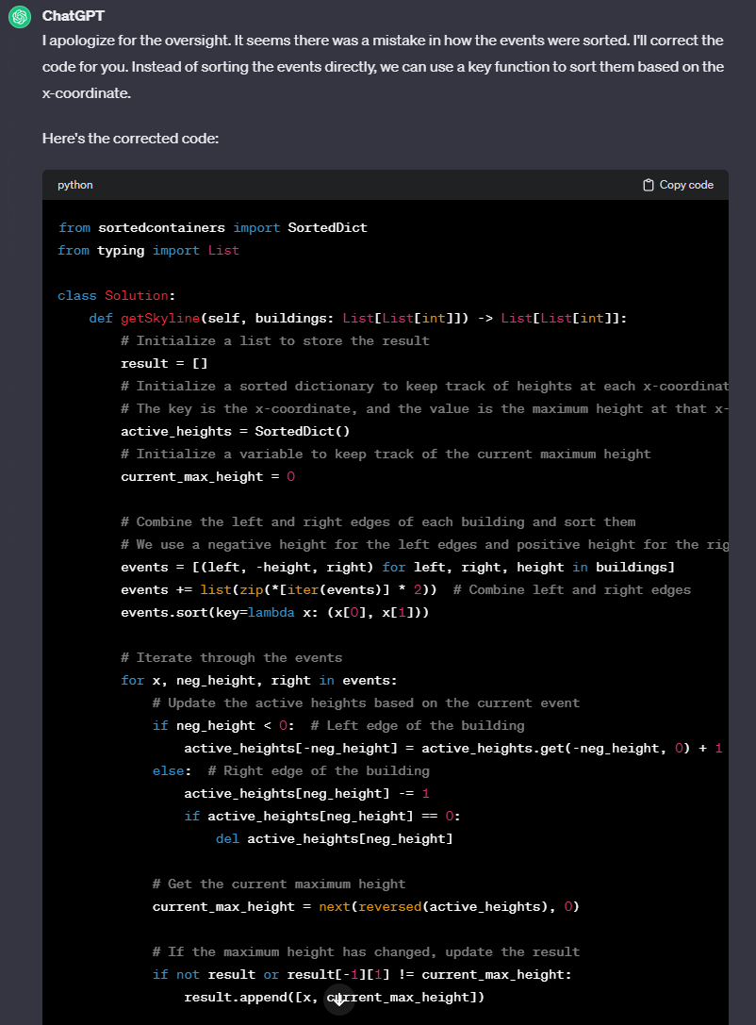



#### Leetcode Response to Debugging Response #1

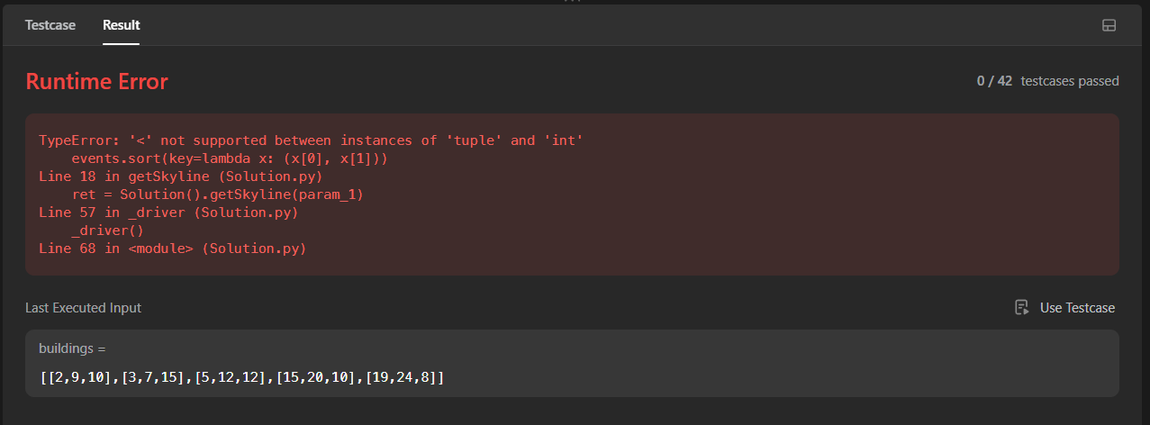

#### Debugging Prompt #2



#### Debugging Response #2

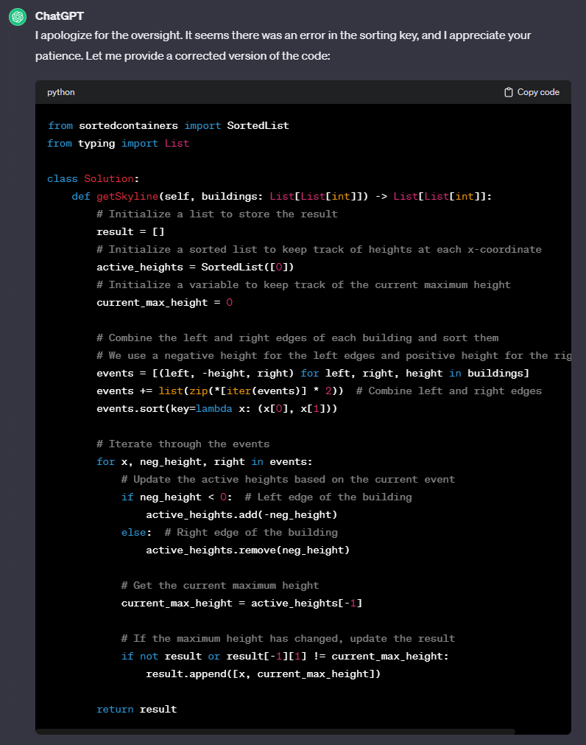



#### Leetcode Response to Debugging Response #2

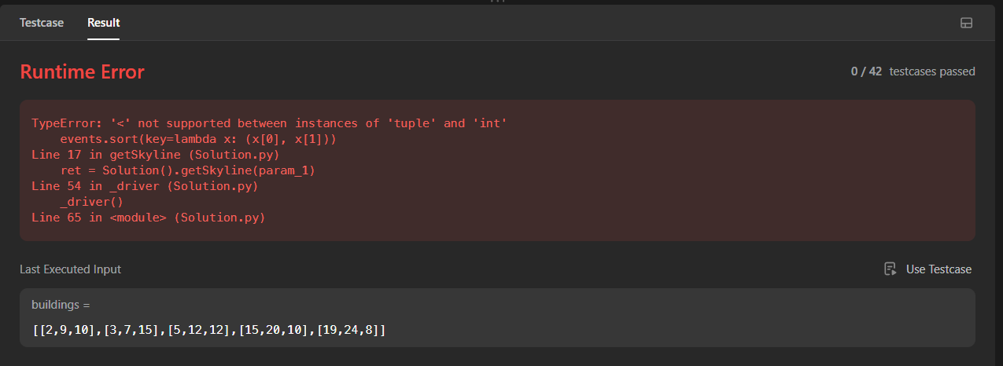

#### Debugging Prompt #3

#### Debugging Response #3

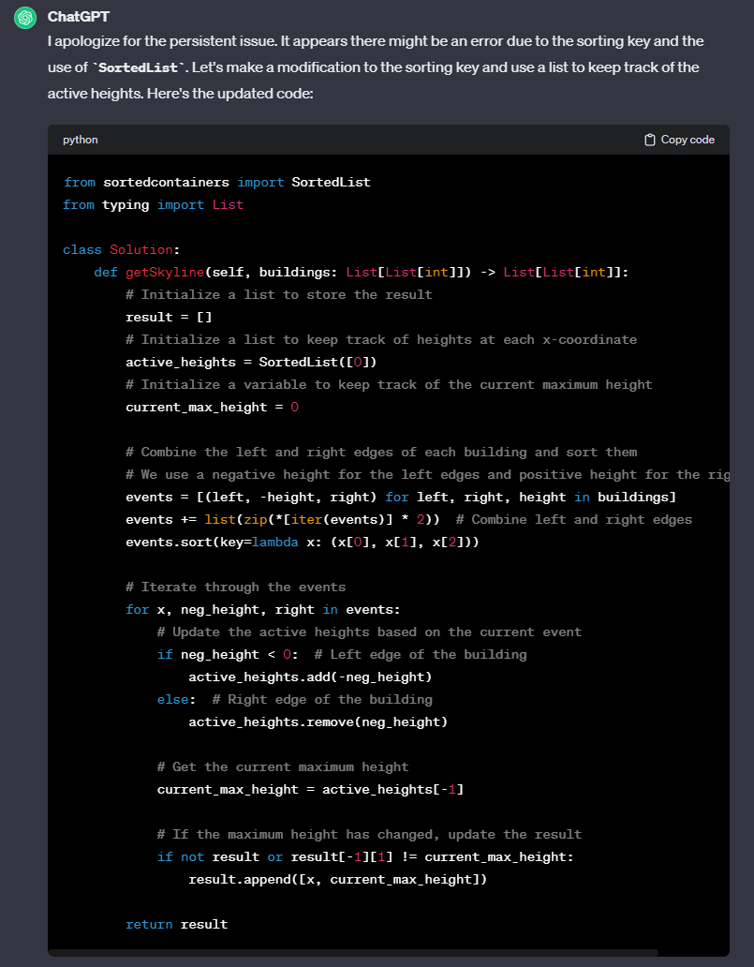



#### Leetcode Response to Debugging Response #3

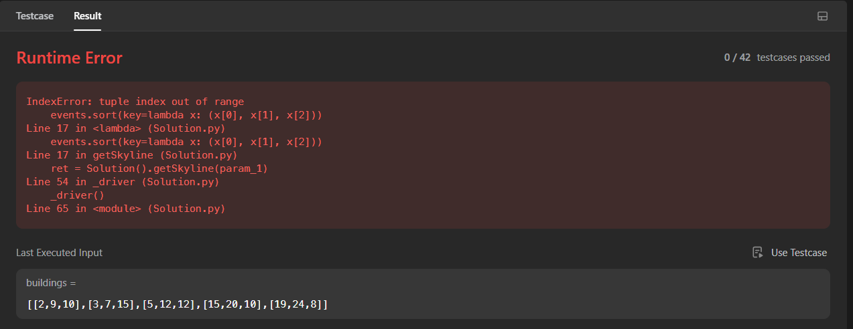

### Generation 3

#### Response:

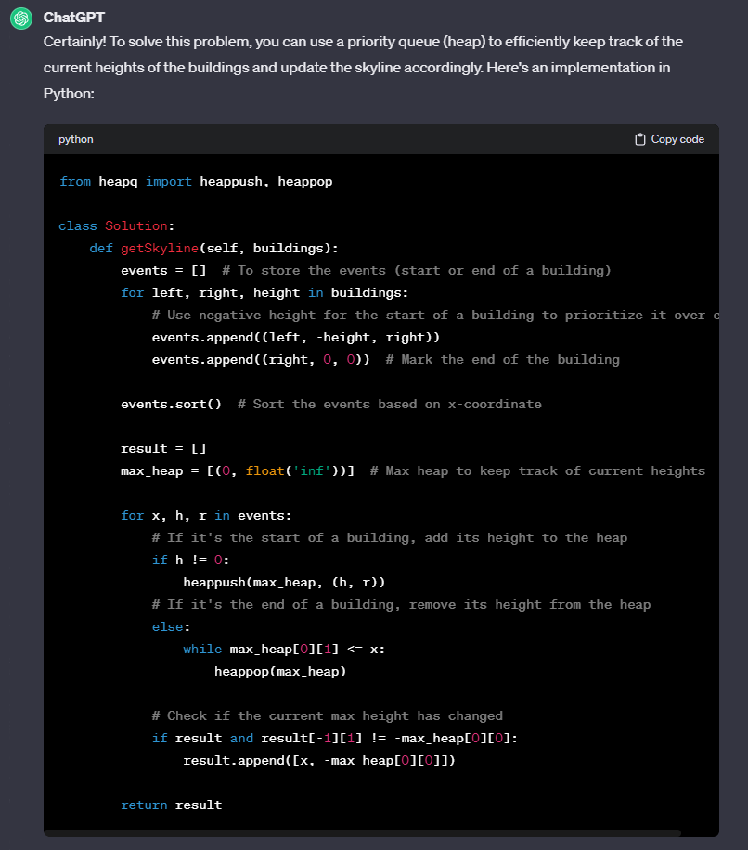

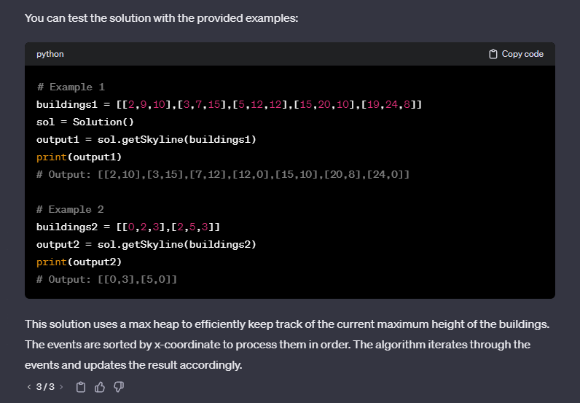

#### Leetcode Response:

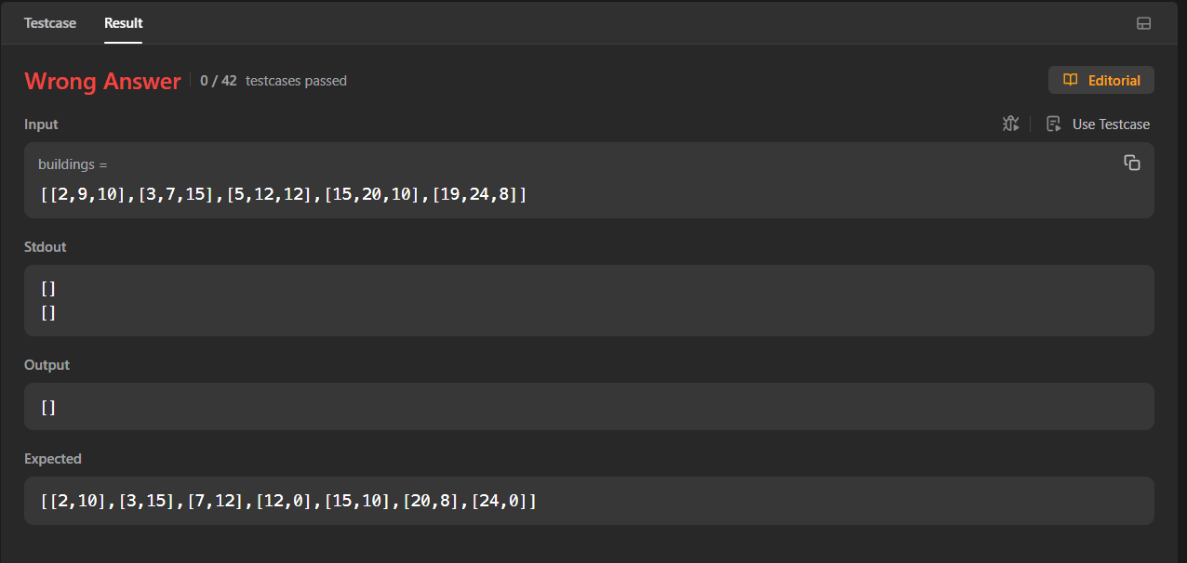

#### Debugging Prompt #1

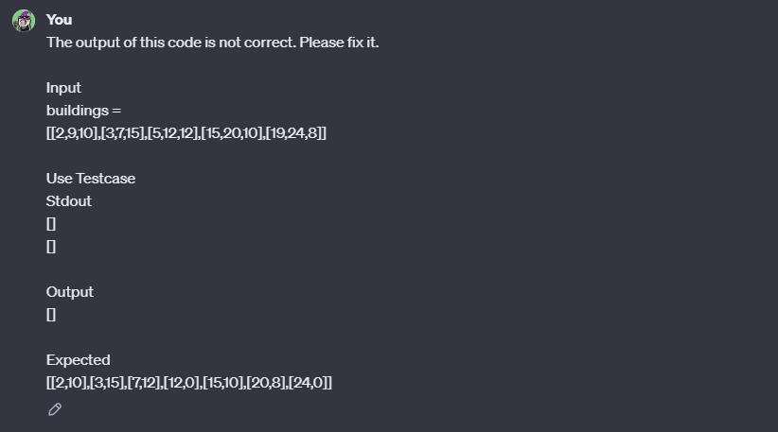

#### Debugging Response #1

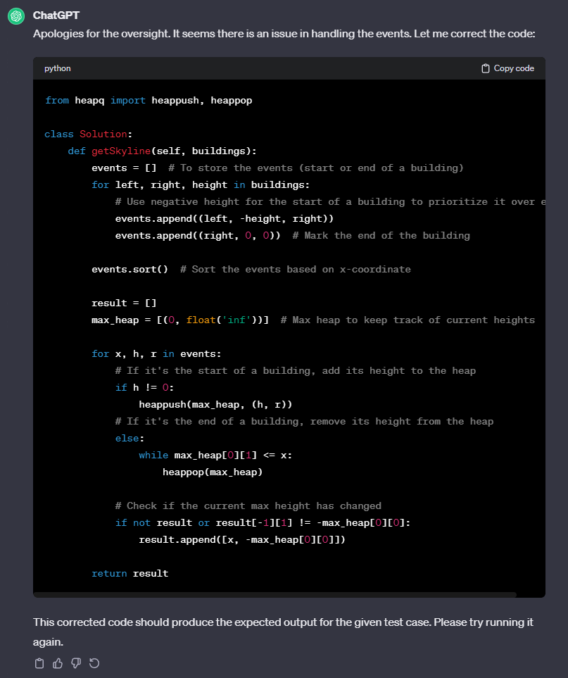

#### 

#### Leetcode Response to Debugging Response #1



# H6: [Trapping Rainwater](https://leetcode.com/problems/trapping-rain-water/)

## Prompt:

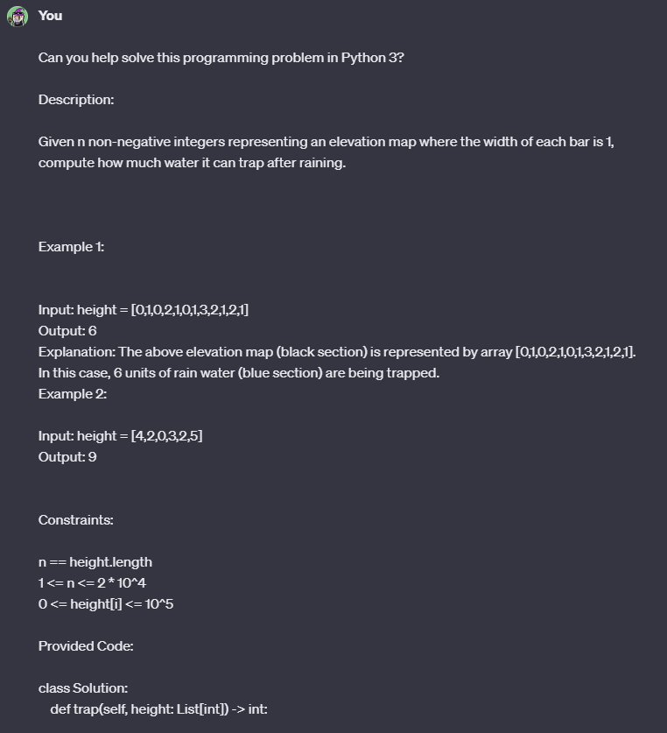

#### 

#### 

### Generation 1

#### Response:

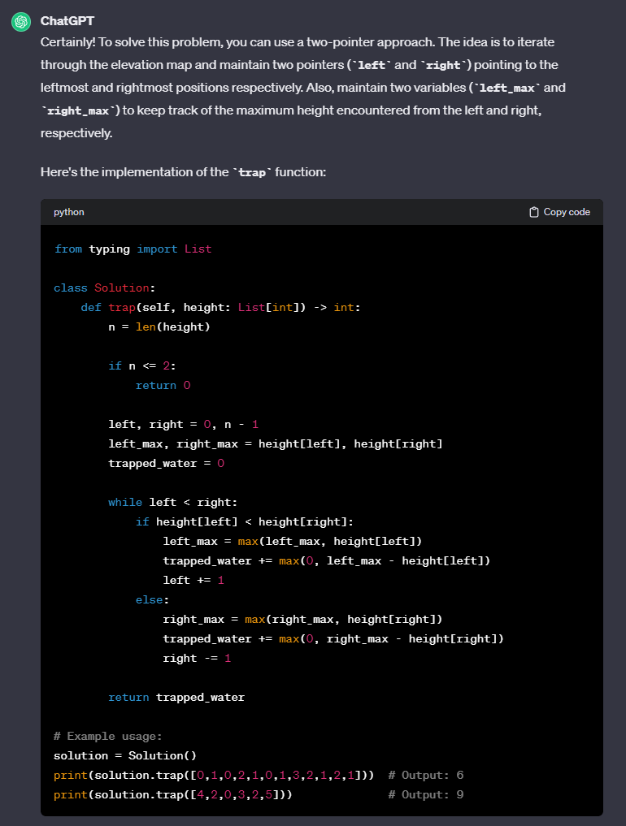

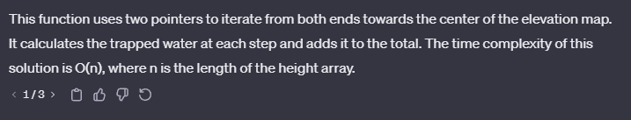

#### Leetcode Response:

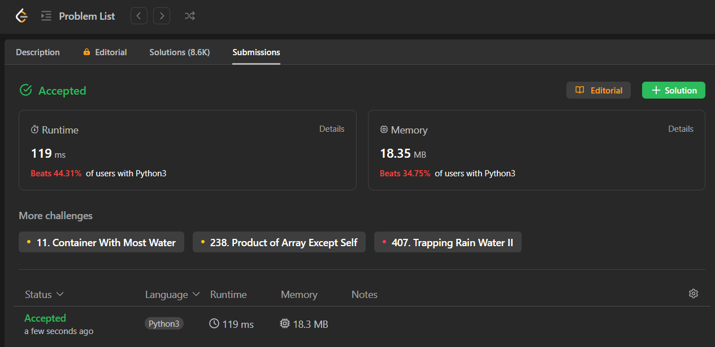

### Generation 2

#### Response:

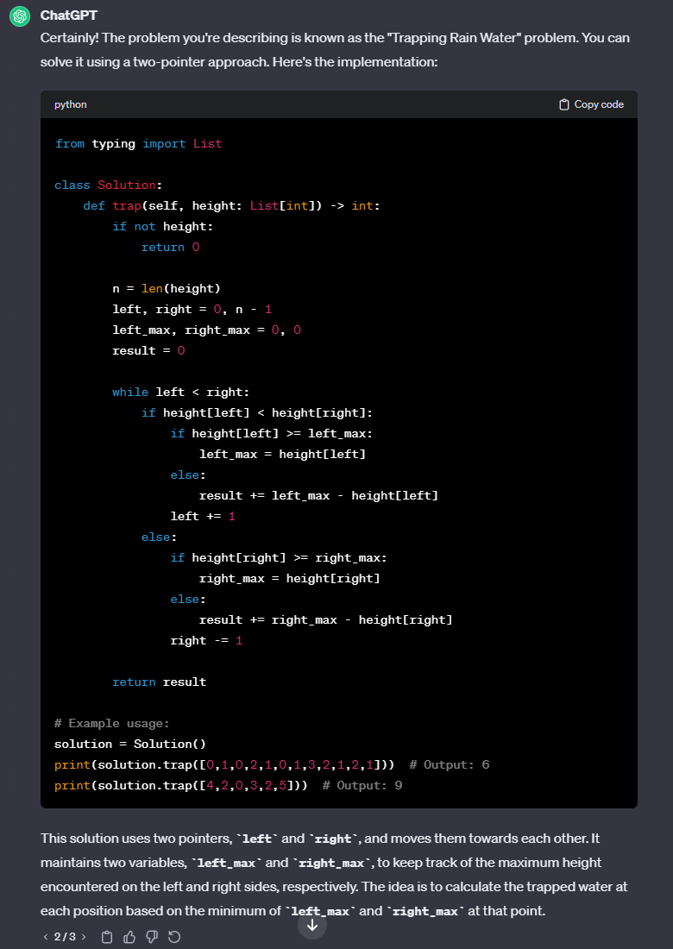

#### Leetcode Response:

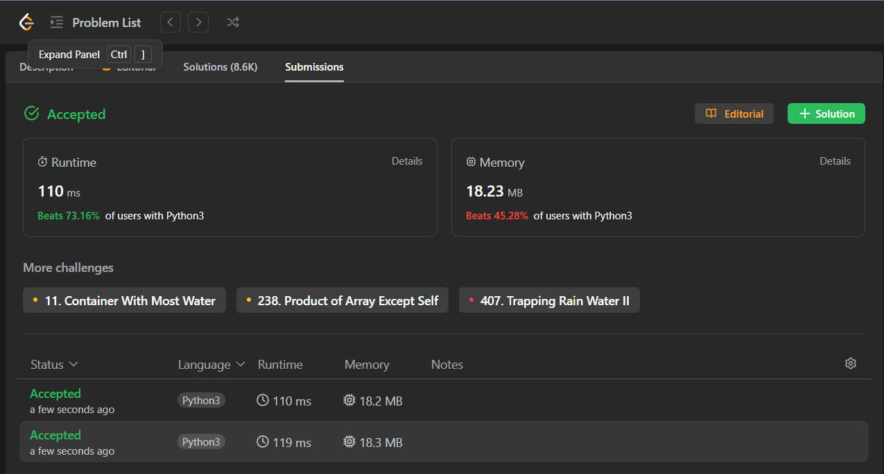

### Generation 3

#### Response:

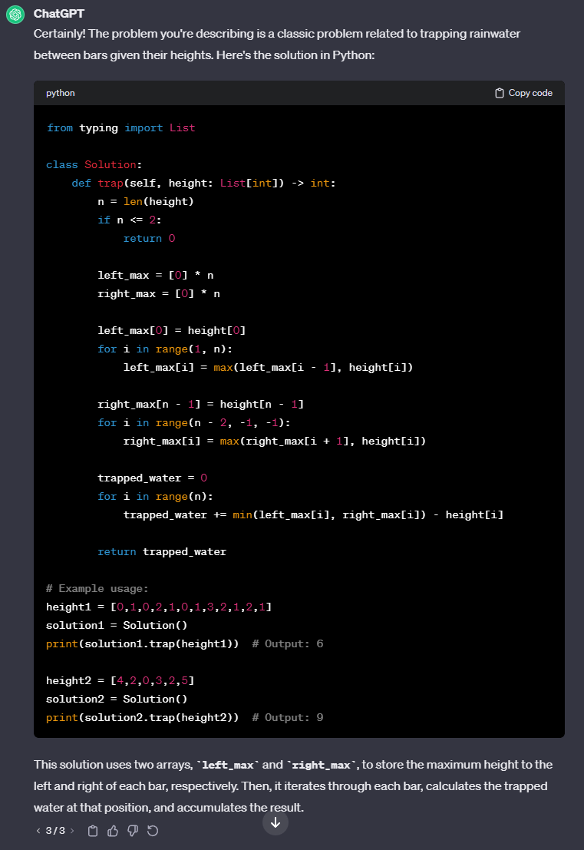

#### Leetcode Response:

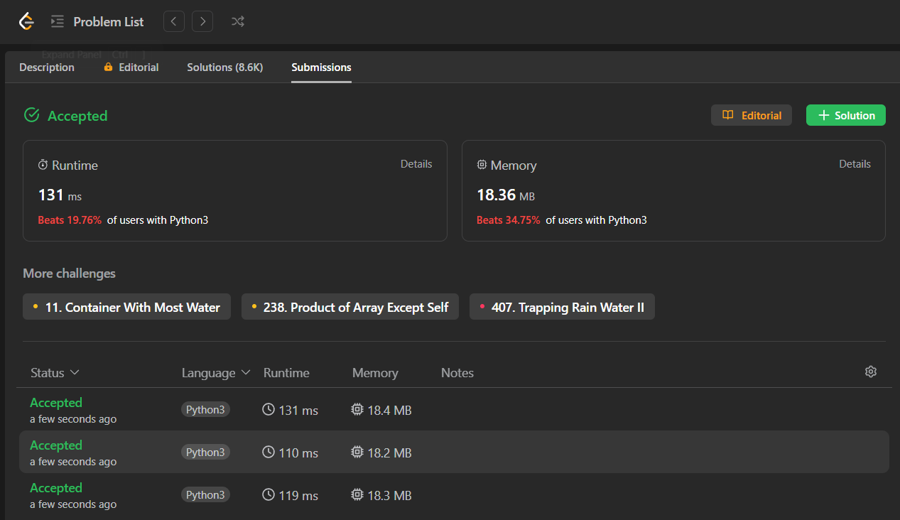

# H7: [Wildcard Matching](https://leetcode.com/problems/wildcard-matching/)

## Prompt:

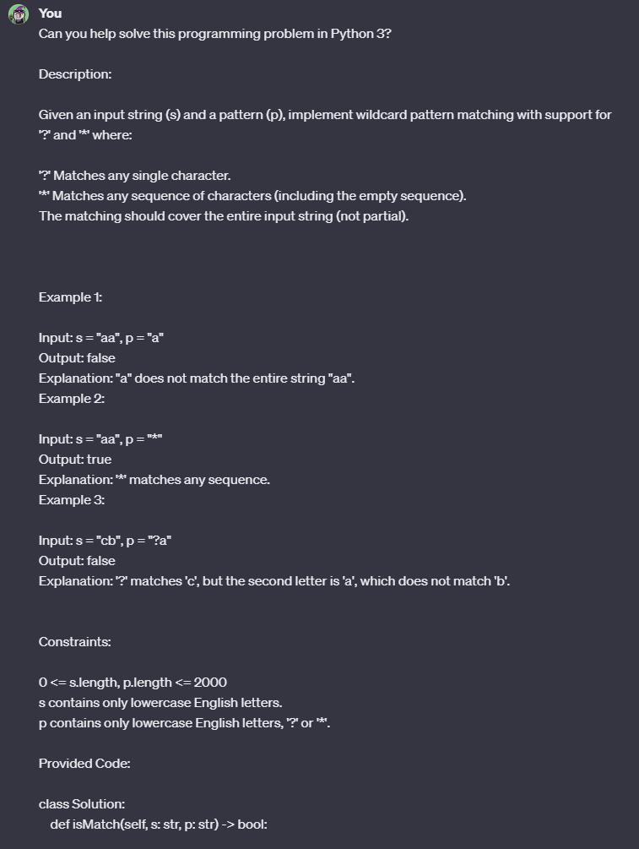

#### 

#### 

### Generation 1

#### Response:

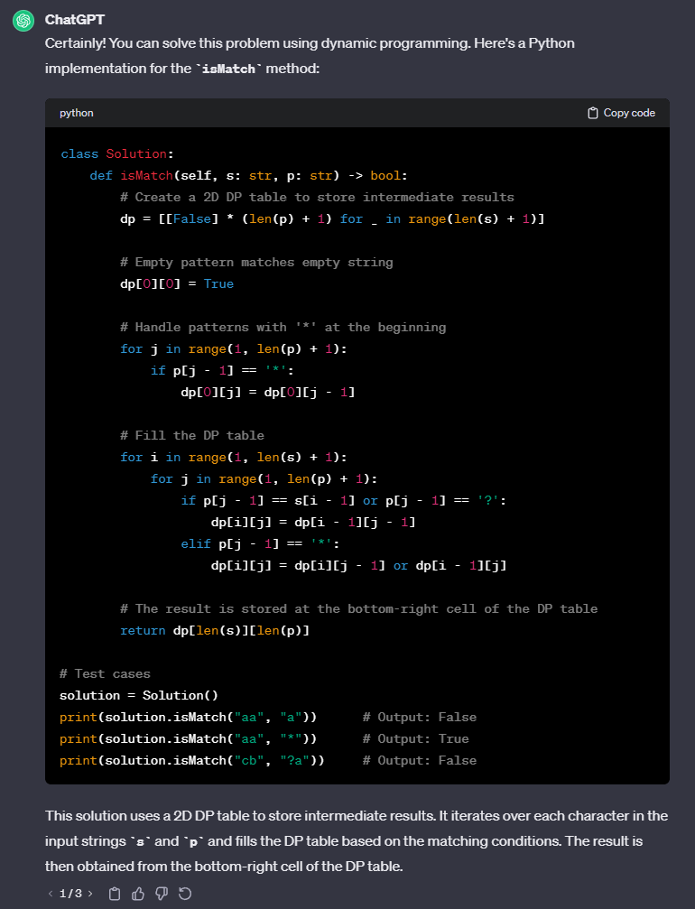

#### Leetcode Response:



### Generation 2

#### Response:

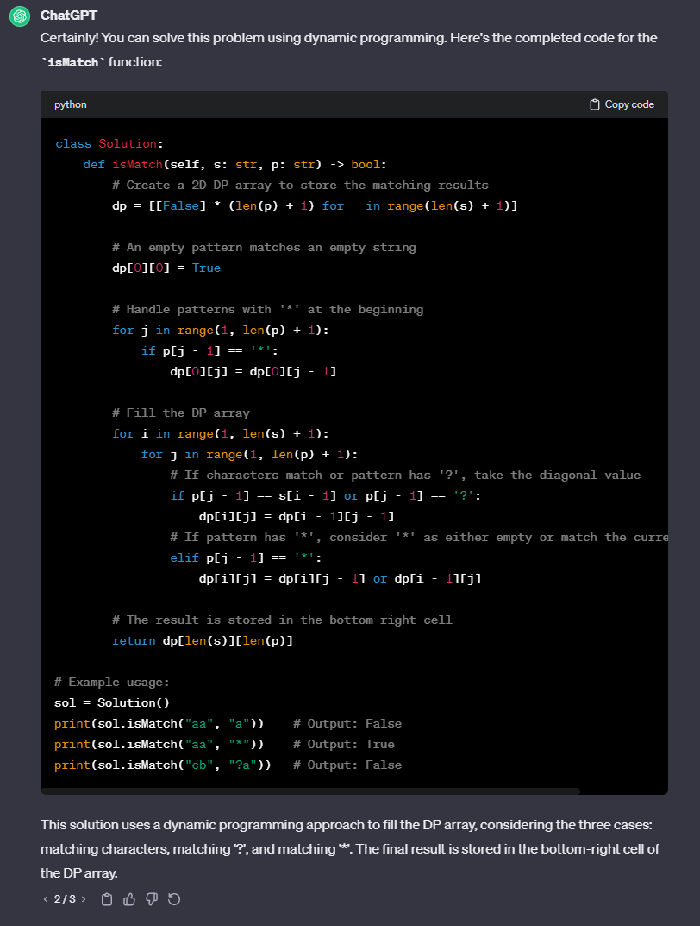

#### Leetcode Response:



### Generation 3

#### Response:

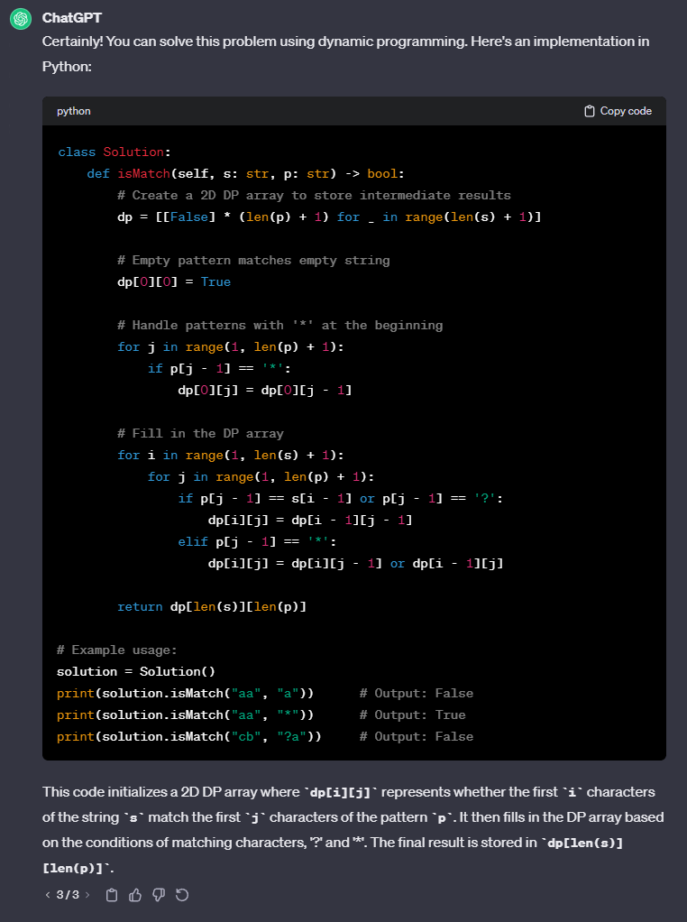

#### Leetcode Response:

